Completing the CIET & Training for CIs
Prism PT-PTA
If you are working with a program who uses Exxat and also utilizes the CIET (Clinical Internship Evaluation Tool), when the midterm or final comes around, you will be asked to complete the form.
- Once the student completes the CIET, you will receive an email from notifications@exxat.com which will include a link for you to access the form.
  - We suggest that you please try to use any of the following internet browsers for the best experience: Google Chrome, Safari, Firefox.
  - Please note that you may experience performance issues (difficulty saving information, submitting, etc.) when using Internet Explorer.

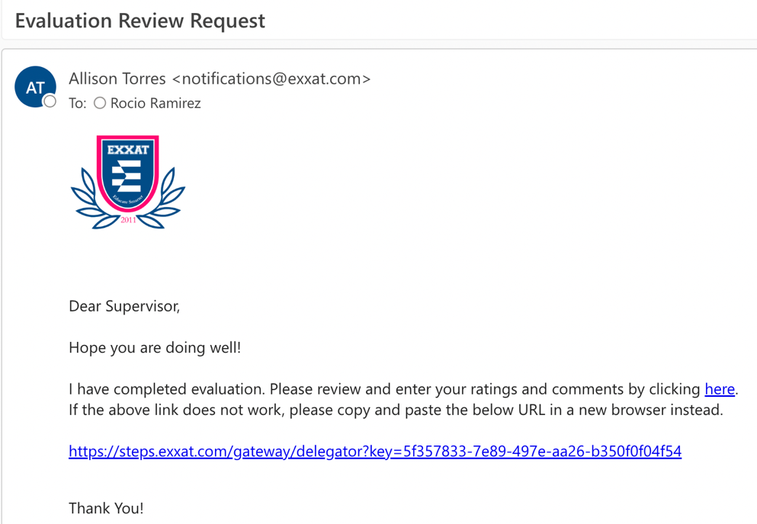

- Once you click on the link, a new tab will open. You will see a pop up asking if you have completed the CIET Training:
  - If you have done the training before, click Yes.
  - If this is the first time you are using the CIET, click No.

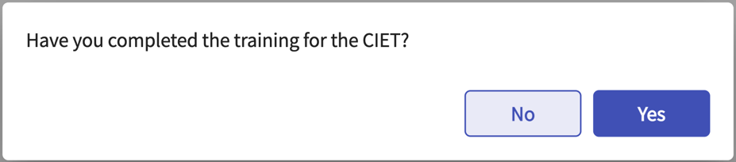

- If this is your first time completing a CIET form, you will be asked to complete the training. You must score at least a 15/20 (75%) on this assessment before you can move forward.
  - Make sure to watch the training video and any additional resources provided within the Instructions header.

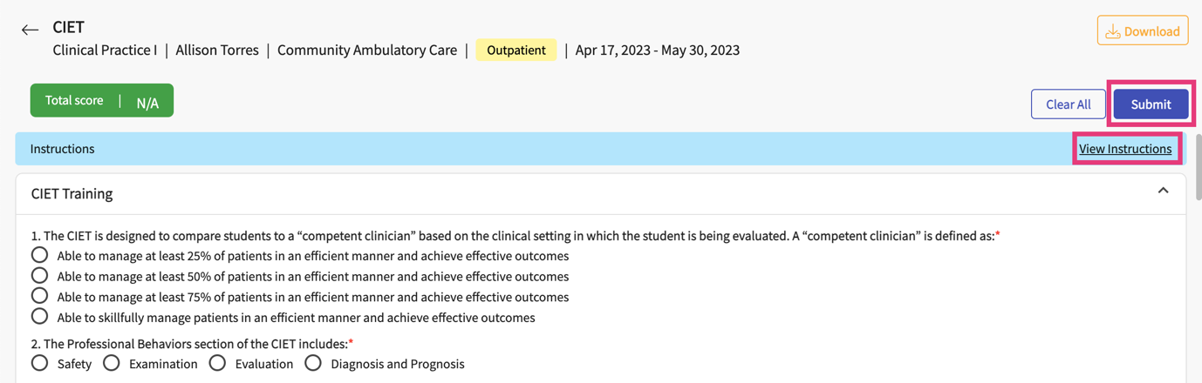

- If you receive a score lower than 75% a message will appear asking you to retake the quiz. The quiz will highlight any questions you missed.

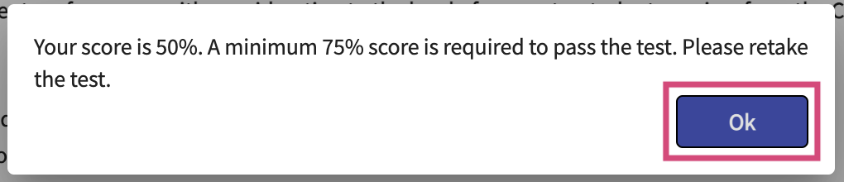

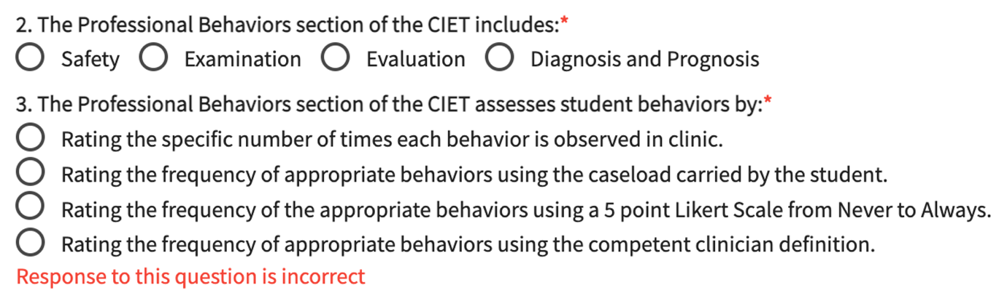

- Once you pass the training, click Ok.

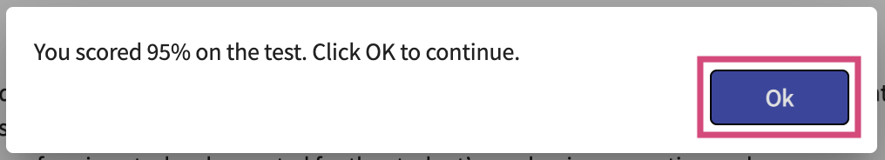

- If you have already completed the training in the past, you’ll be taken to the CIET form. You can then complete the CIET.
  - If you are not able to complete the full form in one sitting, you can save your progress and come back to it by clicking the Save button.
  - You can also remove all responses selected by using the Clear All button.
- On the CIET, you will see a menu to the left showing all of the sections you will complete.
- To the right, you will see the actual form. Questions with a red asterisk are mandatory.

View instructions & resources
Quickly skip to other sections

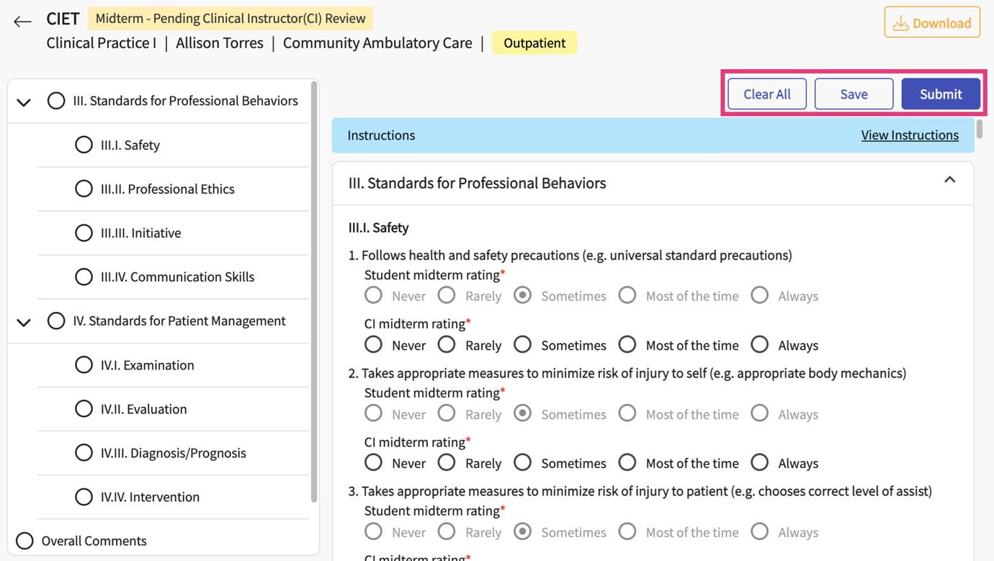

- For each question, you will see the student rating, and a place to add in your own rating.

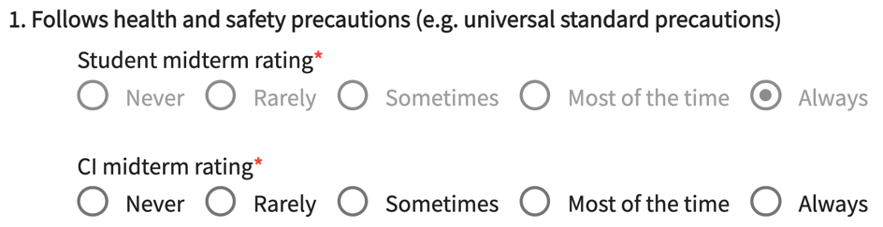

- At the end of every section, there will be a space for you to add comments.
  - Please note, the system will not process any comments that are added once you pass the 10000-character limit.
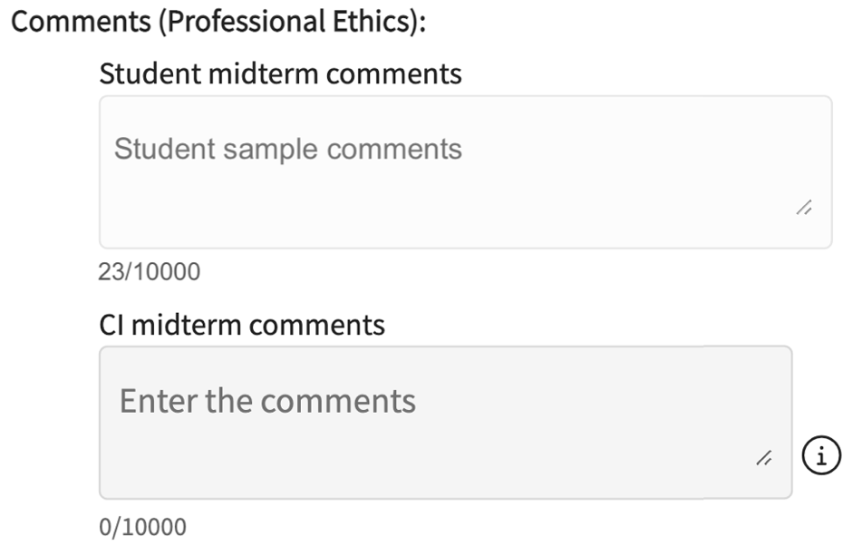

- Towards the end of the form, you can add any overall comments.

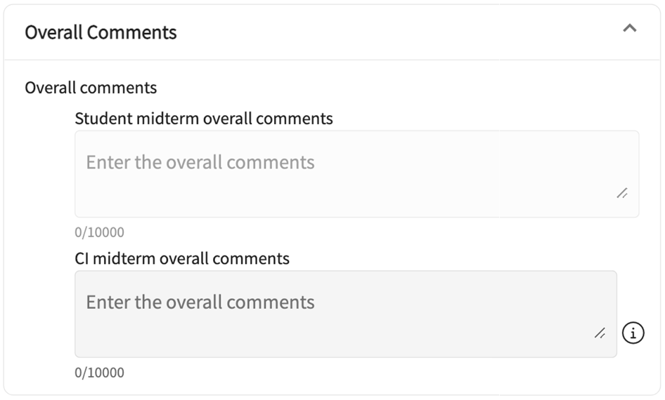

- Rate the student using the Global Rating of Student Clinical Competence.

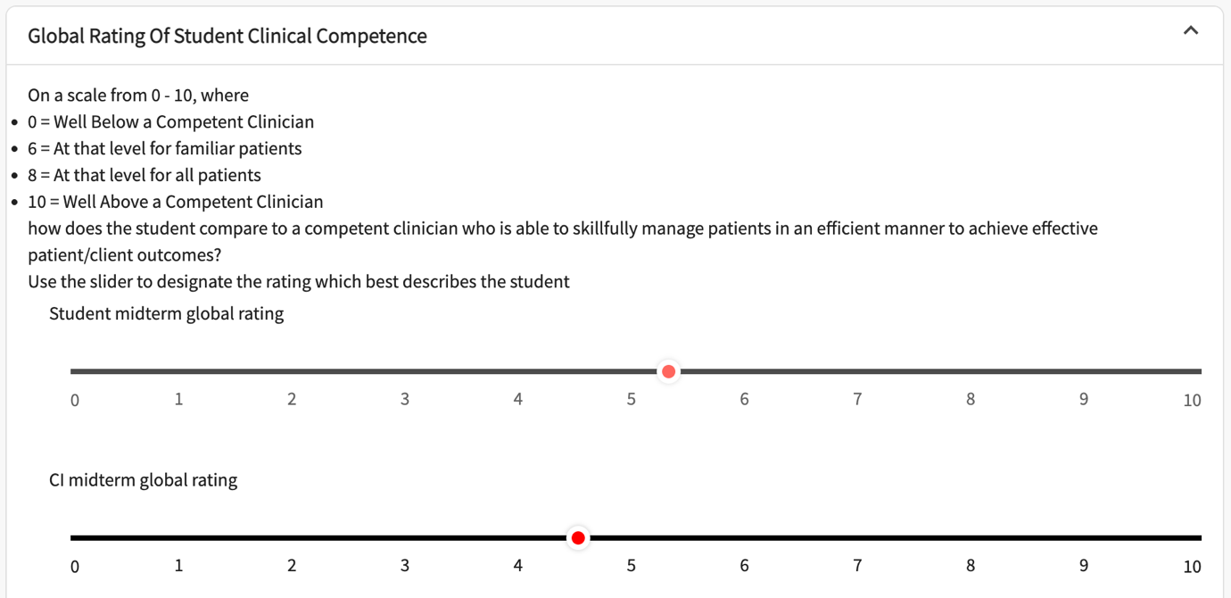

- Answer whether the student is performing at a level that is satisfactory for their current level of education and sign the document. Once done, click Submit.

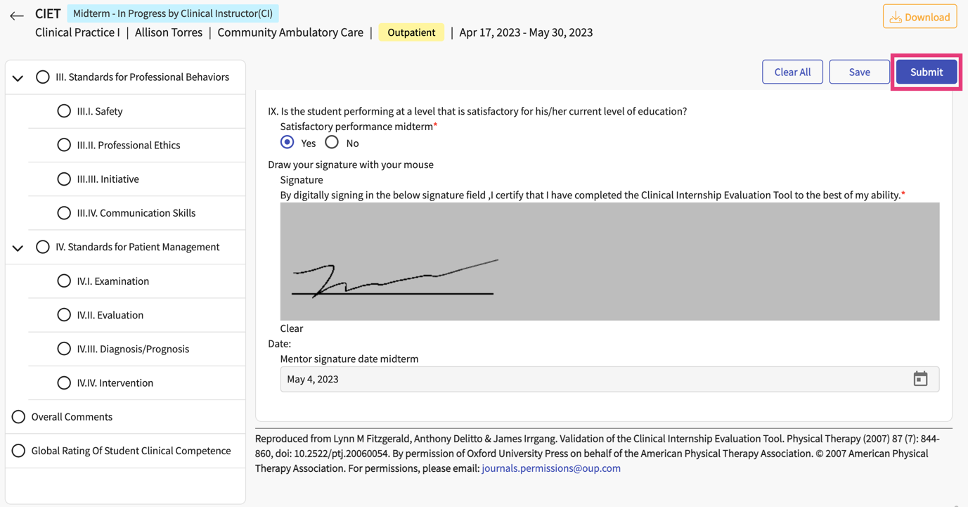

- A pop-up will appear asking you to confirm. Click OK to confirm.

- Your form is submitted! To complete the final, you will follow the same process.

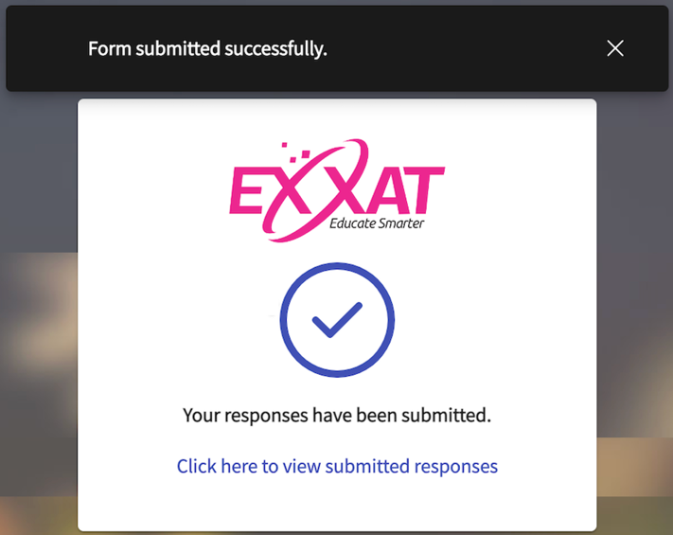

- Please note, students have the option to cancel their submission of the CIET form at any given time up until you submit your form. If this happens, you will be notified via email.

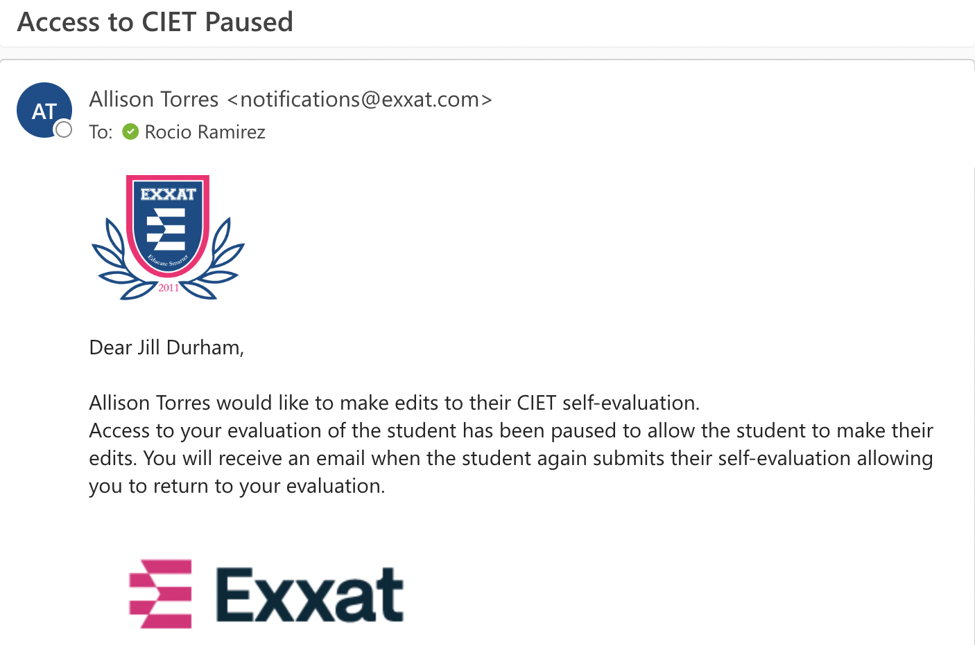

- Once the student re-submits their form, you will be notified with a new link to continue working on your CIET form. Any progress you have made will be saved once you regain access.

