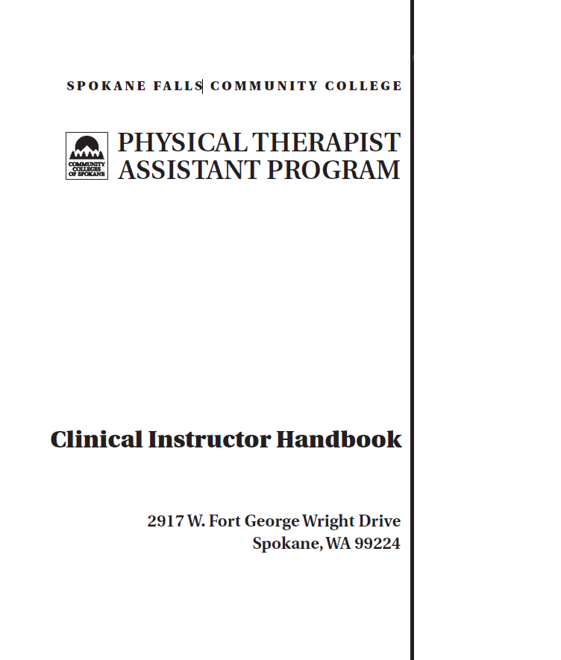

Physical Therapist Assistant Program

CLINICAL INSTRUCTOR HANDBOOK

Clinical education experiences are a major component of physical therapy education. It is through this educational mechanism that students are given the opportunity to develop and refine the skills learned in the academic setting by giving actual patient care in the clinic under structured supervision. Clinical experiences are crucial to gain all the competencies necessary to provide safe and effective patient care as an entry-level physical therapist assistant. Clinical experiences are the best part of an educational program, and we appreciate your willingness to support this program by becoming a part of its clinical education faculty. **To participate in clinical experiences, the student must exhibit appropriate professional behavior as evaluated by the faculty and achieve competency in prior and current coursework.

Spokane Falls Community College
Physical Therapist Assistant Program

Clinical Education Handbook
for Clinical Instructors

PROGRAM INFORMATION 6
GENERAL INFORMATION 7
PROGRAM MISSION 7
ACCREDITATION 7
FACULTY AND STAFF 7
CLINICAL EDUCATION FACULTY 8
PROGRAM POLICIES 9
CONFIDENTIALITY OF STUDENT RECORDS 10
STUDENT RIGHT TO KNOW 10
DIGNITY STATEMENT 10
DISABILITY AND SUPPORT SERVICES 10
VETERAN SUPPORT SERVICES 12
A NOTE ON RESPECT WITHIN THE ACADEMIC COMMUNITY 12
STUDENT HEALTH CENTER 12
STUDENT HEALTH AND INSURANCE 13
ESSENTIAL STUDENT FUNCTIONS 13
HEALTH REGULATIONS 14
ATTENDANCE 14
GUIDE OF CONDUCT FOR CLINICAL EXPERIENCES 15
PROGRAM POLICY FOR FILING A CONCERN OR COMPLAINT. 18
PROGRAM ACADEMIC REGULATIONS 19
PROGRESSION IN THE PROGRAM 20
ROLE OF THE STUDENT 20
ROLE OF THE CLINICAL INSTRUCTOR and/or SCCE 20
GUIDELINES FOR THE CLINICAL INSTRUCTOR 21
ROLE OF THE DCE 21
CLINICAL EDUCATION GRADING POLICY 22
CLINICAL EDUCATION COMMUNICATION PROCESS 23
RIGHTS AND PRIVILEGES OF CLINICAL EDUCATION FACULTY 24
CURRICULUM 25
EDUCATIONAL PRINCIPLES 26
CURRICULUM MODEL 26
STUDENT/GRADUATE GOALS AND STUDENT LEARNING OUTCOMES 26
COURSE REQUIREMENTS 28
COURSE SEQUENCE 29
COURSE DESCRIPTIONS 30
PTA 151 - 1 CREDIT 35
PTA 251 - 1 CREDIT 40
PTA 252 - 3 CREDITS 47
PTA 253 - 12 CREDITS 55
PROFESSIONAL DOCUMENTS 64
CORE VALUES FOR THE PT AND PTA 65
STANDARDS OF ETHICAL CONDUCT FOR THE PTA 67
STANDARDS OF PRACTICE FOR PHYSICAL THERAPY 69
CLINICAL EDUCATION FORMS 76
AFFILIATION/FIELDWORK AGREEMENT 77
ABSENCES FROM CLINIC 84
REMEDIATION PLAN 85
NOTICE OF PROBATION 86
STUDENT EVALUATION, PTA 151 87
STUDENT EVALUATION, PTA 251 90
APTA PTA STUDENT EVALUATION: 95
FACULTY – CI – STUDENT CONFERENCE 103
DCE ASSESSMENT SURVEY SAMPLE 105
SITE ASSESSMENT OF CLINICAL CENTER 115
SITE ASSESSMENT WORKSHEET 116
RELEASE OF STUDENT Academic Information 119
ACKNOWLEDGEMENT OF HEALTH CARE CONFIDENTIALITY 120
STUDENT BIOGRAPHICAL DATA SHEET 121
APPENDIX 122
DIRECTION AND SUPERVISION OF THE PTA 123
THE ROLE OF AIDES IN A PHYSICAL THERAPY SERVICE 126
WAC 246-915-010, DEFINITIONS 127
WAC 246-915-140, PERSONNEL IDENTIFICATION 128
WAC 246-915-180, PROFESSIONAL CONDUCT 129
RCW 18.74.010, DEFINITIONS 130
CLINICAL PERFORMANCE INSTRUMENT 133
FACULTY AND STAFF 134
GENERAL INFORMATION 134
ACCREDITATION 134
TABLE OF CONTENTS 136
INSTRUCTIONS FOR THE USE OF THE PTA CPI 138
COMPONENTS OF THE FORM 143
SAFETY 149
CLINICAL BEHAVIORS 150
ACCOUNTABILITY* 151
CULTURAL COMPETENCE* 152
COMMUNICATION* 153
SELF-ASSESSMENT AND LIFELONG LEARNING 154
CLINICAL PROBLEM SOLVING 155
INTERVENTIONS: THERAPEUTIC EXERCISE 156
INTERVENTIONS: THERAPEUTIC TECHNIQUES 158
INTERVENTIONS: PHYSICAL AGENTS AND MECHANICAL MODALITIES 160
INTERVENTIONS: ELECTROTHERAPEUTIC MODALITIES 162
INTERVENTIONS: FUNCTIONAL TRAINING 164
DOCUMENTATION 166
RESOURCE MANAGEMENT 167
GLOSSARY 172
APPENDIX A: DEFINITIONS OF PERFORMANCE DIMENSIONS 179
APPENDIX B: EXAMPLES OF COMPLETED PTA CPI CRITERIA 180
APPENDIX C: DATA COLLECTION TECHNIQUES 185
APPENDIX D: PROBLEM SOLVING ALGORITHM 187
APPENDIX E: PTA CPI PERFORMANCE CRITERIA 189

Physical Therapist Assistant Program

PROGRAM INFORMATION

GENERAL INFORMATION

The goal of the Physical Therapist Assistant Program at SFCC is to provide the community with graduates who are educationally and clinically prepared to accept an entry-level position as a PT assistant, and who are capable of providing quality physical therapy services under the supervision of a licensed physical therapist. Upon successful completion of this program, students are awarded an Associate in Applied Science Degree (AAS).

PROGRAM MISSION

The Spokane Falls Community College Physical Therapist Assistant Program and faculty are committed to developing lifelong learning through excellence in educational and clinical experiences to enable the student to possess skills necessary for successful employment within varied scope of physical therapy practice. The program will strive to admit and graduate students who demonstrate professional behaviors which includes effective communication, commitment to learning, critical thinking, responsibility and therapeutic presence and who will provide physical therapy services ethically within the standards of practice under the guidance and supervision of physical therapists.

ACCREDITATION

This educational program is planned in accordance with the standards, guidelines, regulations, and evaluative criteria set forth by:

• Community Colleges of Spokane and the Washington Community College System
• Spokane Falls Community College
• American Physical Therapy Association (APTA)
• Commission on Accreditation in Physical Therapy Education (CAPTE)
• Washington State Law, Chapter 18.74 RCW, Physical Therapy
• Washington State Board of Physical Therapy

Spokane Falls Community College is accredited by the Commission on Colleges of the Northwest Association of Schools and Colleges. Both the college and the PTA program are approved for veterans training by the Veterans Administration.

This program is currently accredited by the Commission on Accreditation in Physical Therapy Education for the American Physical Therapy Association. Accreditation of a physical therapy education program is an ongoing process. Please be reminded that your participation in all accreditation activities is vitally important to the ongoing success and high standards of the program.

FACULTY AND STAFF

Renée Compton, PTA, MSEd Program Director 279-6245; Bldg. 27, Rm. 349
Core Faculty

Megan Guthrie-Martinez, PTA, ATC Director of Clinical Education 279 6249; Bldg. 27, Rm. 347
Core Faculty

Dana McPhee, PT Core Faculty 279-6224; Bldg. 27, Rm. 353

Emily Orne Program Coordinator 279-6204; Bldg. 27, Rm. 355

Stacey Kent, PTA Adjunct Instructor 279-6242; Bldg. 27, Rm. 359

Erin Johnson, PTA Adjunct Instructor 279-6242; Bldg. 27, Rm. 151D

Natasha Volkmann, OT Adjunct Instructor 279-6083; Bldg. 27, Rm. 350

Amy Sanderson, PT Adjunct Instructor 279-6242; Bldg. 27, Rm. 151D

Lance Best, PTA Instructional Technician 279-6242; Bldg. 27, Rm. 151D

Laura Woods Counselor 533-3503; Bldg. 30, Rm. 227

Chris Pelchat Dean of Professional Studies, 533-3429; Bldg. 19, Rm. 103B
Library & Workforce Education

Cynthia Cobbs Administrative Assistant 3 533-3523; Bldg. 19, Rm. 103A

Skylor Mitchell Administrative Assistant 2 279-6073; Bldg. 27, Rm. 357

CLINICAL EDUCATION FACULTY

Many individuals are involved in providing each clinical experience for a student. The following is a description of the primary roles to help you understand the relationships and responsibilities of each.

• DCE (Director of Clinical Education)
The DCE coordinates the clinical education portion of the program. The DCE represents the college in the contractual agreement, coordinates scheduling with the SCCE, manages conflict resolution, and provides indirect supervision of students in the clinic in collaboration with the clinical instructor. The DCE will visit each student at least once during each spring clinical affiliation.

• SCCE (Site Coordinator of Clinical Education)
The SCCE is usually a physical therapist employed by the clinical facility, with 2 or more years of experience, who has the responsibility of arranging for clinical education experiences of students in that facility. The SCCE represents the facility in the contractual agreement, coordinates scheduling of students with the DCE, assigns students to clinical instructors, and usually provides the student with the “first day” orientation. The SCCE may also be involved with conflict resolution.

• CI (Clinical Instructor)
Clinical instructors are physical therapists or physical therapist assistants with a minimum of one year of experience who provide the direct supervision of students in the clinic. The clinical instructor is responsible for arranging and scheduling student-learning experiences, providing appropriate supervision during patient treatment, providing a mid-term and final evaluation and conferences, giving frequent feedback on student performance, and communicating with the DCE and SCCE regarding student issues.

• Other team and staff members
Generally clinic sites are very accustomed to the presence of students from a variety of medical professions. You will have the opportunity to interact with other rehab team members such as the physicians, occupational therapists, nurses, orthotists/prosthetists, recreation therapists, speech therapists, educators, psychologists, social workers, equipment vendors, and etc. Take advantage of the unique opportunity this presents and learn all you can from these professionals. They will be appreciative of your interest and are usually happy to answer all of your questions!

Physical Therapist Assistant Program

PROGRAM POLICIES

CONFIDENTIALITY OF STUDENT RECORDS

In addition to the college policies regarding confidentiality of student records as described in the Student Code of Conduct (WAC,132Q-02).
http://catalog.spokane.edu/StudentRights.aspx?page=PV2
it is important for you to know about the records kept within the program. All program faculty shall respect confidential information about students which they necessarily acquire in the course of their work as school officials. Further, faculty advisors may obtain copies of student transcripts. Each student has the right to inspect and review PTA program records which pertain to the student. All student files and records are maintained and kept in the program director’s office or the program coordinator’s office, and are accessed through the program director or program coordinator only. In order to be able to share information to students and between students, the program will use CANVAS to communicate amongst all students.

STUDENT RIGHT TO KNOW
Community Colleges of Spokane complies with a variety of state and federal requirements concerning providing information to students and prospective students regarding campus crime statistics and security, undergraduate completion and graduation rates, athletic information including expenditures and revenue, and participation by team and gender.
View detailed information on the CCS website:
http://www.ccs.spokane.edu/Future-Students/righttoknow.aspx

DIGNITY STATEMENT

“Community Colleges of Spokane is committed to providing all our students with an education of the highest quality and in a manner which exhibits concern and sensitivity to our students, faculty and others who utilize our services and facilities. It is therefore essential that every person who is connected with the district exhibit appropriate and conscientious behavior in dealing with others.”

DISABILITY AND SUPPORT SERVICES

In accordance with the Americans with Disabilities Act, the Rehabilitation Act of 1973, the Washington State RCW Chapter 49.60 and the Washington State Law Against Discrimination, SFCC will consider accommodations for students with disabilities at the student’s request. It is the student’s responsibility to make known any disability for which accommodation is requested and to register with the Disability Support Services (DSS) office providing documentation of the disability. Once the student is qualified by the DSS Manager as having a disability, requested accommodations will be considered. Accommodations that compromise patient care or that fundamentally alter the nature of the program or activity are not considered reasonable.

All students, with or without a disability, are required to perform the essential job functions in order to successfully complete their clinical experience. The essential functions for the PTA Program will depend on the setting. The essential functions which students are required to perform in a classroom setting will differ from the essential functions students are required to perform in a lab setting. The essential functions which students perform in a clinical setting will differ from both the classroom and lab. As a result, accommodations which are reasonable in a clinical setting or a lab setting may be very different from accommodations which are reasonable in an academic setting. All students are required to meet the essential functions of the classroom, lab and clinical settings. For example, a student may have an accommodation in the classroom which permits them to have an expanded timeframe to complete testing. Since the clinical settings involve treatment of patients and other demands that are different from the classroom, the tasks required in a clinical setting may not permit the same amount of flexibility for extended timeframes to complete tasks. As a result, it is necessary to evaluate the essential functions of the different settings to determine what accommodations are appropriate for the different environments. Extended or additional time to read patient charts or to document patient care may be considered reasonable in a clinical setting depending upon the time requested and the essential functions required for the work being performed. As the student progresses through clinical education experiences, efficiency should progress from a high expenditure of time and effort to economical and timely performance. This performance dimension applies to all of the CPI performance criteria.

The clinical experiences and internship courses are conducted at third party facilities that are not owned or operated by SFCC. If a student also wants accommodation(s) during a Clinical placement, the student must meet with Disability Support Services and discuss his/her needs for accommodation at least three months prior to the clinical experience. The student and the Disability Support Services staff will review the Clinical Performance Instrument and other relevant information to identify potential accommodations. The Disability Support Services Staff and student will coordinate with SFCC Director of Clinical Education to initiate discussion with the clinical facility’s SCCE to evaluate and coordinate reasonable accommodations in that clinic.

The ADA has legal requirements regarding performance standards:

Q. May an employer apply the same quantitative and qualitative requirements for performance of essential functions to an employee with a disability that it applies to employees without disabilities?
A. Yes. An employee with a disability must meet the same production standards, whether quantitative or qualitative, as a non-disabled employee in the same job. Lowering or changing a production standard because an employee cannot meet it due to a disability is not considered a reasonable accommodation. However, a reasonable accommodation may be required to assist an employee in meeting a specific production standard.

If placement is not successful at a specific clinic, staff will engage in an interactive process with the students and DSS in an effort to provide equal access to an appropriate clinical experience.

It is important to note that the curriculum design of this program (based upon accreditation standards) prepares all students to be generalists as practicing therapists. All students are required to meet the essential skills of a PTA, with or without reasonable accommodation. All PTA students must successfully complete all lab skill check-offs, and successfully pass both academic and lab courses to progress in the program.

Procedures for student grievances as related to Disability Services are included in the CCS Administrative Procedure 3.20.01B- Grievance Procedure for Students with Concerns with Disability Support Services.

Any student with a health condition or disability which may require accommodations in order to effectively participate in any PTA class or clinical, should contact Disability Support Services (DSS). [Building 17, Room 201, 533-4166]

Community Colleges of Spokane provides equal opportunity in education and employment.

VETERAN SUPPORT SERVICES

SFCC appreciates students who have served our country and understands that students with military experience may face unique challenges in completing their educational goals. The Veterans Resource Center (VRC) can be found in the Library (Building 2, Room 001), or can be contacted at (509) 533- 3900 or (509) 533-3504.

Additional information can be found at:
https://sfcc.spokane.edu/For-Our-Students/Student-Resources/Veterans-One-Stop

A NOTE ON RESPECT WITHIN THE ACADEMIC COMMUNITY

In order for learning to take place, students and other participants must be valued in the classroom setting. Value and mutual respect is due all students, not just those that share your values, beliefs and life experiences. Acceptance should not be confused with agreement; one need not agree with a person to listen, and one must listen well in order to disagree either cogently or respectfully. Every student in this course has a voice and so deserves the courtesy of attentive listening and the freedom to express diverse ideas.

STUDENT HEALTH CENTER
The Student Health Center is located at Spokane Community College and is in Building 7 (Jenkins Wellness Center), Room 118. The Clinic is walk-in only*; Mental Health Counseling is by appointment.

SCC address:
1810 N Greene St
Spokane, WA 99217

For more information, please go to https://scc.spokane.edu/For-Our-Students/Student-Resources/Student-Health-Clinic *
*Clinic hours are different every quarter, and costs are also subject to change. Please call the clinic ahead of time prior to when you go in and always confirm the cost of service and the available clinic hours at (509) 533-8611. It is the responsibility of the student to contact the SCC Health Center for information. Always call ahead.

The Student Health Center is open to all currently enrolled SCC and SFCC students. It is a walk-in clinic that provides limited health care services by Washington State licensed nurse practitioners (ARNPs). Services include diagnosis and management of minor illness and injury, interval management of stable chronic illness, simple diagnostic testing including urinalysis and pregnancy testing, clearance for return to school or work, TB testing, health promotion services and referrals (e.g., smoking cessation, stress management, and weight and nutrition management), and required Health Science Program and Department of Transportation physical exams. Competitive sports physicals are not included. Most services will be provided at no cost to SCC and SFCC students. Depending on vaccine availability, some immunizations will be available for students at a reduced cost. The Student Health Center is sponsored by student government at SCC and SFCC.

STUDENT HEALTH AND INSURANCE

Students in the PTA program will be conducting therapy treatments in the laboratory classes, and on patients during the clinical education portions of your training. Participation in these activities necessarily involves some degree of risk, either to you or others. Additionally, because you are considered to be a health care provider, you are subject to all policies and regulations governing health care workers including all policies and procedures of your affiliation sites. Therefore, your participation in this program necessitates some special requirements.

Health
Students who are accepted into an allied health program must be able to perform all course-related physical activities and meet the “Essential Student Functions for Success in the PTA program”. In addition, immunizations including MMR titer, tuberculin test, tetanus vaccination, varicella titer, Covid-19 and hepatitis B vaccine (or waiver) is highly recommended before entrance into this program*. Documentation verifying these will need to be submitted to Exxat by their respective due dates.

It is the student’s responsibility to consult your medical provider if you become pregnant. We recommend the pregnant student review the “Essential Student Functions for Success in the PTA program” with your health care provider.

In the event of an extended illness, injury or surgery, a physician’s written statement is required stating the student’s ability to return to normal course-related activities. This must be received by the program director prior to returning to the program. In these types of extenuating circumstances, the faculty will make every attempt to accommodate your needs. However, you must keep us informed on a regular basis in order for us to make appropriate decisions.

Insurance
Liability: All students are covered by liability insurance through the college when they are out on clinicals. A fee to cover the cost of liability insurance is included in course fees.

Accident/Medical: The PTA program strongly recommends students be protected by an accident insurance policy. If you are covered by private medical insurance, accident insurance will be included in your policy. If you do not have private medical insurance, accident insurance may be purchased through the college. The current cost of accident insurance is $39.00/quarter.* Please bring copies/re-confirm your insurance coverage with the PTA Program Coordinator. If you purchase it through SFCC or change policy holders, notify the Program Coordinator immediately.

* Entrance to the PTA Program may not be denied due to lack of immunizations or health insurance. This may be required for clinical education; therefore, without access to the clinical facilities, a student may not be able to satisfactorily complete the PTA program and will be so advised.

ESSENTIAL STUDENT FUNCTIONS
FOR SUCCESS IN THE PTA PROGRAM

The following information is provided to assist you in achieving a better understanding of the sensory, physical, communication, cognitive, behavioral, social and professional skills necessary to successfully work as a PTA. These criteria are identified as being essential job functions for physical therapist assistants and as such, closely match the abilities needed to successfully complete the clinical and laboratory components of the PTA program at SFCC. Students must be able to meet these minimum standards throughout the program, with or without reasonable accommodation, for successful completion of the program requirements. The Occupational Information Network which is part of the US Dept of Labor provides a more detailed report regarding this occupation: http://www.onetonline.org/link/details/31-2021.00

It is the policy of Spokane Falls Community College to provide reasonable accommodation to qualified students with disability so they can meet these required standards. If you are disabled and need special accommodations, please contact the program supervisor of disability support services program at 533-4166. Please refer to the DISABILITY AND SUPPORT SERVICES section earlier in this handbook.

It is important to note that the curriculum design of this program (based upon accreditation standards) prepares all students to be generalists as practicing therapists. All students are required to meet the essential job functions of a PTA, with or without reasonable accommodation. All PTA students must successfully complete all lab skill check-offs, and successfully pass all academic, clinical and lab courses to progress in the program.

HEALTH REGULATIONS

CPR and First Aid: Students must have current certification in First Aid and in American Heart Association Basic Life Support.
Background Checks: Clinical sites comply with the “Child/Adult Abuse Information Act”, RCW 43.43.830 through 43.43.840. This law requires that organizations which care for children, vulnerable adults or developmentally disabled persons must have prospective caregivers disclose to the organization whether the applicant has been convicted of certain crimes against persons, certain crimes related to financial exploitation, and certain crimes relating to drugs. The disclosure must be made in writing and signed by the applicant.

“Crimes against persons” means a conviction for offenses such as murder, kidnapping, assault, rape, robbery, arson, burglary, manslaughter, extortion, incest, indecent liberties, vehicular homicide, prostitution, or criminal mistreatment. For your information, the Washington State List of Negative Crimes and Actions is posted at http://app.leg.wa.gov/rcw/default.aspx?cite=43.43.830

Each successful PTA applicant may be required to complete a background check, drug testing and submit proof of immunization and insurance. If a clinical facility requests your information, it will be your responsibility to provide that information to them. Background Checks are performed annually for each student and includes: Statewide Criminal WA, National Healthcare Fraud and Abuse Scan, National record Indicator Alias and Sex Offender Index, Social Security Alert and Residency History. Clinical facilities may deny access to a student for any of the following:
- A “discrepancy” on the criminal background check
- A positive drug test
- Lack of current immunizations required by the site
- Lack of accident/medical insurance

ATTENDANCE

Student Holidays for Reasons of Faith or Conscience (SB5166)
Community Colleges of Spokane will grant reasonable accommodation so that grades are not impacted for students who are absent for reasons of faith or conscience, or for an organized activity conducted under the auspices of a religious denomination, church, or religious organization. Such absences must be requested in writing on the Class Absence Request form within two weeks of course start. There are no additional fees associated with this request. https://sfcc.spokane.edu/About-Us/Public-Disclosures#RuleMaking

While absences or tardiness may be unavoidable for acceptable reasons, please be reminded that your attendance is considered a critical factor in judging your values to your profession.
Attendance as it Pertains to Grading:
Please refer to the section under “PTA Program Grading Policy.”

Communication via Email: Communication via email is an integral part of the program. Students are expected to check their school email account daily, Monday through Friday. This is a requirement of the program and may be factored into your grade as a component of your professional expectation.

Procedures:

1. Email or Call in: Any absence or tardiness from lecture classes, laboratory sections or clinics must be accompanied by a notification to the instructor prior to the start time (consult the class syllabi for contact information. This is a professional courtesy that will always be required of you. If you are missing a class on campus, please notify the course instructor at the PTA program office (messages may be left on voice-mail). If you are missing a clinical experience, you must notify the clinical instructor and the DCE m.guthrie-martinez@sfcc.spokane.edu .

4. If absent from a clinic: Any absence from clinical experiences must be made up by arrangement with the clinical instructor and at their convenience. While it is important to attend at the correct time, please also consider that we do not want you to be in the clinic if you truly are ill because that puts everyone at risk. Please exercise good judgment. The DCE must be notified immediately by e-mailing or calling their office.

5. Tardiness: Don’t be late - it is very discourteous. Without notification, tardiness by more than 15 minutes from a lecture, from a lab or from a clinic will be considered an absence.

6. Leaving clinic early: Leaving clinic without permission 15 or more minutes early is considered an absence.

7. Extended absences: For any extended absences due to personal illness or death/illness of an immediate family member, you must contact the Program Director and the instructors of your courses via the contact provided in the syllabus and provide appropriate documentation for readiness to return to the program. For extended absence during clinical rotations, in addition to the clinical instructor, the DCE at SFCC needs to be notified.

Program faculty will strive to assist students as best they can for legitimate absences. If absence procedures are not followed, your grade and participation in the program will be affected.

GUIDE OF CONDUCT FOR CLINICAL EXPERIENCES

It is essential to bear in mind that when you are in clinic you are representing your profession. When clinics have good experiences with student PT assistants, they are more likely to hire them. In order to represent yourself and your profession well, the following guidelines must be adhered to:

- Maintain a professional attitude at all times and conduct yourself as a mature adult. Note that you must follow the APTA Standards of Ethical Conduct for the PTA. (The Standards are found in the Professional Documents section of this handbook.)

- Follow all policies and procedures of the facility including but not limited to dress, hours, safety, conduct, etc. Be respectful of clinical personnel and the environment, remembering you are there by invitation.

- Patients must be informed when students are involved in patient care. In addition, the patients need to know that they have the risk-free right to refuse to participate in clinical education. It is the student’s responsibility to make sure the patient has this information. The student should share this information immediately upon greeting the patient.

- Perform all tasks within the boundaries and scope of practice as stated in Washington Law and Regulations as well as the APTA Standards of Ethical Conduct for the PTA. Recognize and be able to tactfully explain any limitations on your part because of your student status.

- Maintain confidentiality; follow HIPAA guidelines. Health care providers are privileged to a great deal of confidential information regarding patient histories and conditions. Safeguarding the privacy of the patient is the responsibility of all. A patient’s condition or personal problems must never be discussed with anyone except as it relates to the care of the patient. Discussion of your clinical assignment and information gathered is not a topic for social conversation, telephone discussion, social media, or other personal communication whether written or verbal. Your signature is required on the Acknowledgement of Health Care Confidentiality statement found in the section of the handbook titled Forms to be Completed.

- Student conduct in the clinical facilities follow the Student Code of Conduct and CCS Policies as described earlier in this handbook under Student Rights and Responsibilities. In all circumstances, this program adheres to all regulations, policies and procedures established by the Community Colleges of Spokane. Students violating the Student Code of Conduct and Policies of the Community Colleges of Spokane will be subject to disciplinary action and may constitute cause for dismissal from the program (Chapter 132Q-10 WAC). Dismissal from the program may also occur with any violation of the Standards of Ethical Conduct for the Physical Therapist Assistant. In addition, violations of the policies or procedures of the clinical facility are also considered as just cause for dismissal from the program.

- PTA Program Clinical Dress Code: Due to the professional expectations from clinicians/clinics/hospitals and other physical therapy environments regarding professional appearance/attire, students will abide by the SFCC PTA program dress code while in a clinical setting.

The development of trust and rapport is crucial to a successful relationship between client and health care provider. In developing this trust and rapport, appropriate dress and professional demeanor is particularly important. The SFCC PTA program dress code was developed based upon recommendations from the PTA Advisory Committee. Failure to follow the PTA professional dress code will result in implementation of the remediation process outlined in the student handbook. Potential consequences of remediation may include sanctions up to and including dismissal from the PTA program.

The dress code is as follows:
- Plain posts may be worn for pierced ears. No other visible body jewelry or facial piercings are allowed.
- Hair is to be kept clean and professionally groomed. No unnatural hair color (e.g. green, purple, blue, etc.)
- Tattoos should remain as covered as possible. Students may be asked to cover hard-to-conceal tattoos with Band-Aids.
- Students must wear their name badge while in clinic unless specifically requested not to.
- Hygiene needs to be consistent with close personal contact.
- Long hair should be pulled back (plain elastic hair accessory), fingernails short with no polish, no scented products such as lotions, perfume/cologne, etc.
- No chewing gum or tobacco, smoking or vaping.
- Provocative clothing is not allowed. Students are expected to have their chest, midriff, and buttocks fully covered at all times with NO undergarments exposed.
- Caps or hats are not allowed
- Clothes must be clean and well maintained. Pants that are frayed, have holes, or are written on are not acceptable. Slacks and pant are acceptable, jeans and sweats are not acceptable. Sandals without socks, slippers, boots or high heels (above one inch) are not acceptable. Check with the clinical instructor about wearing running shoes or tennis shoes.
- Avoid wearing loose jewelry, rings with large stones and any other jewelry that may injure a patient.
- There may be additional clothing requirements based on the unit the student is participating in. Students must comply with specific clothing requests of clinical instructor based.
- Students are responsible for purchasing appropriate professional attire in the clinical setting.
Please note, in the event that a clinical facility has stricter dress code standard, the student will abide by the clinical facility standard.

Please contact the Director of Clinical Education or Program Director directly via e-mail to seek exceptions to this policy. Include a description of the exception(s) requested as described in the dress code policy above and the reason for the request. Exceptions to the PTA dress code may be made for religious, cultural, or medical reasons. The program, with the guidance from administration, will respond to the request within five business days.

The program will comply with CCS 3.30.01 Non-discrimination/Anti-harassment policy and corresponding CCS Administrative procedure 1.10.01 regarding prevention and response to complaints of discrimination.

- Attendance: Refer to program attendance policy. Remember that you must call in to the clinical instructor, the DCE if you are going to be absent for any reason please leave an email or phone message if unable to make immediate contact. You must make up any missed clinical education time at the convenience of the clinical instructor. If you are ill, exercise good judgment about exposure to others. You are expected to report to the clinic assignment at the designated time and be ready to work. Don’t be late. Do not take or make personal phone calls/texts while on assignment or allow unauthorized visits.

If a clinical experience must be rescheduled for a medical reason, the student will be asked to provide to the program a written release from a physician prior to consideration for rescheduling of the clinical. Time of any re-scheduled clinical experience due to medical or personal reasons that falls outside the scheduled quarter will be scheduled at the discretion of the DCE and Dean and availability of clinical sites.

Program Policy for PTA program student scheduled days off during clinical:

The PTA program expects the student to follow the clinical instructor’s professional schedule. This may require weekend, holiday and greater than the hours assigned to that rotation. According to the Dean over the PTA program, students are expected to follow the clinic schedule. If a clinical day falls on a college holiday, the student is expected to still attend the clinical as scheduled. Per our Dean:
“I think clinicals are a special case, and no, I do not think we are required to give them the day off from those. As a pre-professional arrangement, the students need to get used to being on the schedule they will be working in.”

If the student does miss a day for any other reason such as for Reasons of Faith or Conscience, the student will need to make up the hours missed in order to meet the required hours assigned to that rotation prior to going onto their next clinical experience.

- Email: Please check your email daily. The DCE will not contact you while you are at clinical, but will email you important dates, schedules and information you are required to be aware of. Failure to respond to your email can result in unprofessional conduct on your evaluation.

- CPI electronic: All students will be required to utilize the electronic version of the PTA Clinical Performance Instrument (CPI). You may access the training online at the SFCC PTA Website. You may access the CPI online at PTA CPI Web.

PROGRAM POLICY FOR FILING A CONCERN OR COMPLAINT.

The Physical Therapist Assistant Program at Spokane Falls Community College engages in continuous and systematic evaluation and improvement. We welcome your comments, suggestions, ideas, and constructive criticism as part of that process. The Grievance/Due Process policies (Community Colleges of Spokane website https://ccs.spokane.edu/About-Us/Public-Disclosures/Right-to-Know and https://ccs.spokane.edu/About-Us/Leadership/Board-of-Trustees/Policies-Procedures/Chapter2 ) provide a voice for current and prospective students, employees, and other affiliated persons.

Comments must be submitted to the following address:
PTA Program Director
Spokane Falls Community College
2917 W Whistalks Way, MS 3029
Spokane, WA 99224-5202
Email renee.compton@sfcc.spokane.edu or email the Dean's Office chris.pelchat@sfcc.spokane.edu
The complainant has the right to be free from retaliation following complaint submission.

The PTA Program Director shall respond to all comments within seven (7) business days to further determine if the complaint needs to be handled by administration or can be resolved at the program level. If satisfactory resolution is not or cannot be reached, appeal may be made to the Dean of Business, Professional Studies and Workforce Education within seven (7) business days. Again, if satisfactory resolution is not or cannot be reached, appeal may be made to the Office of the President within seven (7) business days. The decision of the President will be final and not subject to further appeal. Neither the Dean nor the President will become involved until all attempts to resolve the issue with the Program Director have been exhausted, unless the comment is directly related to the performance of the Program Director. Records of all correspondence will be confidentially maintained by the Program Dean's Office for five (5) years. These records are not open to the public.

Complaints regarding accreditation of this program should be addressed to the Commission on Accreditation in Physical Therapy Education.
Commission on Accreditation in Physical Therapy Education (CAPTE)
3030 Potomac Ave., Suite 100, Alexandria, Virginia 22305-3085
703-706-3245
accreditation@apta.org

Physical Therapist Assistant Program

PROGRAM ACADEMIC REGULATIONS

PROGRESSION IN THE PROGRAM

PTA program courses are designed to occur in a specific sequence within the curriculum. Skills are taught once in the curriculum and become the building blocks for the acquisition of other skills until all entry-level competencies of a physical therapist assistant are successfully achieved. Philosophical, theoretical, and didactic information are similarly presented in a fashion that provides a knowledge framework to support the building blocks of skills.

Students must achieve competency in each PTA course before progressing to the next courses in the sequence. Additionally, all treatment skills must be successfully performed in the laboratory setting before a student can receive a grade for that procedures laboratory course. This ensures that all students who are placed in the clinical education courses have demonstrated successful performance of treatment skills prior to providing care to patients. In order to successfully complete this program, students must earn a grade of 2.0 or higher in any PTA lecture course/ 2.3 in a PTA Lab course or a “satisfactory” grade in any clinical course to continue in the program.

ROLE OF THE STUDENT

The success of your clinical experiences is largely dependent on the student. Student are encouraged to take an active role in planning learning experiences with clinical instructors.

1. It is important to work with your clinical instructor to make a plan that will help you to achieve as many of the clinical experience objectives as possible to be evaluated and checked off in your Clinical Performance Instrument (CPI).

2. Ask about other opportunities for learning that may be available in that setting and make a plan to schedule them into your days. For example: physician rounds, lectures, observation of medical procedures, visit other hospital floors/units, team meetings, family conferences, recreation events, observing other therapists doing specific treatments and evaluations, etc.

3. Tell your clinical instructor about specific areas of interest that you have and find out how to accomplish your own objectives.

4. Inquire about learning facilities such as the professional library so that you can make good use of any “down” time. Read articles, view videos, review exercise protocols, etc.

5. Seek out frequent communication with your clinical instructor. Get issues resolved immediately. Don’t assume that your needs are known; find out how you are doing. Don’t wait for the mid-quarter evaluation!

6. Take evaluative comments and criticism well, professionally, and to heart. Your primary objective is to learn and grow both professionally and personally. Maturity in this area is essential.

7. You are not alone. If you need assistance from the college DCE, do not hesitate to call.

ROLE OF THE CLINICAL INSTRUCTOR and/or SCCE
1. The CI/SCCE should provide the student with an adequate orientation to the facility (parking, hours, dress code, eating facilities, staff introductions, physical plant, location of equipment, etc.).
2. Instruction should be provided regarding facility policies and expectations (emergency procedures, scheduling, documentation, billing, communication with other departments, patient records, etc.).
3. The CI should establish goals with the student for their clinical experience and develop a plan/schedule to meet the goals.
4. The CI/SCCE should assist the student to access additional learning experiences.
5. CIs should be available to the student and give frequent, sufficient, and honest feedback. Please do not wait for the midquarter evaluation to give feedback or express concerns!
6. The CI should provide appropriate levels of supervision and make sure the student is aware of expectations.
7. The CI/SCCE should IMMEDIATELY notify the DCE of any perceived problems relating to the student so that problem resolution can be initiated promptly.
8. The Family Educational Rights and Privacy Act of 1974 (FERPA) requires that the college adopt institutional procedures and guidelines in compliance with Public Law 93-380. Student rights to privacy are protected with certain restrictions on the disclosure of student educational records and information. The CI/SCCE must follow FERPA guidelines when sharing information about the student. Further information is available in the college catalog at: http://catalog.spokane.edu/StudentRights.aspx?page=PV2

GUIDELINES FOR THE CLINICAL INSTRUCTOR

IDENTIFY specific areas of concern regarding student performance as soon as possible.

NOTIFY the DCE and SCCE immediately to establish a resolution plan.

DISCUSS concerns with the student immediately and counsel the student with suggestions of ways to rectify the problem(s).

DOCUMENT these steps and attain CI, SCCE, and student signatures.

MIDTERM EVALUATION (5&6-week full-time affiliations only). If the student has not made an adequate attempt to rectify the problem, discuss the possibility of failing the clinical course with the student, the DCE and SCCE. Assist the DCE to develop the Clinical Education Probation Contract and obtain student, CI, and DCE signatures.

SUPERVISE the student closely and advise the student as necessary.

STOP the student immediately if their performance is in any way dangerous or unsafe. Contact the SCCE and DCE to discuss the possibility of terminating the clinical affiliation.

- If the student’s performance improves and the student remains in the clinic setting, supervise the student closely and encourage the student to progress. Document attainment of clinical probation remediation plans.

- If the student’s performance does not improve and the student must be removed from the clinical setting, inform the DCE, SCCE, and the student of the decision for student failure.

COMPLETE the final evaluation with the pass or fail grade.

ROLE OF THE DIRECTOR OF CLINICAL EDUCATION
1. Provide clinical education faculty with adequate advanced notification of student placements with a placement confirmation letter and student biographical information with the assistance of the Program Coordinator.
2. Provide clinical instructors with all necessary student evaluation materials and clinical experience goals/objectives with the assistance of the Program Coordinator.
3. DCE directs each clinical instructor to the online version of the Clinical Instructor Handbook. Handbook is posted to the PTA website.
4. Manage contractual agreements and all health/insurance requirements with the assistance of the Program Coordinator.
5. Prepare the students for successful clinical education experiences (readiness for placement, understanding expectations, setting goals, etc.).
6. Meet/discuss with clinic sites prior to student placements to assure compliance with selection criteria.
7. Visit each clinic placement site during full-time affiliations. Exceptions to this may include distant clinic sites where all contact may necessarily be made by phone.
8. Attend student evaluation conferences upon request of the clinical instructor.
9. Provide assistance with clinical education probation contracts.
10. Make final decisions regarding student suspension or expulsion from the program based upon performance in clinical education.

CLINICAL EDUCATION GRADING POLICY

The final grades for the clinical experience courses and the clinical affiliation will be determined by the DCE based on the clinical instructor’s evaluations (clinical objectives and competencies, mid-quarter and final check off, final clinical evaluation), student and CI conferences, and any additional academic assignments.

Grade/Evaluation Criteria:
Clinical courses will be graded on a pass, incomplete, or fail basis.

The criteria for a pass grade:
1. Attendance at all scheduled clinical visits on time. If the student is absent due to illness or an emergency, it is the student’s responsibility to notify the clinical instructor, the DCE, and the Program Coordinator as soon as possible. It will then be the student’s responsibility to arrange a make-up time for any clinical sessions that are missed.
2. Student shall receive no “unacceptable” reports from the clinical instructors, based on performance, attendance, appearance, and conduct.
3. Student will return all student evaluation and clinical feedback forms on time to the Program Coordinator.
4. Student must immediately report any accidents or incidents to the clinical instructor, the DCE and the Program Coordinator.
5. Student will attend all campus lecture/discussion sessions.
6. Student will actively participate in the campus lecture/discussion sessions.
7. Student must complete all assignments in the clinic and in the campus lecture/discussion class satisfactorily and on time.
8. Student must observe strict levels of confidentiality at all times. They must refrain from referring to patients by name during any clinic discussion class or in any casual conversations outside of class.
9. Communication via email is an integral part of the program. Students are expected to check their personal and school email account (Bigfoot account) daily, Sunday through Friday.

CLINICAL EDUCATION COMMUNICATION PROCESS
1. DCE conducts site visits, site selection, develop contracts, and obtain Clinical Site Information Forms.
2. Students meet with the DCE at the end of their first year in the program. Student interests and preferences for their 2nd-year clinicals are discussed at that time.
3. DCE sends out memos to sites with the following academic year clinic schedules and a request for available student slots. The request is sent out March 1st in accordance with APTA guidelines. Responses are requested by the end of April.
4. SCCE’s return the form indicating available student slots for following year.
5. DCE and Program Coordinator assign students to specific clinics and rotations.
6. Program Coordinator mails confirmations to clinic sites.
7. Students are notified of their clinic sites in Spring quarter of their 2nd year.
8. Three to four weeks prior to the start of each clinical, the Program Coordinator mails to each SCCE:
  - Placement Confirmation Letter
  - Course Syllabus
9. Two weeks prior to the start of each Full time clinical the DCE mails to each Clinical Instructor:
  - Student Biographical Data Sheet
  - Student Goal Letter
  - Course Syllabus
10. Students bring all evaluation forms to each clinical.
11. DCE contact procedure by clinic course:
  - PTA 151, 251, 252: DCE sends email to each CI with course objectives, detail information regarding student evaluations with reference links and makes phone contact with clinical instructor as needed. Sends follow up email and thank you note for opportunity to comment.
  - PTA 253: DCE sends email to each CI with course objectives, detail information regarding student evaluations with reference links and makes phone contact with clinical instructor as needed. DCE visits the clinic site to observe and conference with each student and CI. Sends follow up email and thank you note for opportunity to comment.
12. Administrative Assistant mails surveys to each Clinical Instructor following clinical (Feedback from Clinical Instructors on PTA Program).
13. DCE mails Certificate of Completion to each Clinical Instructor following clinical through Exxat.
14. DCE and Program Coordinator conduct Clinical Instructor Workshops at institution or at the clinic sites as needed.
15. DCE or Program Coordinator will provide additional in-service at the clinic site as requested.
16. DCE directs each clinical instructor to the new online instrument Clinical Instrument Evaluation Tool (CIET) and the latest version of the Clinical Instructor Handbook. Handbook and CIET instructions are posted to the Clinical Education Canvas Page: https://ccs.instructure.com/courses/2293830 .

RIGHTS AND PRIVILEGES OF CLINICAL EDUCATION FACULTY

Spokane Falls Community College PTA program recognizes the sacrifices that the clinical faculty make to enable the students in the program to achieve their goals. Because of this, the program has developed a list of rights and privileges provided to the clinical instructors.

- All clinical instructors who oversee SFCC PTA students are eligible to receive one on one professional development opportunities regarding student assessment, expectations, web-based CIET, and teaching strategies in order to help improve the effectiveness of the clinical experience for both the instructor and the student. Contact the DCE at 509-279-6249 for more information.

- Any clinical instructor who instructs an SFCC PTA student is eligible for a scholarship to an APTA CI Credentialing Course. Contact the Director of Clinical Education at (509) 279-6249 for more information.

- All clinical education faculty are eligible to have a Spokane Falls Community College e-mail account. Please contact the Allied Health Administrative Assistant at (509) 279-6073 in order to set up this account.

- A clinical office is available in the PTA program department during working hours for clinical education faculty to use. This office has access to a computer and online resources such as our library and research tools. Please contact the Allied Health Administrative Assistant to schedule the office at (509) 279-6073.

- Continuing education units (CEU’s) are available for mentoring a student during a quarter. 32+ hours clinical instruction = 1 hours CEU, maximum allowed per continued competency cycle is 10 hours. https://app.leg.wa.gov/wac/default.aspx?cite=246-915-085&pdf=true WA State Law, other states may vary.

Physical Therapist Assistant Program

CURRICULUM

EDUCATIONAL PRINCIPLES

The program faculty believe that learning should progress from basic concepts to applicable skills for work in the profession: Start with basic concepts in a classroom setting, then progress to application of those concepts in a laboratory setting, culminating to applying learned concepts in a real-world environment during the final clinical setting.

CURRICULUM MODEL

Every PTA program in the United States has its own curriculum model- course work, flow of coursework and important threads in the program that are unique to the program itself. This is also true with the SFCC PTA program. Following the one quarter anatomy and physiology prerequisite course, the students are able to complete the PTA program with three quarters of technical education course work and one quarter of general education requirements the first year, followed by three quarters of technical course work the second year. Once admitted, the student must progress through the courses corresponding to the curriculum model with a 2.0 or higher in seminar/lecture courses and 2.3 (75%) or higher in laboratory courses.

The program is built on sound educational theory and principles of current PT practices - The Standards for PTA Education as established by CAPTE (Commission on Accreditation for Physical Therapy Education), APTA’s documents including the Guide for Conduct of the Physical Therapist Assistant, Standards of Ethical Conduct, APTA’s Values Based Behaviors of the Physical Therapist Assistant, and the Normative Model of Physical Therapist Assistant Education. All these documents are either located in this handbook, on the APTA website or available from the Program Director.

The SFCC PTA program is an integrated program with clinical experiences interwoven through the program. In addition, there are laboratory practicums, the development of professional behaviors, the emphasis on clinical reasoning and the use of evidence-based practice to guide treatment are also threaded throughout the program.

The curriculum is designed to be developmental. That is, the foundational courses are offered first in the sequence, and then followed by the courses requiring you to layer your foundational knowledge with physical therapy practice, and then finally your one full quarter clinical affiliation is at the completion of the program- offering you the chance to successfully demonstrate application of the skills and knowledge you have learned in clinic settings. If at any time you have questions about our curriculum model, please ask the program director.

STUDENT/GRADUATE GOALS AND STUDENT LEARNING OUTCOMES

- Students admitted to the Physical Therapist Assistant program, upon successful completion of the program will graduate as entry-level physical therapist assistants who provide services in a variety of patient care settings under the supervision of a physical therapist.
  - PTA program students will have clinical experiences in inpatient and outpatient clinical settings.
  - PTA students who graduate will have met all of the Student Learning Outcomes/14 CPI performance criteria* as described below:
- Performs in a safe manner that minimizes the risk to patient, self, and others.
- Demonstrates expected clinical behaviors in a professional manner in all situations.
- Performs in a manner consistent with established legal standards, standards of the profession, and ethical guidelines.
- Adapts delivery of physical therapy services with consideration for patients’ differences, values, preferences, and needs.
- Communicates in ways that are congruent with situational needs.
- Participates in self-assessment and develops plans to improve knowledge, skills, and behaviors.
- Demonstrates clinical problem solving.
- Performs selected therapeutic exercises and associated data collection in a competent manner.
- Applies selected manual therapy, airway clearance, and integumentary repair and protection techniques, and performs associated data collection in a competent manner.
- Applies selected physical agents and mechanical modalities and performs associated data collection in a competent manner
- Applies selected electrotherapeutic modalities, and performs associated data collection in a competent manner.
- Performs functional training in self-care and home management, applies and adjust devices and equipment, and performs associated data collection in a competent manner.
- Produces quality documentation in a timely manner to support the delivery of physical therapy services.
- Participates in the effiecient delivery of physical therapy services.
“Adapted from http://www:apta.org/PTACPI/, with permission of the American Physical Therapy Association. Copyright ©2008 American Physical Therapy Association. All rights reserved.”

- Students demonstrate professional behaviors including effective communication, commitment to learning, critical thinking, responsibility and therapeutic presence.
- Graduates will successfully pass the licensing exam and obtain employment as physical therapist assistants.
- Graduates will practice within ethical standards and deliver therapy services in a professional manner.

COURSE REQUIREMENTS

First Year:

PTA 101 Introduction to Physical Therapy
PTA 102 Physical Therapy Terminology
PTA 103 Applied Anatomy
PTA 104 Survey of Pathophysiology
PTA 105 Introduction to Neuroscience
PTA 107 Physical Therapy Documentation
PTA 108 Regional Human Anatomy
PTA 110 PTA Procedures I: Basic PT Procedures
PTA 111 PTA Procedures II: PT Modalities
PTA 112 PTA Procedures III: Functional Restoration
PTA 151 Clinical Experience I
PTA 170 PTA Procedures I Lab
PTA 171 PTA Procedures II Lab
PTA 172 PTA Procedures III Lab
PTA 173 Applied Anatomy Lab
PTA 180 Regional Human Anatomy Lab

Second Year:

PTA 201 Issues in Physical Therapy and Health Care
PTA 202 Introduction to Orthopedics
PTA 203 Physical Therapy Preparatory Lab
PTA 210 PTA Procedures IV: Therapeutic Exercise
PTA 211 PTA Procedures V: Rehabilitation Applications
PTA 212 PTA Procedures VI: Pediatric Rehabilitation
PTA 251 Clinical Experience II
PTA 252 Clinical Experience III
PTA 253 Clinical Affiliation
PTA 254 Clinical Seminar II
PTA 255 Clinical Seminar III
PTA 270 PTA Procedures IV Lab
PTA 271 PTA Procedures V Lab
PTA 272 PTA Procedures VI Lab

COURSE SEQUENCE
First Year
Prerequisite: | BIOL& 241 | Human Anatomy & Physiology | 5
Fall | PTA 101 | Introduction to Physical Therapy | 3
 | PTA 102 | Physical Therapy Terminology | 1
 | PTA 106 | Regional Human Anatomy & Physiology | 5
 | PTA 110 | PTA Procedures I: Basic PT Procedures Seminar | 3
 | PTA 170 | PTA Procedures I: Basic PT Procedures Lab | 4 | 16
Winter | PTA 103 | Applied Anatomy Seminar | 3
 | PTA 173 | Applied Anatomy Lab | 3
 | PTA 104 | Survey of Pathophysiology | 5
 | PTA 105 | Introduction to Neuroscience | 4
 | PTA 107 | Physical Therapy Documentation | 1 | 16
Spring | PTA 111 | PTA Procedures II: PT Modalities Seminar | 3
 | PTA 171 | PTA Procedures II: PT Modalities Lab | 4
 | PTA 112 | PTA Procedures III: Functional Restoration Seminar | 3
 | PTA 172 | PTA Procedures III: Functional Restoration Lab | 4
 | PTA 151 | Clinical Experience I | 1 | 15
Summer | (It is possible to do this the summer between the 1st and 2nd year; however, preference is given to students who complete this before entry.)
 | ENGL& 101 | English Composition I | 5
 | PSYC& 100 | General Psychology | 5
 | MATH 92/94/96/107 | Elementary Algebra II | 5 | 15
COURSE SEQUENCE
Second Year
Fall | PTA 202 | Introduction to Orthopedics | 3
 | PTA 210 | PTA Procedures IV: Therapeutic Exercise Seminar | 3
 | PTA 270 | PTA Procedures IV: Therapeutic Exercise Lab | 4
 | PTA 212 | PTA Procedures VI: Pediatric Rehab Seminar | 1
 | PTA 272 | PTA Procedures VI: Pediatric Rehab Lab | 2
 | PTA 251 | Clinical Experience II | 1
 | PTA 254 | Clinical Seminar II | 1 | 15
Winter | PTA 201 | Issues in Physical Therapy and Health Care | 2
 | PTA 203 | Physical Therapy Preparatory Lab | 1
 | PTA 211 | PTA Procedures V: Rehab Applications Seminar | 3
 | PTA 271 | PTA Procedures V: Rehab Applications Lab | 4
 | PTA 252 | Clinical Experience III | 3
 | PTA 255 | Clinical Seminar III | 1 | 14
Spring | PTA 253 | Clinical Affiliation | 12 | 12
 |  | TOTAL CREDITS | 103

COURSE DESCRIPTIONS

PTA 101: Introduction to Physical Therapy (3 credits)
This course is an introduction to the practice of physical therapy emphasizing the role of the physical therapist assistant as a member of the health care team. Investigation of the law pertaining to the practice of physical therapy and ethical conduct. Issues of teamwork, interpersonal communication skills, and patient motivation will be explored.
PREREQUISITE: Acceptance into the PTA program

PTA 102: Physical Therapy Terminology (1 credit)
This course is a supervised self-study of terminology and abbreviations used to describe the anatomy, physiology, and pathology of the body systems used in relationship to the practice of physical therapy. Terms associated with diagnostics, surgery, laboratory tests, pharmacology, and patient care are included.
PREREQUISITE: Acceptance into the PTA program

PTA 103: Applied Anatomy (3 credits)
Instruction in human anatomy with an emphasis on the musculoskeletal system. Musculoskeletal structures are explained in their relationship to function. Basic principles of kinesiology (the study of the body in motion) will be presented. The principles of joint range of motion and manual muscle testing will be taught. Respiration and its neuromuscular process will be provided.
PREREQUISITE: Grade of 2.0 or better in previous PTA courses

PTA 104: Survey of Pathophysiology (5 credits)
This course includes a basic overview of disease processes including general pathological responses and the physiology of healing and repair. A description of specific diseases and conditions, and the medical and surgical forms of treatment as they relate to rehabilitation is covered and there is discussion of systemic origins of musculoskeletal pain.
PREREQUISITE: Grade of 2.0 or better in previous PTA courses

PTA 105: Introduction to Neuroscience (4 credits)
An introduction to the structures and basic functions of the nervous systems in relationship to physical therapy treatment of patients with neurological diagnoses is offered in this course.
PREREQUISITE: Grade of 2.0 or better in previous PTA courses

PTA 106: Regional Human Anatomy and Physiology (5 credits)
Human body structure and function with emphasis on the skeletal, muscular and nervous systems, the respiratory and cardiovascular systems and introduction of digestive and endocrine system.
PREREQUISITE: BIOL& 241

PTA 107: Physical Therapy Documentation (1 credit)
Instructional focus on physical therapy documentation that follows guidelines and specific documentation format required by state practice acts, practice setting and other regulatory agencies. Billing and payment information will also be discussed.
PREREQUISITE: Acceptance into the PTA program

PTA 110: PTA Procedures I (Basic PT Procedures Seminar) (3 credits)
Basic introduction to patient care skills including body mechanics, preparation for different patient diagnoses and treatment environments. Basic concepts and components of aseptic and infection control techniques, wound care, edema management, compression bandaging, and taping will be explored. Methodology of data collection including vital signs and anthropometric measurements is presented. An introduction to modalities including superficial heat, cold, light therapy, diathermy and hydrotherapy as it pertains to patient care will be taught.
PREREQUISITE: Grade of 2.0 or better in previous PTA courses

PTA 111: PTA Procedures II (PT Modalities Seminar) (3 credits)
Theory and principles of deep heat modalities, electrotherapy, postural drainage, basic massage, and introduction to fundamentals of traction and other physical agents used in physical therapy.
PREREQUISITE: Grade of 2.0 or better in previous PTA courses

PTA 112: PTA Procedures III (Functional Restoration Seminar) (3 credits)
Instructional focus on functional restoration techniques for neurologic, orthopedic and other patients requiring physical therapy; including bed mobility, patient transfers, use of assistive devices, orthotics and prosthetics, wheelchair positioning, and postural analysis. Issues pertaining to the principles of normal and abnormal gait, Americans with Disability Act pertaining to environmental accessibility and community service opportunities will be explored.
PREREQUISITE: Grade of 2.0 or better in previous PTA courses

PTA 151: Clinical Experience I (1 credit)
Supervised clinical observation and experience based in a variety of physical therapy clinic settings affiliated with the college are provided. All Clinical Performance Instrument criteria for safety, clinical behaviors, accountability, cultural competence, and communication will be performed satisfactorily. Demonstrate knowledge of rationale for interventions and data collection methods identified in the plan of care from previous coursework through discussions with the clinical instructor. Grading option: Pass/fail.
PREREQUISITE: Grade of 2.0 or better in PTA courses

PTA 170: PTA Procedures I (Basic PT Procedures Lab) (4 credits)
Experiential learning of basic patient care skills including vital signs, bandaging, aseptic techniques, wound care and edema management, and athletic taping. Preparation of patient and treatment environment in a laboratory setting. Application of superficial heat, cold, light therapy, diathermy and hydrotherapy.
PREREQUISITE: Acceptance into the PTA program

PTA 171: PTA Procedures II (PT Modalities Lab) (4 credits)
Laboratory course focusing on the application of deep heat modalities, electrotherapy and basic massage techniques. Laboratory sessions include the fundamentals of traction and other physical agents used in physical therapy with an emphasis on communication, utilization and safety in all applications.
PREREQUISITE: Grade of 2.0 or better in previous PTA courses

PTA 172: PTA Procedures III (Functional Restoration Lab) (4 credits)
Instruction in physical restoration techniques including bed mobility, patient transfers, postural analysis, principles of normal and abnormal ambulation, balance, use of assistive devices, and selected functional rehabilitation activities.
PREREQUISITE: Grade of 2.0 or better in previous PTA courses

PTA 173: Applied Anatomy Lab (3 credits)
Laboratory course focusing on human anatomy with an emphasis on the musculoskeletal system and functional movement. External palpation and identification of structures is explained and their relationship to function. Application of basic principles of kinesiology (the study of the body in motion) will be presented. Data collection and assessment pertaining to joint range of motion, manual muscle testing, and respiration will be taught.
PREREQUISITE: Grade of 2.0 or better in previous PTA courses

PTA 201: Issues in Physical Therapy and Health Care (2 credits)
Survey of medical, ethical, legal, and psychosocial issues relating to the role of the PTA in various physical therapy facilities and in the delivery of health care. Emphasis on ethics, reimbursement and documentation, patient motivation/communication, assertiveness, adjustment to disability, resume and interview skills, and preparation for continuing education and professional development.
PREREQUISITE: Grade of 2.0 or better in PTA courses or permission of instructor

PTA 202: Introduction to Orthopedics (3 credits)
This course is the basic introduction to biomechanics and mechanisms of orthopedic injuries and diseases. Fundamentals of orthopedic terminology are addressed and a survey of surgical repair with emphasis on rehabilitation is included.
PREREQUISITE: Grade of 2.0 or better in PTA courses or permission of instructor

PTA 203: Physical Therapy Preparatory Lab (1 credit)
Instructional focus is on general pharmacological concepts for the physical therapist assistant, preparation for the physical therapist assistant (PTA) licensing exam, special tests and evidence-based standardized tools for assessment of the patient in physical therapy.
PREREQUISITE: Grade of 2.0 or better in previous PTA courses

PTA 210: PTA Procedures IV (Therapeutic Exercise Seminar) (3 credits)
Instructional focus on physical therapy concepts for therapeutic exercise techniques as they relate to treatment of the spine, extremities, cardiovascular, pulmonary, and vestibular systems. Discussion of stages of healing, post-operative indications and contraindications will be explored. Common exercise programs, protocols, equipment and exercise strategies will also be examined. Patient motivational issues and the PTA role as a member of the healthcare team will also be incorporated.
PREREQUISITE: Grade of 2.0 or better in previous PTA courses

PTA 211: PTA Procedures V (Rehab Applications Seminar) (3 credits)
Instructional focus on physical therapy concepts for specific neurologic disabilities including spinal cord injuries, stroke, head injuries, MS and other neurologic diseases. Normal and abnormal aging processes including Parkinson’s, Alzheimer’s, pulmonary and balance related disorders will be explored. Investigation of appropriate data collection methods and treatments for orthopedic patients including upper- and lower-extremity dysfunctions, injuries to the spine, and lower-extremity amputations according to the Guide to Physical Therapist Practice. Issues pertaining to physical therapy management of the burn patient, functional assessments and testing for sensory-related deficits is discussed.
PREREQUISITE: Grade of 2.0 or better in previous PTA courses

PTA 212: PTA Procedures VI (Pediatric Rehab Seminar) (2 credits)
Instructional focus on pediatric physical therapy pertaining to normal and abnormal development, pediatric treatment philosophies and principles, pediatric assessment tools, gross motor skill development, behavior management and communication skills, and common pediatric disorders.
PREREQUISITE: Grade of 2.0 or better in previous PTA courses

PTA 251: Clinical Experience II (1 credit)
This course is a continuation of clinical experiences based in a variety of physical therapy clinic settings affiliated with the college. All Clinical Performance Instrument criteria will be performed at a "beginner to intermediate" performance or higher depending on the level of the student’s didactic and laboratory competencies. Application of different interventions and data collection methods identified in the plan of care from previous coursework will be achieved through facilitation by the clinical instructor. Grading option: Pass/fail.
PREREQUISITE: Grade of 2.0 or better in previous PTA courses

PTA 252: Clinical Experience III (3 credits)
This is the third clinical experience course based in a variety of physical therapy clinic settings affiliated with the college. All Clinical Performance Instrument criteria will be performed at “Advanced beginner to Advanced Intermediate” performance or higher depending on the level of the student’s didactic and laboratory competencies. Application of interventions and data collection methods identified in the plan of care from previous coursework will be achieved through facilitation by the clinical instructor. Grading option: Pass/fail.
PREREQUISITE: Grade of 2.0 or better in previous PTA courses

PTA 253: Clinical Affiliation (12 credits)
This is a full-time internship of practical performance and appropriate application of physical therapy procedures and techniques under supervision in two selected clinic settings or a physical therapy department associated with the college. This affiliation is sufficient to ensure the student has reached the minimum level of competency required for an entry-level physical therapist assistant in the application of physical therapy procedures and the understanding of clinic responsibilities and supervisory relationships prior to graduation. The Clinical Instructor is informed of the current skill level of the student. All Clinical Performance Instrument criteria will be performed at “Entry level” performance. Grading option: Pass/fail.
PREREQUISITE: Grade of 2.0 or better in PTA courses

PTA 254: Clinical Seminar II (1 credit)
Clinical lecture and discussion seminar will focus on cultural competence and verbal and written communication with clients and the health care team.
PREREQUISITE: Grade of 2.0 or better in previous PTA courses

PTA 255: Clinical Seminar III (1 credit)
Survey of issues surrounding patient care and teamwork. Topics will focus on patient interaction, adjustment to disability and grief, ethics, and physical therapist and physical therapist assistant roles and responsibilities.
PREREQUISITE: Grade of 2.0 or better in previous PTA courses

PTA 270: PTA Procedures IV (Therapeutic Exercise Lab) (4 credits)
Laboratory course focusing on development of therapeutic exercise programs for prevention and treatment of dysfunction of the spine, extremities, cardiovascular system, vestibular system, and somatosensory system. Implementation of treatment protocols and exercise techniques for specific diagnoses and conditions including orthopedic and neurological. Assessment techniques for posture, strength, flexibility and cardiovascular fitness will be employed. Documentation of treatment, response to treatment, assessment and planning.
PREREQUISITE: Grade of 2.0 or better in previous PTA courses

PTA 271: PTA Procedures V (Rehab Applications Lab) (4 credits)
Laboratory course focusing on the application of physical therapy skills for the treatment of specific neurologic disabilities including spinal cord injuries, stroke, head injuries, MS and other neurologic diseases. Emphasize the development of treatment programs for orthopedic patients including upper and lower extremity dysfunctions, injuries to the spine and lower extremity amputations. Develop specific home programs, instruct in family training and select appropriate assistive devices and equipment for neurologic, geriatric and orthopedic patients. Apply physical therapy skills for the comprehensive treatment of the geriatric patient.
PREREQUISITE: Grade of 2.0 or better in previous PTA courses

PTA 272: PTA Procedures VI (Pediatric Rehab Lab) (2 credits)
Laboratory sessions focus on pediatric physical therapy with an emphasis on facilitation of the developmental sequence, common treatment approaches including handling, positioning, range of motion, strength and mobility.
PREREQUISITE: Grade of 2.0 or better in previous PTA courses

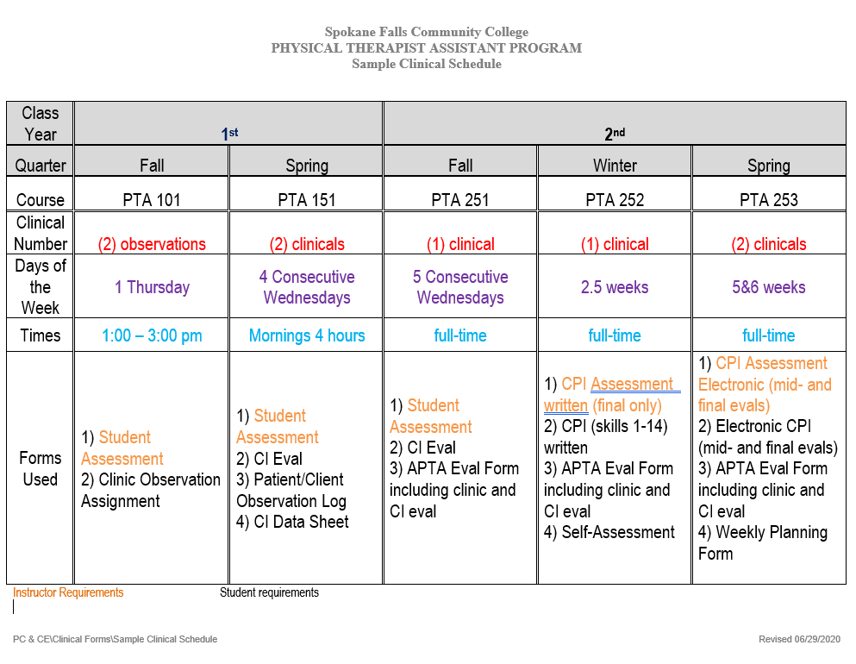

PTA 151 - 1 CREDIT
Clinical Experience I
FIRST YEAR, SPRING QUARTER

Students will rotate through two different clinics, spending a half day per week in each clinic for four weeks.

PRIOR COURSEWORK:

BIO& 241 Human Anatomy and Physiology
PTA 106 Regional Anatomy and Physiology
PTA 101 Introduction to Physical Therapy
PTA 102 Physical Therapy Terminology
PTA 104 Survey of Pathophysiology
PTA 110 Procedures I: Basic Physical Therapy Procedures Seminar
PTA 170 Procedures I: Basic Physical Therapy Procedures Lab
PTA 103 Applied Anatomy Seminar
PTA 173 Applied Anatomy Lab
PTA 105 Introduction to Neuroscience
PTA 107 Physical Therapy Documentation

CONCURRENT COURSEWORK:

PTA 111 Procedures II: Therapeutic Modalities Seminar
PTA 171 Procedures II: Therapeutic Modalities Lab
PTA 112 Procedures III: Functional Restoration Seminar
PTA 172 Procedures III: Functional Restoration lab

COURSE GOALS:

- To provide the PTA student with an extended experience of physical therapy services provided in two different types of clinic settings.

- Supervision should be “immediate” (within the same room).

- Based upon the judgment of the CI, the student is able to assist the CI in patient and treatment preparation and may assist with the implementation of the indicated therapy modalities and procedures.

STUDENT EVALUATION:

- Student evaluation will consist of a two-page rating scale of CI’s perceptions of the student’s performance related to professional behaviors, interpersonal skills, and general understanding of the rationale and effectiveness of the treatments observed. Instructions located in forms.

CLINICAL INSTRUCTOR EVALUATION:

- Student will complete the APTA Physical Therapist Assistant Student Evaluation: Clinical Experience and Clinical Instruction. This form must be finished and ready to share with CI at the time set aside for evaluation at the end of the rotation.

PTA 151: Clinical Experience I
SFCC COURSE ABILITIES AND LEARNING OUTCOMES

Course Title: Clinical Experience I
Course Number: PTA 151

Course Learning Outcomes:
All of the following standards for safety, behaviors, accountability, cultural competence and communication will be performed satisfactory in the clinic.
- Safety: Demonstrates expected behavior in regards to safety of the patient/client, self and others which may including the following:
  - Performs in a safe manner that minimizes the risk to patient, self, and others.(7D24 a,c,d,e,m) (7D27)
  - Describe effective patient/client emergencies that may occur in the clinical setting.(7D26)
- Clinical behaviors: Demonstrates expected clinical behaviors in a professional manner including which may include the following:
  - Adhere to legal practice standards, including all federal, state, and institutional regulations related to pt/client care and fiscal management(7D1)
  - Describe the appropriate procedure for reporting suspected cases of abuse of vulnerable populations. (7D2)
  - Describe the appropriate procedure for reporting of fraud and abuse related to the utilization of and payment for physical therapy and other health care services. (7D3)
  - Perform duties in a manner consistent with the Guide for Conduct of the Physical Therapist Assistant (APTA) and Standards of Ethical Conduct (APTA) to meet the expectations of patients, members of the physical therapy profession, and other providers as necessary. (7D4)
  - Describe, in response to an ethical situation, a plan of action that demonstrates sound moral reasoning congruent with core professional ethics and values. (7D6)
- Accountability: Performs in a manner consistent with established legal standards, standards of the profession, and ethical guidelines including the following:
  - Perform duties in a manner consistent with APTA’s Values Based Behaviors for the Physical Therapist Assistant.(7D5)
  - Report any changes in patient/client status or progress to the supervising physical therapist. (7D20)
- Cultural Competence: Adapts delivery of physical therapy services with consideration for patients’ differences, values, preferences, perspective, and needs. (7D8)(7D9)
- Communication: Communicate and/or educate in ways that are congruent with situational needs. (7D7) (7D12) (7D28)
- Documentation: Selects relevant information to document the delivery of physical therapy care. (7D25)
- Interventions and Data Collection: Demonstrates rationale for interventions and data collection methods identified in the plan of care appropriate for current level of coursework completed in program and which may include the following. (7D23) (7D24)
  - Practice the interventions in the plan of care in response to patient/client status and clinical indications.(7D19)
  - Explain the relationship between the plan of care developed by the physical therapist and the ability to achieve short/long term goals and intended outcomes. (7D17)
- Demonstrate understanding of the PT/PTA relationship and the PTA realtionship to other healthcare professionals (7D28)
- Practices in a clinical environment as a student PTA under the direction and supervision of the physical therapist to prepare the student to perform as an entry-level physical therapist assistant. (7C)

Clinical Course Criteria
- Adhere to the Guide for Conduct of the Physical Therapist Assistant (in manual)
- Attendance at all scheduled clinic sessions on time. If the student is absent due to illness or an emergency, it is the student’s responsibility to notify both the clinical instructor/facility and the college clinical coordinator as soon as possible. It will then be the student’s responsibility to arrange with the clinical instructor a make-up time for any clinic sessions that are missed.
- Receive no unacceptable reports from the clinical instructors, based on performance, attendance, appearance, and conduct.
- Return all student evaluation and clinic feedback forms on time to the ACCE.
- Immediately report any accidents or incidents to the facility clinical instructor and to the college clinical coordinator.
- Observe strict levels of confidentiality at all times. Refrain from referring to patients by name during any clinic discussion class or in any casual conversations outside of class.

Course Schedule example
Week 1 | Wed 10:00 – noon  April 5  Lecture 1 | Intro to Clinical Education Course Requirements, Expectations, Attendance, Assignments  Comparing Academic vs. Clinical Education  Fears and Expectations
Week 2 | Wed 8:00 – noon  April 12 | 1st Clinical
Week 3 | Wed 8:00 – noon  April 19 | 1st Clinical
Week 4 | Wed 8:00 – noon  April 26 | 1st Clinical
Week 5 | Wed 8:00 – noon  May 3 | 1st Clinical  Forms due CI Evaluation; Student Evaluation; Observation Log
Week 6 | Wed 8:00 – noon  May 10 | 2nd Clinical
Week 7 | Wed 8:00 – noon  May 17 | 2nd Clinical
Week 8 | Wed 8:00 – noon  May 24 | ^{2nd} Clinical
Week 9 | Wed 8:00 – noon  May 31 | 2nd  Forms due CI Evaluation; Student Evaluation; Observation Log  Clinical
Unit Objectives for PTA 151

- Adhere to the Guide for Conduct of the Physical Therapist Assistant
- Demonstrate understanding of the relationship of the PTA to the PT and to other clinic personnel.
- Establish satisfactory working relationships with the PT and other clinic personnel.
- Write documentation for each patient seen in clinic using the SOAP format. Delineate each element sequentially with patients as it is reviewed in class.
- Demonstrate understanding of the competencies and limitations of the PTA by performing assigned physical therapy procedures only under the direction and supervision of the PT.
- Demonstrate an understanding of the role of a student in the delivery of care.
- Appropriately discuss patient conditions and issues with the clinical instructor.
- Follow the policies and procedures of an assigned facility (i.e., working hours, uniforms, housekeeping duties, administrative and clerical duties).
- Interact with patients and families in a manner which provides the desired psychological support including recognition of cultural and socioeconomic differences.
- Participate in the clinical performance evaluation process with the supervising clinical instructor.
- Demonstrate knowledge of the rationale and effectiveness of the physical therapy treatments and procedures observed and practiced.
- Document relevant aspects of a patient’s treatment as appropriate.
- Observe and report on a variety of different types of physical therapy.
- Objectively describe observations and results of treatment
- Comply with the documentation requirements of the clinical environment.
- Observe and participate as appropriate in patient and treatment preparation and implementation of the following therapy procedures and modalities as available in the clinic:
- Participate in the clinical performance evaluation process with the supervising clinical instructor.
- Identify and discuss behaviors observed in the clinical setting that promote or detract from healing.

LABORATORY COMPETENCY LEVEL: Student has practiced and been tested on this skill in the lab to assure competency. Please note that this is a lab competency and not a clinic competency as will be addressed in the PTA CPI.

body mechanics  positioning and draping  superficial heat modalities (hot packs, paraffin)  superficial cold modalities (cold packs, ice massage, ice baths)  hydrotherapy, contrast baths, whirlpools  vital signs  Infection control principles  CPR and basic first aid  aseptic techniques and wound dressing  Diathermy | Anthropometric measurements  compression pumps  cold compression devices  compression bandaging for edema  residual limb wrapping  passive range of motion  measure functional range and Goniometry - all joints  Manual Muscle Testing  segmental length (leg length)  dynamometer, pinchmeter  inspirometer, chest expansion measurements

LABORATORY DEMONSTRATION LEVEL: Student has observed demonstration of this skill and has performed it but has not practiced it or been tested for competency.
wound debridement and water pik  compression bandaging for lymphedema  pain assessments  UV light, UV test dose (MED) | pool therapy and aquatic programs  athletic and therapeutic taping  Infrared light  vapocoolant

LABORATORY EXPOSURE LEVEL: Student has received instruction about the skill but has not actually performed it, however they have answered verbal and written test questions about the skill.

Basic First Aid, MSDS  life support and special equipment (monitoring devices, ventilators, lines, catheters, ostomies, etc.) | fluidotherapy  laser  General components of a PT evaluation

CURRENT LABORATORY SKILLS: Student is currently enrolled in:

- PTA 112/171 - Functional Restoration
- PTA 111/172 - Therapeutic Modalities

Student will benefit from observation of these skills in the clinic setting:

therapeutic massage  ultrasound  HVPGS  TENS  FES/NMES  biofeedback  iontophoresis  phonophoresis  Microamperage Electrical Nerve Stimulation  Electrical muscle stimulation for denervated tissue  Interferential current  Manual traction  UV light, UV test dose (MED)  Pulmonary care - postural drainage | lumbar traction  cervical traction  home traction units  manual lymphatic drainage  myofacial release techniques  strength-duration curve test  nerve conduction velocity test  reaction of degeneration  patient transfers  bed mobility/mat routines  Balance activities  tilt table  posture evaluation  gait aid device adjustment  Gait training

PTA 251 - 1 CREDIT
Clinical Experience II
SECOND YEAR, FALL QUARTER

Students will spend a full day in clinic each Wednesday for the last five weeks of the quarter.

PRIOR COURSEWORK:

BIO& 241 Human Anatomy and Physiology
PTA 106 Regional Anatomy and Physiology
PTA 101 Introduction to Physical Therapy
PTA 102 Physical Therapy Terminology
PTA 104 Survey of Pathophysiology
PTA 110 Procedures I: Basic Physical Therapy Procedures Seminar
PTA 170 Procedures I: Basic Physical Therapy Procedures Lab
PTA 103 Applied Anatomy Seminar
PTA 173 Applied Anatomy Lab
PTA 105 Introduction to Neuroscience
PTA 107 Physical Therapy Documentation
PTA 111 Procedures II: Therapeutic Modalities Seminar
PTA 171 Procedures II: Therapeutic Modalities Lab
PTA 112 Procedures III: Functional Restoration Seminar
PTA 172 Procedures III: Functional Restoration lab
PTA 151 Clinical Experience I

CONCURRENT COURSEWORK:

PTA 210 Procedures IV: Therapeutic Exercise Seminar
PTA 270 Procedures IV: Therapeutic Exercise Lab
PTA 202 Introduction to Orthopedics
PTA 272 Procedures VI: Pediatric Rehab Lab
PTA 212 Procedures VI: Pediatric Rehab Seminar
PTA 254 Clinical Seminar II

COURSE GOALS:

- To provide the PTA student with an extended experience in one facility to begin providing direct patient care under immediate supervision of the CI.

- Supervision should be “immediate” (within the same room) and may be “direct” (CI on premises) at the CI’s discretion

- Based upon the judgment of the CI, the student is able to assist the CI in patient and treatment preparation and assist with the implementation of the indicated therapy modalities and procedures.

STUDENT EVALUATION:

- The Clinical Instructor must complete this form and be prepared to share it with the student at the time set aside for evaluation at the end of the rotation. Instructions located in forms.

CLINICAL INSTRUCTOR EVALUATION

- Student will complete the APTA Physical Therapist Assistant Student Evaluation: Clinical Experience and Clinical Instruction. This form must be finished and ready to share with CI at the time set aside for evaluation at the end of the rotation.

PTA 251: Clinical Experience II
SFCC COURSE ABILITIES AND LEARNING OUTCOMES

Course Title: Clinical Experience II
Course Number: PTA 251

Course Learning Outcomes:
Upon successful completion of the course, the student will be able to perform all the following ‘Clinical Performance Instrument’ criteria to at least an Beginner to Intermediate performance while in the clinic environment:
- Safety: Performs in a safe manner that minimizes the risk to patient, self, and others.(7D24 a,c,d,e,m) (7D27) (7D26)
- Clinical behaviors: Demonstrates expected clinical behaviors in a professional manner in all situations.(7D1)(7D2) (7D3) (7D4) (7D6)
- Accountability: Performs in a manner consistent with established legal standards, standards of the profession, and ethical guidelines.(7D5)(7D13) (7D20)
- Cultural competence: Adapts delivery of physical therapy services with consideration for patients’ differences, values, preferences, and needs. (7D8)(7D9)
- Communication: Communicates in ways that are congruent with situational needs. (7D7) (7D12) (7D28)
- Self-Assessment and lifelong learning: Participates in self-assessment and develops plans to improve knowledge, skills, and behaviors. (7D10)(7D11)(7D14)
- Clinical problem solving: Demonstrates clinical problem solving. (7D15)(7D17)(7D18) (7D19)(7D21)
- Interventions:
  - Therapeutic exercise: Performs selected therapeutic exercises in a competent manner.
    - Interventions (7D23h)
    - Associated data collection (7D24h,k,I)
  - Therapeutic techniques: Applies selected manual therapy, airway clearance, and integumentary repair and protection techniques in a competent manner.
    - Interventions: Manual therapy techniques (7D23e)
    - Interventions: Integumentary repair/protection (7D23i)
    - Associated data collection (7D24f,g,h)
  - Physical agents and mechanical modalities: Applies selected physical agents and mechanical modalities in a competent manner
    - Interventions (7D23c)
    - Associated data collection(7D24b,i)
  - Electrotherapeutic modalities: Applies selected electrotherapeutic modalities in a competent manner. (7D23c)
  - Functional training and application of devices and equipment: Performs functional training in self-care and home management and application and adjustment of devices and equipment in a competent manner.
    - Interventions: Breathing strategies/oxygenation (7D23a)
    - Interventions: (7D23b,d,f,g)
- Documentation: Produces quality documentation in a timely manner to support the delivery of physical therapy services. (7D16)(7D25)
- Resource Management: Participates in the efficient delivery of physical therapy services.(7D22)(7D29) (7D30) (7D31)
- Participate in a clinical environment as a student PTA under the direction and supervision of the physical therapist to prepare the student to perform as an entry-level physical therapist assistant including the following: (7C)
  - Utilize evidence based resources, incorporate concepts from professional literature into practice.(7D10)
  - Participate in the clinical performance evaluation process with the supervising clinical instructor and academic clinical coordinator.

Clinical Course Criteria
- Adhere to the Guide for Conduct of the Physical Therapist Assistant (in manual)
- Attendance at all scheduled clinic sessions on time. If the student is absent due to illness or an emergency, it is the student’s responsibility to notify both the clinical instructor/facility and the college clinical coordinator as soon as possible. It will then be the student’s responsibility to arrange with the clinical instructor a make-up time for any clinic sessions that are missed.
- Receive no unacceptable reports from the clinical instructors, based on performance, attendance, appearance, and conduct.
- Return all student evaluation and clinic feedback forms on time to the ACCE.
- Immediately report any accidents or incidents to the facility clinical instructor and to the college clinical coordinator.
- Observe strict levels of confidentiality at all times. Refrain from referring to patients by name during any clinic discussion class or in any casual conversations outside of class.

- If a student fails a clinical education course, it will result in dismissal from the program. It is the ACCE’s responsibility to determine the passing or failure of the clinical education course.

- Students will be allowed to extend one of their clinical education rotations by one week if the Director of Clinical Education (DCE) and the Clinical Instructor (CI) believe the additional time will allow the student to successfully acquire the skills necessary to “pass” the rotation. This extension will constitute a “Remediation Plan.”

Course Schedule:
Second 5 weeks: 6-8 hours/week at assigned clinic site, minimum
Wednesdays, full-time

Each student to spend one full day per week for five weeks in one clinical site. An effort is made to accommodate student choice of sites while meeting experience requirements. Weekly emails will be sent to students and a response to each weekly email is required. See PTA 254 schedule for dates.

Unit Objectives for PTA 251
- Adhere to the Guide for Conduct of the Physical Therapist Assistant (Attached)
- Establish satisfactory working relationships with the PT and other clinic personnel.
- Demonstrate understanding of the competencies and limitations of the PTA by performing assigned physical therapy procedures only under the direction and supervision of the PT and appropriate delegation of tasks to support personnel.
- Demonstrate understanding of the role of the PTA student in the delivery of care and appropriately communicate this to the patient.
- Communicate on a timely basis with the clinical instructor about patient status.
- Follow the policies and procedures of an assigned facility (i.e., working hours, uniforms, housekeeping duties, administrative and clerical duties)
- Interact with patients and families in a manner which provides the desired psychological support including recognition of cultural and socioeconomic differences.
- Participate in the clinical performance evaluation process with the supervising clinical instructor.
- Develop skills in patient and treatment preparation:
A. obtain necessary preliminary information
B. prepare area and equipment prior to patient’s arrival
C. prepare the patient comfortably for treatment (positioning, draping, explanation)
D. execute correct treatment techniques
E. set up and operate equipment effectively and safely
F. monitor and adjust treatment as indicated
G. budget time to complete treatment and appropriate documentation as scheduled
H. assume responsibility for the patient’s safety during treatment
I. clean area and equipment at the completion of treatment
- Demonstrate knowledge of the rationale and effectiveness of the physical therapy treatments and procedures observed and practiced.
- Document relevant aspects of a patient’s treatment.
- Adjust treatments as appropriate under guidance of PT.
- Read and discuss patient evaluations with supervising PT.
- Educates others (patients, family, caregivers, staff, students, other health care providers) using relevant and effective teaching methods.
- Develop professional characteristics:
A. demonstrate appropriate grooming and dress
B. effective communication with patients, families, peers, and supervisors
C. effective teaching skills with patients and families
D. convey appropriate self-confidence
E. accept responsibility
F. initiate tasks appropriately
G. demonstrate flexibility and adaptability within clinic environment
H. accept constructive feedback from clinical instructors to improve knowledge and skills
I. utilize good body mechanics in performance of tasks
J. use spare clinic time to enhance learning
K. demonstrate good planning and time management skills
L. respect confidential information
M. be aware of fiscal considerations in the clinic setting
- Demonstrate the ability to use technology for communication
- Participate in direct patient care and develop skills in treatment preparation and implementation of the following therapy procedures and modalities as available in the clinic:

LABORATORY COMPETENCY LEVEL: Student has practiced and been tested on this skill in the lab to assure competency. Please note that this is a lab competency and not a clinic competency but should be prepared to perform these in the clinical setting.

- Body Mechanics  - Bed Mobility - Functional training - Basic  - Position and Draping  - Vital signs  - Pulses  - Temp  - Blood Pressure  - Respiration/oxygen sats  - Standard and Isolation precautions  - Isolation techniques  - Sterile techniques  - Wound and Edema management and assessment  - Anthropometric Measurement  - Compression Therapies  - Cryotherapy  - Cryotherapy with Compression  - Light therapy  - Hydrotherapy  - Superficial thermal agents  - Deep Thermal Agents  - Joint Integrity and Mobility assessment  - Therapeutic Taping  - Manual Muscle Testing  - Goniometry  - Anthropometric testing – Leg length  - Special Tests – Ober, Thomas etc  - Manual Therapy techniques - Passive Range of Motion  - Reflex Testing  - Respiration assessment  - Manual Therapy techniques – Therapeutic Massage  - Electrotherapeutic Agents  - High Volt Pulsed Current  - Functional Electrical Simulation/Neuromuscular electrical simulation  - Transcutaneous electrical muscle stimulator  - iontophoresis  - Interferential current | - Electromyography – Biofeedback  - Ultrasound – Deep thermal agents  - Combo -electrical stimulation  - Traction –  - Mechanical  - Manual  - Home  - Bed mobility – Functional training - Advanced  - Wheelchair  - Maintenance  - Measuring and fitting  - Wheelchair mobility - Functional training -Basic  - W/C mobility - Functional training - Advanced  - Transfers - Functional training  - Bed/mat to and from wheelchair  - Floor to and from wheelchair/mat  - Specialty lifts - Functional training  - Posture assessment  - Gait without walker/crutches/cane - Functional training  - Gait with assistive devices  - Walker  - Crutches  - Canes  - Donning/Doffing Orthotic devices

LABORATORY DEMONSTRATION LEVEL: Student has observed demonstration of this skill and has performed it but has not practiced it or been tested for competency.

Interventions
- Airway Clearance Technique: breathing exercises
- Airway Clearance Technique: coughing techniques
- Airway Clearance Technique: secretion mobilization
- Application of prosthetic and orthotic devices
- Biophysical Agent: cryotherapy-vapocoolant
- Anthropometrical Characteristics: measurements of height
- Anthropometrical Characteristics: measurements of weight
- Mental Functions: detect changes in patient’s state of arousal
- Mental Functions: detect changes in patient’s state of mentation
- Mental Functions: detect changes in patient’s state of cognition
- Assistive Technology: recognize changes in skin condition and safety factors while using devices and equipment
- Neuromotor Development: equilibrium reactions
- Neuromotor Development: righting
- Self-Care and Civic, Community, Domestic, Education, Social and Work Life: administer standardized questionnaires to patients and others
- Ventilation, Respiration and Circulation: describe thoracoabdominal movements and breathing patterns with activity, and cough and sputum characteristics

LABORATORY EXPOSURE LEVEL: Student has received instruction about the skill but has not actually performed it, however they have answered verbal and written test questions about the skill.

Interventions
- Integumentary Integrity: recognize viable versus nonviable tissue
Test and Measures
- Muscle Performance: changes in muscle tone

CURRENT LABORATORY SKILLS: Student is currently enrolled in:

- PTA 210 – Therapeutic Exercise
- PTA 212 – Pediatric Rehabilitation

Student will benefit from observation and participation as appropriate of these skills in the clinic setting.

Interventions
- Airway Clearance Technique: breathing exercises
- Airway Clearance Technique: coughing techniques
- Airway Clearance Technique: secretion mobilization
- Manual Therapy Technique: passive range of motion
- Motor Function Training: balance
- Patient/Client Education
- Therapeutic Exercise
Test and Measures
- Aerobic Capacity and Endurance: recognize and monitor responses to positional changes and activities (e.g., orthostatic hypotension, response to exercise)
- Mental Functions: detect changes in patient’s state of arousal
- Mental Functions: detect changes in patient’s state of mentation
- Mental Functions: detect changes in patient’s state of cognition
- Gait, Locomotion and Balance: determine the safety, status and progression of patients while engaged in gait
- Gait, Locomotion and Balance: determine the safety, status and progression of patients while engaged in locomotion
- Gait, Locomotion and Balance: determine the safety, status and progression of patients while engaged in balance
- Gait, Locomotion and Balance: determine the safety, status and progression of patients while engaged in mobility
- Joint Integrity and Mobility: detect normal
- Joint Integrity and Mobility: abnormal joint movement
- Muscle Performance: measure muscle strength by manual muscle testing
- Muscle Performance: observe the presence or absence of muscle mass
- Muscle Performance: recognize normal and abnormal muscle length
- Neuromotor Development: detect gross motor milestones
- Neuromotor Development: fine motor milestones
- Neuromotor Development: righting
- Neuromotor Development: equilibrium reactions
- Posture: determine normal and abnormal alignment of trunk and extremities at rest and during activities
- Range of Motion: measure functional range of motion
- Self-Care and Civic, Community, Domestic, Education, Social and Work Life: recognize safety and barriers in the home, community and work environments
- Ventilation, Respiration and Circulation: detect signs and symptoms of respiratory distress and activities that aggravate or relieve edema, pain, dyspnea or other symptoms
- Ventilation, Respiration and Circulation: describe thoracoabdominal movements and breathing patterns with activity, and cough and sputum characteristics

PTA 252 - 3 CREDITS
Clinical Experience III
SECOND YEAR, WINTER QUARTER

Students will spend 12 full days at one clinical site.

PRIOR COURSEWORK:

BIO& 241 Human Anatomy and Physiology
PTA 106 Regional Anatomy and Physiology
PTA 101 Introduction to Physical Therapy
PTA 102 Physical Therapy Terminology
PTA 104 Survey of Pathophysiology
PTA 110 Procedures I: Basic Physical Therapy Procedures Seminar
PTA 170 Procedures I: Basic Physical Therapy Procedures Lab
PTA 103 Applied Anatomy Seminar
PTA 173 Applied Anatomy Lab
PTA 105 Introduction to Neuroscience
PTA 107 Physical Therapy Documentation
PTA 111 Procedures II: Therapeutic Modalities Seminar
PTA 171 Procedures II: Therapeutic Modalities Lab
PTA 112 Procedures III: Functional Restoration Seminar
PTA 172 Procedures III: Functional Restoration lab
PTA 151 Clinical Experience I
PTA 210 Procedures IV: Therapeutic Exercise Seminar
PTA 270 Procedures IV: Therapeutic Exercise Lab
PTA 202 Introduction to Orthopedics
PTA 272 Procedures VI: Pediatric Rehab Lab
PTA 212 Procedures VI: Pediatric Rehab Seminar
PTA 251 Clinical Experience II
PTA 254 Clinical Seminar II

CONCURRENT COURSEWORK:

PTA 201 Issues in PT
PTA 201 Physical Therapy Preparatory Lab
PTA 211 Procedures V: Rehab Applications Seminar
PTA 271 Procedures V: Rehab Applications Lab
PTA 255 Clinical Seminar III

COURSE GOALS:

- To provide the PTA student with extended experiences in two different facilities to begin to refine skills in providing direct patient care under immediate supervision of the CI.

- Supervision should be “immediate” (within the same room) and may be “direct” (CI on premises) at the CI’s discretion.

- Based upon the judgment of the CI, the student is able to provide direct patient treatment of the indicated therapy modalities and procedures.

STUDENT EVALUATION:

- Student evaluation will consist of the paper version of the Clinical Performance Instrument (final evaluation only). The evaluation is to be completed by both the student and the CI.

CLINICAL INSTRUCTOR EVALUATION

- Student will complete the APTA Physical Therapist Assistant Student Evaluation: Clinical Experience and Clinical Instruction. This form must be finished and ready to share with CI at the time set aside for evaluation at the end of the rotation.

Course Title: Clinical Experience 3
Course Number: PTA 252

Course Description: This is the third clinical experience course based in a variety of physical therapy clinic settings affiliated with the college. All Clinical Performance Instrument criteria will be performed at “Advanced beginner to Advanced Intermediate” performance or higher depending on the level of the student’s didactic and laboratory competencies. Application of interventions and data collection methods identified in the plan of care from previous coursework will be achieved through facilitation by the clinical instructor.

Department: Allied Health Science
Course Credits: 3 credits

Clock Hours/Instructional Delivery: 96 hours
- 8 hours/day at assigned clinic site for 12 days (96 hours)

Students will spend 12 full days in one clinical site. An effort will be made to accommodate student choice of site while meeting experience requirements.

Prerequisites: Grade of 2.0 or better in all PTA courses.

Course Learning Outcomes:
Upon successful completion of the course, the student will be able to perform all the following ‘Clinical Performance Instrument’ criteria to at least an Advanced Beginner to Advanced Intermediate performance while under the direction and supervision of the physical therapist in the clinic environment: (7C)
- Safety: Performs in a safe manner that minimizes the risk to patient, self, and others.(7D24 a,c,d,e,m) (7D27) (7D26)
- Clinical behaviors: Demonstrates expected clinical behaviors in a professional manner in all situations.(7D1)(7D2) (7D3) (7D4) (7D6)
- Accountability: Performs in a manner consistent with established legal standards, standards of the profession, and ethical guidelines.(7D5)(7D13) (7D20)
- Cultural competence: Adapts delivery of physical therapy services with consideration for patients’ differences, values, preferences, and needs. (7D8)(7D9)
- Communication: Communicates in ways that are congruent with situational needs. (7D7) (7D12) (7D28)
- Self-Assessment and lifelong learning: Participates in self-assessment and develops plans to improve knowledge, skills, and behaviors. (7D10)(7D11)(7D14)
- Clinical problem solving: Demonstrates clinical problem solving. (7D15)(7D17)(7D18) (7D19)(7D21)
- Interventions:
  - Therapeutic exercise: Performs selected therapeutic exercises in a competent manner.
    - Interventions (7D23h)
    - Associated data collection (7D24h,k,I)
  - Therapeutic techniques: Applies selected manual therapy, airway clearance, and integumentary repair and protection techniques in a competent manner.
    - Interventions: Manual therapy techniques (7D23e)
    - Interventions: Integumentary repair/protection (7D23i)
    - Associated data collection (7D24f,g,h)
  - Physical agents and mechanical modalities: Applies selected physical agents and mechanical modalities in a competent manner
    - Interventions (7D23c)
    - Associated data collection(7D24b,i)
  - Electrotherapeutic modalities: Applies selected electrotherapeutic modalities in a competent manner. (7D23c)
  - Functional training and application of devices and equipment: Performs functional training in self-care and home management and application and adjustment of devices and equipment in a competent manner.
    - Interventions: Breathing strategies/oxygenation (7D23a)
    - Interventions: (7D23b,d,f,g)
- Documentation: Produces quality documentation in a timely manner to support the delivery of physical therapy services. (7D16)(7D25)
- Resource Management: Participates in the efficient delivery of physical therapy services.(7D22)(7D29) (7D30) (7D31)
- Participate in the clinical performance evaluation process with the supervising clinical instructor and academic clinical coordinator.

Course Schedule:
12 days in clinic Feb 5 - 20

Unit Objectives for PTA 252
- Adhere to the Guide for Conduct of the Physical Therapist Assistant (attached)
- Establish satisfactory working relationships with the PT and other clinic personnel.
- Demonstrate understanding of the competencies and limitations of the PTA by performing assigned physical therapy procedures only under the direction and supervision of the PT and appropriate delegation of tasks to support personnel.
- Demonstrate understanding of the role of the PTA student in the delivery of care and appropriately communicate this to the patient.
- Communicate on a timely basis with the clinical instructor about patient status.
- Follow the policies and procedures of an assigned facility (i.e., working hours, uniforms, housekeeping duties, administrative and clerical duties)
- Interact with patients and families in a manner that provides the desired psychological support including recognition of cultural and socioeconomic differences.
- Participate in the clinical performance evaluation process with the supervising clinical instructor.
- Demonstrate skill in patient and treatment preparation:
  - obtain necessary preliminary information
  - prepare area and equipment prior to patient’s arrival
  - prepare the patient comfortably for treatment (positioning, draping, explanation)
  - execute correct treatment techniques
  - set up and operate equipment effectively and safely
  - monitor and adjust treatment as indicated
  - budget time to complete treatment and appropriate documentation as scheduled
  - assume responsibility for the patient’s safety during treatment
  - clean area and equipment at the completion of treatment
- Demonstrate knowledge of the rationale for and effectiveness of the physical therapy treatments and procedures carried out.
- Document relevant aspects of a patient’s treatment and write progress notes.
- Adjust treatments as appropriate under guidance of PT.
- Read and discuss patient evaluations with supervising PT.
- Discuss progression of patient’s exercise program as appropriate with PT.
- Instruct patient and family members in exercise programs as appropriate.
- Demonstrate professional characteristics:
a. appropriate grooming and dress
b. effective communication with patients, families, peers, and supervisors
c. effective teaching skills with patients and families
d. convey appropriate self-confidence
e. accept responsibility
f. initiate tasks appropriately
g. demonstrate flexibility and adaptability within clinic environment
h. accept and utilize constructive feedback from clinical instructors to improve knowledge and skills
i. utilize good body mechanics in performance of tasks
j. use spare clinic time to enhance learning
k. demonstrate good planning and time management skills
l. respect confidential information
m. be aware of fiscal considerations in the clinic setting
- Demonstrate the ability to use technology for communication
- Participate in direct patient care and develop skills in treatment preparation and implementation of the following therapy procedures and modalities as available in the clinic AND as appropriate to the student’s level of proficiency:

LABORATORY COMPETENCY LEVEL: Student has practiced and been tested on these skills in the lab to assure competency. Please note that these are lab competencies and not clinic competencies as will be addressed in the Clinical Performance Instrument.

Interventions
- Airway Clearance Technique: coughing techniques
- Application of assistive/adaptive devices-canes, walkers, crutches, etc
- Biophysical Agent: biofeedback
- Biophysical Agent: electrotherapeutic agents
- Biophysical Agent: compression therapies
- Biophysical Agent: cryotherapy-cold packs, ice massage, icy baths
- Biophysical Agent: hydrotherapy-contrast baths
- Biophysical Agent: deep thermal agents
- Biophysical Agent: superficial thermal agents
- Biophysical Agent: light therapies
- Biophysical Agent: traction
- Biophysical Agent: hydrotherapy-whirlpools
- Functional Training: ADLs/IADLs, self-care, domestic, education, work, community, social and civic life
- Manual Therapy Technique: passive range of motion
- Manual Therapy Technique: therapeutic massage
- Motor Function Training: gait
- Motor Function Training: balance
- Patient/Client Education
- Therapeutic Exercise
- Wound Management: isolation techniques
- Wound Management: sterile technique
- Wound Management: application and removal of dressing or agents
- Wound Management: identification of precautions for dressing removal

Test and Measures
- Aerobic Capacity and Endurance: measurement of standard vital signs
- Aerobic Capacity and Endurance: recognize and monitor responses to positional changes and activities (e.g., orthostatic hypotension, response to exercise)
- Anthropometrical Characteristics: measurements of girth
- Assistive Technology: identify the individual’s and caregiver’s ability to care for the device
- Gait, Locomotion and Balance: determine the safety, status and progression of patients while engaged in gait
- Gait, Locomotion and Balance: determine the safety, status and progression of patients while engaged in locomotion
- Gait, Locomotion and Balance: determine the safety, status and progression of patients while engaged in balance
- Gait, Locomotion and Balance: determine the safety, status and progression of patients while engaged in wheelchair management
- Gait, Locomotion and Balance: determine the safety, status and progression of patients while engaged in mobility
- Integumentary Integrity: detest absent or altered sensation
- Integumentary Integrity: Normal and abnormal integumentary changes, activities, positioning and postures that aggravate or relieve pain or altered sensations or that can produce associated skin trauma
- Joint Integrity and Mobility: detect normal
- Joint Integrity and Mobility: abnormal joint movement
- Muscle Performance: measure muscle strength by manual muscle testing
- Muscle Performance: observe the presence or absence of muscle mass
- Muscle Performance: recognize normal and abnormal muscle length
- Neuromotor Development: detect gross motor milestones
- Neuromotor Development: fine motor milestones
- Neuromotor Development: righting
- Neuromotor Development: equilibrium reactions
- Pain: administer standardized questionnaires, graphs, behavioral scales or visual analog scales for pain
- Pain: recognize activities, positioning and postures that aggravate or relieve pain or altered sensations
- Posture: determine normal and abnormal alignment of trunk and extremities at rest and during activities
- Range of Motion: measure functional range of motion
- Range of Motion: Measure range of motion using an appropriate measurement device
- Self-Care and Civic, Community, Domestic, Education, Social and Work Life: inspect the physical environment and measure physical spaces
- Self-Care and Civic, Community, Domestic, Education, Social and Work Life: recognize safety and barriers in the home, community and work environments
- Self-Care and Civic, Community, Domestic, Education, Social and Work Life: recognize level of functional status
- Ventilation, Respiration and Circulation: detect signs and symptoms of respiratory distress and activities that aggravate or relieve edema, pain, dyspnea or other symptoms
- Ventilation, Respiration and Circulation: describe thoracoabdominal movements and breathing patterns with activity, and cough and sputum characteristics
- Complete accurate documentation that follows guidelines and specific documentation formats required by state practice acts, the practice setting and other regulatory agencies

LABORATORY DEMONSTRATION LEVEL: Student has received instruction about these skills but has not actually performed them; however, student has answered verbal and written test questions about these skills.

Interventions
- Airway Clearance Technique: breathing exercises
- Airway Clearance Technique: secretion mobilization
- Application of prosthetic and orthotic devices
- Biophysical Agent: cryotherapy-vapocoolant
Test and Measures
- Anthropometrical Characteristics: measurements of height
- Anthropometrical Characteristics: measurements of weight
- Assistive Technology: recognize changes in skin condition and safety factors while using devices and equipment
- Mental Functions: detect changes in patient’s state of arousal
- Mental Functions: detect changes in patient’s state of mentation
- Mental Functions: detect changes in patient’s state of cognition
- Self-Care and Civic, Community, Domestic, Education, Social and Work Life: administer standardized questionnaires to patients and others

LABORATORY EXPOSURE LEVEL: Student has received instruction about these skills but has not actually performed them; however, student has answered verbal and written test questions about these skills.

Test and Measures
- Integumentary Integrity: recognize viable versus nonviable tissue
- Muscle Performance: changes in muscle tone

CURRENT LABORATORY SKILLS: Student is currently in:

  - PTA 211/271 – Rehab Applications

Student will benefit from observation and participation as appropriate of these skills in the clinic setting.

Interventions
- Application of assistive/adaptive devices-canes, walkers, crutches, etc.
- Biophysical Agent: biofeedback
- Biophysical Agent: electrotherapeutic agents
- Biophysical Agent: compression therapies
- Biophysical Agent: cryotherapy-cold packs, ice massage, icy baths
- Biophysical Agent: hydrotherapy-contrast baths
- Biophysical Agent: deep thermal agents
- Biophysical Agent: superficial thermal agents
- Biophysical Agent: light therapies
- Biophysical Agent: traction
- Biophysical Agent: hydrotherapy-whirlpools
- Functional Training: ADLs/IADLs, self-care, domestic, education, work, community, social and civic life
- Manual Therapy Technique: passive range of motion
- Manual Therapy Technique: therapeutic massage
- Motor Function Training: gait
- Motor Function Training: balance
- Patient/Client Education
- Therapeutic Exercise
- Wound Management: isolation techniques
- Wound Management: application and removal of dressing or agents
Test and Measures
- Aerobic Capacity and Endurance: measurement of standard vital signs
- Aerobic Capacity and Endurance: recognize and monitor responses to positional changes and activities (e.g., orthostatic hypotension, response to exercise)
- Anthropometrical Characteristics: measurements of height
- Anthropometrical Characteristics: measurements of weight
- Anthropometrical Characteristics: measurements of length
- Anthropometrical Characteristics: measurements of girth
- Assistive Technology: identify the individual’s and caregiver’s ability to care for the device
- Assistive Technology: recognize changes in skin condition and safety factors while using devices and equipment
- Gait, Locomotion and Balance: determine the safety, status and progression of patients while engaged in gait
- Gait, Locomotion and Balance: determine the safety, status and progression of patients while engaged in locomotion
- Gait, Locomotion and Balance: determine the safety, status and progression of patients while engaged in balance
- Gait, Locomotion and Balance: determine the safety, status and progression of patients while engaged in wheelchair management
- Gait, Locomotion and Balance: determine the safety, status and progression of patients while engaged in mobility
- Integumentary Integrity: Normal and abnormal integumentary changes, activities, positioning and postures that aggravate or relieve pain or altered sensations or that can produce associated skin trauma
- Joint Integrity and Mobility: detect normal
- Joint Integrity and Mobility: abnormal joint movement
- Muscle Performance: measure muscle strength by manual muscle testing
- Muscle Performance: observe the presence or absence of muscle mass
- Muscle Performance: recognize normal and abnormal muscle length
- Muscle Performance: changes in muscle tone
- Neuromotor Development: righting
- Neuromotor Development: equilibrium reactions
- Pain: administer standardized questionnaires, graphs, behavioral scales or visual analog scales for pain
- Pain: recognize activities, positioning and postures that aggravate or relieve pain or altered sensations
- Posture: determine normal and abnormal alignment of trunk and extremities at rest and during activities
- Range of Motion: measure functional range of motion
- Self-Care and Civic, Community, Domestic, Education, Social and Work Life: recognize level of functional status
- Self-Care and Civic, Community, Domestic, Education, Social and Work Life: administer standardized questionnaires to patients and others
- Ventilation, Respiration and Circulation: detect signs and symptoms of respiratory distress and activities that aggravate or relieve edema, pain, dyspnea or other symptoms
- Complete accurate documentation that follows guidelines and specific documentation formats required by state practice acts, the practice setting and other regulatory agencies

PTA 253 - 12 CREDITS
Clinical Affiliations
SECOND YEAR, SPRING QUARTER

Students will attend clinic 40 hours each week during 5 & 6 week rotations. Students will have two rotations during spring quarter.

BIO& 241 Human Anatomy and Physiology
PTA 106 Regional Anatomy and Physiology
PTA 101 Introduction to Physical Therapy
PTA 102 Physical Therapy Terminology
PTA 104 Survey of Pathophysiology
PTA 110 Procedures I: Basic Physical Therapy Procedures Seminar
PTA 170 Procedures I: Basic Physical Therapy Procedures Lab
PTA 103 Applied Anatomy Seminar
PTA 173 Applied Anatomy Lab
PTA 105 Introduction to Neuroscience
PTA 107 Physical Therapy Documentation
PTA 111 Procedures II: Therapeutic Modalities Seminar
PTA 171 Procedures II: Therapeutic Modalities Lab
PTA 112 Procedures III: Functional Restoration Seminar
PTA 172 Procedures III: Functional Restoration lab
PTA 151 Clinical Experience 1
PTA 210 Procedures IV: Therapeutic Exercise Seminar
PTA 270 Procedures IV: Therapeutic Exercise Lab
PTA 202 Introduction to Orthopedics
PTA 272 Procedures VI: Pediatric Rehab Lab
PTA 212 Procedures VI: Pediatric Rehab Seminar
PTA 251 Clinical Experience II
PTA 254 Clinical Seminar II
PTA 201 Issues in PT
PTA 203 Physical Therapy Preparatory Lab
PTA 211 Procedures V: Rehab Applications Seminar
PTA 271 Procedures V: Rehab Applications Lab
PTA 252 Clinical Experience III
PTA 255 Clinical Seminar III

COURSE GOALS:

- To provide the PTA student with extended experiences in two different facilities to refine skills in providing direct patient care under immediate or direct supervision of the CI.

- This affiliation should be sufficient to ensure that the student has reached the minimum level of competency required for an entry-level PTA in the application of PT procedures and the understanding of clinic responsibilities and supervisory relationships prior to graduation.

- Based upon the judgment of the CI, the student is able to provide direct patient treatment of the indicated therapy modalities and procedures.

STUDENT EVALUATION:

- Student evaluation will consist of:
Mid-clinical evaluation using the electronic version of the Clinical Performance Instrument (CPI). Mid-clinical evaluation to be completed by both student and CI independently.
Mid-clinical conference with the student, CI and DCE
Final evaluation using the electronic version of the CPI. Final evaluation to be completed by both student and CI independently.

CLINICAL INSTRUCTOR EVALUATION

- Student will complete the APTA Physical Therapist Assistant Student Evaluation: Clinical Experience and Clinical Instruction. This form must be finished and ready to share with CI at the time set aside for evaluation at the end of the rotation.

Course Title: Clinical Affiliation
Course Number: PTA 253

Course Learning Outcomes:
Upon successful completion of the course, the student will be able to perform all the following ‘Clinical Performance Instrument’ criteria to Entry Level performance while under the direction and supervision of the physical therapist in the clinic environment: (7C)

- Safety: Performs in a safe manner that minimizes the risk to patient, self, and others.(7D24 a,c,d,e,m) (7D27) (7D26)
- Clinical behaviors: Demonstrates expected clinical behaviors in a professional manner in all situations.(7D1)(7D2) (7D3) (7D4) (7D6)
- Accountability: Performs in a manner consistent with established legal standards, standards of the profession, and ethical guidelines.(7D5)(7D13) (7D20)
- Cultural competence: Adapts delivery of physical therapy services with consideration for patients’ differences, values, preferences, and needs. (7D8)(7D9)
- Communication: Communicates in ways that are congruent with situational needs. (7D7) (7D12) (7D28)
- Self-Assessment and lifelong learning: Participates in self-assessment and develops plans to improve knowledge, skills, and behaviors. (7D10)(7D11)(7D14)
- Clinical problem solving: Demonstrates clinical problem solving. (7D15)(7D17)(7D18) (7D19)(7D21)
- Interventions:
  - Therapeutic exercise: Performs selected therapeutic exercises in a competent manner.
    - Interventions (7D23h)
    - Associated data collection (7D24h,k,I)
  - Therapeutic techniques: Applies selected manual therapy, airway clearance, and integumentary repair and protection techniques in a competent manner.
    - Interventions: Manual therapy techniques (7D23e)
    - Interventions: Integumentary repair/protection (7D23i)
    - Associated data collection (7D24f,g,h)
  - Physical agents and mechanical modalities: Applies selected physical agents and mechanical modalities in a competent manner
    - Interventions (7D23c)
    - Associated data collection(7D24b,i)
  - Electrotherapeutic modalities: Applies selected electrotherapeutic modalities in a competent manner. (7D23c)
  - Functional training and application of devices and equipment: Performs functional training in self-care and home management and application and adjustment of devices and equipment in a competent manner.
    - Interventions: Breathing strategies/oxygenation (7D23a)
    - Interventions: (7D23b,d,f,g)
- Documentation: Produces quality documentation in a timely manner to support the delivery of physical therapy services. (7D16)(7D25)
- Resource Management: Participates in the efficient delivery of physical therapy services.(7D22)(7D29) (7D30) (7D31)
- Participate in the clinical performance evaluation process with the supervising clinical instructor and academic clinical coordinator.

Grade/Evaluation Criteria:
Clinical courses will be graded on a pass, incomplete or non-credit basis.
The criteria for a pass grade:
1. Attendance at all scheduled clinical visits on time. If the student is absent due to illness or an emergency, it is the student’s responsibility to notify the clinical instructor/facility, the ACCE and the program coordinator as soon as possible. It will then be the student’s responsibility to arrange a make-up time for any clinical sessions that are missed.
2. Receive no “unacceptable” reports from the clinical instructors, based on performance, attendance, appearance, and conduct.
3. Return all student evaluation and clinical feedback forms on time to the college program coordinator. Refer to the Form Preparations Guidelines for submission deadlines.
4. Immediately report any accidents or incidents to the clinical instructor/facility, the ACCE and the program clinical coordinator as soon as possible.
5. Complete all assignments (e.g. inservice) in the clinic satisfactorily and on time.
6. Observe strict levels of confidentiality at all times. Refrain from referring to patients by name in any casual conversations outside of the clinic.
7. All applicable skills in the Clinical Performance Instrument must be checked off as a competency met. Special exceptions may be given by the academic coordinator of clinical education in situations where certain experiences were not available to the student.

If a student fails a clinical education course, it will result in dismissal from the program. It is the ACCE’s responsibility to determine the passing or failure of the clinical education course.

Students will be allowed to extend one of their clinical education rotations by one week if the Academic Coordinator of Clinical Education (ACCE) and the Clinical Instructor (CI) believe the additional time will allow the student to successfully acquire the skills necessary to “pass” the rotation. This extension will constitute a “probationary form.”

SPRING Example – Form Preparation Guidelines

 | MONDAY | TUESDAY | WEDNESDAY | THURSDAY | FRIDAY
Week -3 | Mar 13
Due to Carolyn for PTA 253:1, PTA 253:2
- CI names for both spring clinicals
- CI emails for both spring clinicals
- Student Biographical Data Sheets for both spring clinicals
- Goal letters for both spring clinicals
Week -2 | Mar 20 | Mar 21 | Mar 22
 | FINALS – review PTA 253 manual; date/time TBA
Week -1 | Mar 27 | Mar 28 | Mar 29 | Mar 30 | Mar 31
 | SPRING BREAK
Week 1 | April 3
FIRST DAY of 1ST CLINICAL
Email your work schedule to DCE
Week 2 | April 10 | April 11 | April 12 | April 13 | April 14
 |  | “M” evaluations must be completed prior to your clinic visit |  |  | CLINIC VISITS
Week 3 | April 17 | April 18 | April 19 | April 20 | April 21
 | CLINIC VISITS | CLINIC VISITS | CLINIC VISITS | CLINIC VISITS | CLINIC VISITS
Week 4 | April 24 | April 25 | April 26 | April 27 | April 28
 | CLINIC VISITS
Week 5 | May 1 |  |  |  | May 5
 | Clinical Site Information Form (CSIF) is due |  |  | LAST DAY of 1ST CLINICAL
Week 6 | May 8 |  |  |  | May 12
 | FIRST DAY of 2ND CLINICAL  - Email your work schedule to DCE and Program Coordinator  - Mail or submit your thank-you note to your CI for your first clinical  - Submit completed clinic forms for your first clinical to Program Coordinator |  |  | If you have not yet heard from Student Services about graduation please contact Registar immediately (533-3506)
Week 7 | May 15 | May 16 | May 17 | May 18 | May 19
 |  | “M” evaluations must be completed prior to your clinic visit |  |  | CLINIC VISITS
Week 8 | May 22 | May 23 | May 24 | May 25 | May 26
 | CLINIC VISITS | CLINIC VISITS | CLINIC VISITS | CLINIC VISITS | CLINIC VISITS
Week 9 |  | May 30
 |  | CLINIC VISITS
Week 10 | June 5 |  |  |  | June 9
 | Clinical Site Information Form (CSIF) is due |  |  | LAST DAY of 2ND CLINICAL
Week 11 | June 12 | June 13 |  |  | June 16
 | - Mail or submit your thank-you note to your CI  - Submit completed clinic forms to PC | EXIT INTERVIEW  9:00am - noon  - Bring completed Program Outcome Objectives form  - Bring completed Program Curricular Objectives Survey  - Bring completed Clinical Education Survey  - Bring completed Address Update/Job Survey form |  |  | GRADUATION  11:30-2:00pm  PTA Party  3:00pm  Commencement

Graduation ceremonies will be held on the afternoon of June 16th at the Veterans’ Memorial Arena. The PTA program will be hosting a party from 11:30am to 2:00pm in the lab prior to graduation.

*Clinic Forms
APTA form (8 pages; salmon color). Be sure to sign and get signature from CI
Presentation Sign-In Sheet.
PTA Program Presentation Criteria Checklist. Have one completed by each person attending your presentation.

Unit Objectives for PTA 253
- Adhere to the Guide for Conduct of the Physical Therapist Assistant (Attached)
- Perform all key indicator criteria in each skill area of the Clinical Performance Instrument (CPI) appropriate to the facility to the satisfaction of the clinical instructor as indicated by the CPI.
- Participate in the clinical performance evaluation process with the supervising clinical instructor and academic clinical coordinator.
- Prepare a self-assessment to share with the academic clinical coordinator at the student conference or exit interview.
- Conduct an in-service training session for the facility staff on a topic agreed upon by the student and the clinical instructor.
- Read and discuss patient evaluations with supervising PT/PTA.
- Demonstrate knowledge of the rationale for and effectiveness of the physical therapy treatments and procedures carried out.
- Adjust treatments and progress patients as appropriate under guidance of PT/PTA.
- Document relevant aspects of a patient’s treatment and write progress notes.
- Provide patient and family education as appropriate.
- Assist the PT/PTA in assessment and measurement procedures as assigned.
- Demonstrate understanding of the physical therapy treatment of specific disabling conditions and be able to respond to the patient in a global nature.
- Initiate treatment ideas in relationship to patient response within the scope of PTA practice.
- Assist the PT/PTA and patient to access necessary equipment, follow-up care, and other related services as determined by the plan of care.
- Demonstrate the ability to obtain weekly email updates from the academic clinical coordinator, assistant academic clinical coordinator and program coordinator, and respond.
- Participates in activities related to performance improvement
- Deliver direct patient care and demonstrate entry level clinical competency in the treatment preparation and implementation of the following therapy procedures and modalities as available in the clinic:

LABORATORY COMPETENCY LEVEL: Student has practiced and been tested on this skill in the lab to assure competency. Student may have achieved clinic competency (on a patient) as addressed in the CPI.

Interventions
- Airway Clearance Technique: coughing techniques
- Application of assistive/adaptive devices-canes, walkers, crutches, etc
- Biophysical Agent: biofeedback
- Biophysical Agent: electrotherapeutic agents
- Biophysical Agent: compression therapies
- Biophysical Agent: cryotherapy-cold packs, ice massage, icy baths
- Biophysical Agent: hydrotherapy-contrast baths
- Biophysical Agent: deep thermal agents
- Biophysical Agent: superficial thermal agents
- Biophysical Agent: light therapies
- Biophysical Agent: traction
- Biophysical Agent: hydrotherapy-whirlpools
- Functional Training: ADLs/IADLs, self-care, domestic, education, work, community, social and civic life
- Manual Therapy Technique: passive range of motion
- Manual Therapy Technique: therapeutic massage
- Motor Function Training: gait
- Motor Function Training: balance
- Patient/Client Education
- Therapeutic Exercise
- Wound Management: isolation techniques
- Wound Management: sterile technique
- Wound Management: application and removal of dressing or agents
- Wound Management: identification of precautions for dressing removal
Test and Measures
- Aerobic Capacity and Endurance: measurement of standard vital signs
- Aerobic Capacity and Endurance: recognize and monitor responses to positional changes and activities (e.g., orthostatic hypotension, response to exercise)
- Anthropometrical Characteristics: measurements of length
- Anthropometrical Characteristics: measurements of girth
- Assistive Technology: identify the individual’s and caregiver’s ability to care for the device
- Gait, Locomotion and Balance: determine the safety, status and progression of patients while engaged in gait
- Gait, Locomotion and Balance: determine the safety, status and progression of patients while engaged in locomotion
- Gait, Locomotion and Balance: determine the safety, status and progression of patients while engaged in balance
- Gait, Locomotion and Balance: determine the safety, status and progression of patients while engaged in wheelchair management
- Gait, Locomotion and Balance: determine the safety, status and progression of patients while engaged in mobility
- Integumentary Integrity: detest absent or altered sensation
- Integumentary Integrity: Normal and abnormal integumentary changes, activities, positioning and postures that aggravate or relieve pain or altered sensations or that can produce associated skin trauma
- Joint Integrity and Mobility: detect normal
- Joint Integrity and Mobility: abnormal joint movement
- Muscle Performance: measure muscle strength by manual muscle testing
- Muscle Performance: observe the presence or absence of muscle mass
- Muscle Performance: recognize normal and abnormal muscle length
- Muscle Performance: changes in muscle tone
- Neuromotor Development: detect gross motor milestones
- Neuromotor Development: fine motor milestones
- Neuromotor Development: righting
- Neuromotor Development: equilibrium reactions
- Pain: administer standardized questionnaires, graphs, behavioral scales or visual analog scales for pain
- Pain: recognize activities, positioning and postures that aggravate or relieve pain or altered sensations
- Posture: determine normal and abnormal alignment of trunk and extremities at rest and during activities
- Range of Motion: measure functional range of motion
- Range of Motion: Measure range of motion using an appropriate measurement device
- Self-Care and Civic, Community, Domestic, Education, Social and Work Life: inspect the physical environment and measure physical spaces
- Self-Care and Civic, Community, Domestic, Education, Social and Work Life: recognize safety and barriers in the home, community and work environments
- Self-Care and Civic, Community, Domestic, Education, Social and Work Life: recognize level of functional status
- Self-Care and Civic, Community, Domestic, Education, Social and Work Life: administer standardized questionnaires to patients and others
- Ventilation, Respiration and Circulation: detect signs and symptoms of respiratory distress and activities that aggravate or relieve edema, pain, dyspnea or other symptoms
- Ventilation, Respiration and Circulation: describe thoracoabdominal movements and breathing patterns with activity, and cough and sputum characteristics
- Complete accurate documentation that follows guidelines and specific documentation formats required by state practice acts, the practice setting and other regulatory agencies

LABORATORY DEMONSTRATION LEVEL: Student has observed demonstration of this skill and has performed it, but has not practiced it or been tested for competency. Student may have practiced it in previous clinical experiences as indicated in the CPI.

Interventions
- Airway Clearance Technique: breathing exercises
- Airway Clearance Technique: secretion mobilization
- Application of prosthetic and orthotic devices
- Biophysical Agent: cryotherapy-vapocoolant
Test and Measures
- Anthropometrical Characteristics: measurements of height
- Anthropometrical Characteristics: measurements of weight
- Mental Functions: detect changes in patient’s state of arousal
- Mental Functions: detect changes in patient’s state of mentation
- Mental Functions: detect changes in patient’s state of cognition
- Assistive Technology: recognize changes in skin condition and safety factors while using devices and equipment

LABORATORY EXPOSURE LEVEL: Student has received instruction about the skill but has not actually performed it, however they have answered verbal and written test questions about the skill. Student may have received additional practice in previous clinical experiences as indicated in the CPI.

Test and Measures
- Integumentary Integrity: recognize viable versus nonviable tissue

Physical Therapist Assistant Program

PROFESSIONAL DOCUMENTS

CORE VALUES FOR THE PT AND PTA

Last Updated: 9/20/19
Contact: nationalgovernance@apta.org

CORE VALUES FOR THE PHYSICAL THERAPIST AND PHYSICAL THERAPIST ASSISTANT HOD P06‐19‐48‐55
[Amended: HOD P06‐18‐25‐33; Initial HOD P05‐07‐19‐19;] [Previously Titled: Core Values: for the Physical Therapist] [Position]

The core values guide the behaviors of physical therapists (PTs) and physical therapist assistants (PTAs) to provide the highest quality of physical therapist services. These values imbue the scope of PT and PTA activities. The core values retain the PT as the person ultimately responsible for providing safe, accessible, cost‐effective, and evidence‐based services; and the PTA as the only individual who assists the PT in practice, working under the direction and supervision of the PT. The core values are defined as follows:

- Accountability
Accountability is active acceptance of the responsibility for the diverse roles, obligations, and actions of the physical therapist and physical therapist assistant including self‐regulation and other behaviors that positively influence patient and client outcomes, the profession, and the health needs of society.

- Altruism
Altruism is the primary regard for or devotion to the interest of patients and clients, thus assuming the responsibility of placing the needs of patients and clients ahead of the physical therapist’s or physical therapist assistant’s self‐interest.

- Collaboration
Collaboration is working together with patients and clients, families, communities, and professionals in health and other fields to achieve shared goals. Collaboration within the physical therapist‐physical therapist assistant team is working together, within each partner’s respective role, to achieve optimal physical therapist services and outcomes for patients and clients.

- Compassion and Caring
Compassion is the desire to identify with or sense something of another’s experience; a precursor of caring. Caring is the concern, empathy, and consideration for the needs and values of others.

- Duty
Duty is the commitment to meeting one’s obligations to provide effective physical therapist services to patients and clients, to serve the profession, and to positively influence the health of society.

- Excellence
Excellence in the provision of physical therapist services occurs when the physical therapist and physical therapist assistant consistently use current knowledge and skills while understanding personal limits, integrate the patient or client perspective, embrace advancement, and challenge mediocrity.

- Integrity
Integrity is steadfast adherence to high ethical principles or standards, being truthful, ensuring fairness, following through on commitments, and verbalizing to others the rationale for actions.

- Social Responsibility
Social responsibility is the promotion of a mutual trust between the profession and the larger public that necessitates responding to societal needs for health and wellness.

Explanation of Reference Numbers:
HOD P00‐00‐00‐00 stands for House of Delegates/month/year/page/vote in the House of Delegates minutes; the "P" indicates that it is a position (see below). For example, HOD P06‐17‐05‐04 means that this position can be found in the June 2017 House of Delegates minutes on Page 5 and that it was Vote 4.

P: Position | S: Standard | G: Guideline | Y: Policy | R: Procedure

STANDARDS OF ETHICAL CONDUCT FOR THE PTA

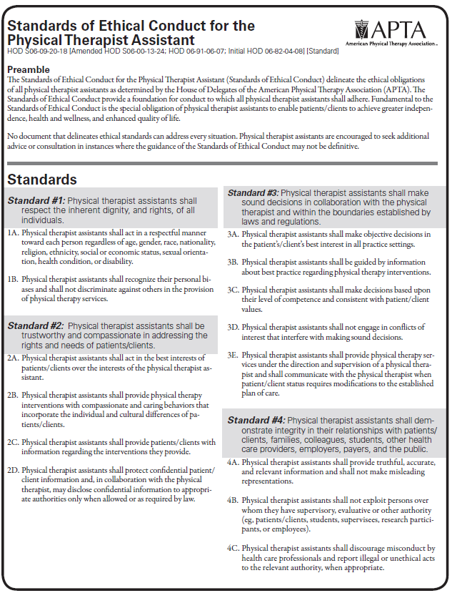

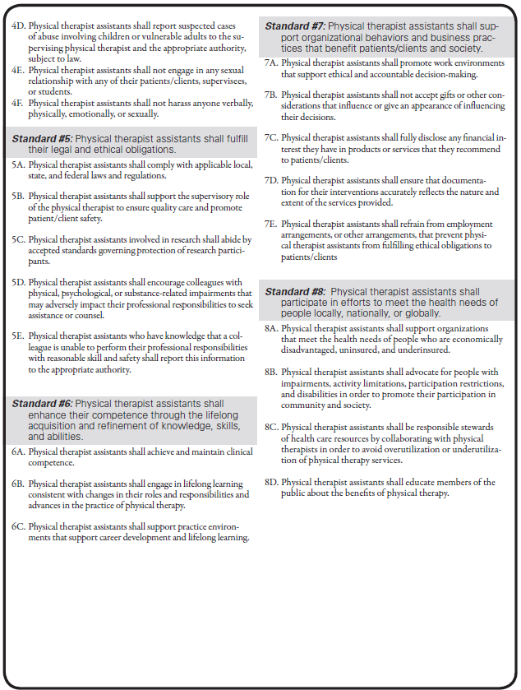

STANDARDS OF PRACTICE FOR PHYSICAL THERAPY
HOD S06‐19‐29‐50 [Amended: HOD S06‐13‐22‐15; HOD S06‐10‐09‐06; HOD S06‐03‐09‐10; HOD 06‐03‐09‐10; HOD 06‐99‐18‐22; HOD 06‐96‐16‐31; HOD 06‐91‐21‐25; HOD 06‐85‐30‐56; Initial: HOD 06‐80‐04‐04; HOD 06‐80‐03‐03] [Standard]
Preamble
The physical therapy profession is committed to transforming society by optimizing movement to improve the human experience. Physical therapists pursue excellence in a professional scope of practice that includes optimizing physical function, health, quality of life, and well‐being across the lifespan, and they work to improve population health in the communities where they practice. The American Physical Therapy Association (APTA) attests to this commitment by adopting and promoting the following Standards of Practice for Physical Therapy. These standards are the profession’s statement of conditions and performances that are essential for provision of high‐quality professional service to society, and they provide a foundation for assessment of physical therapist practice.

I. Ethical/Legal Considerations
A. Ethical Considerations
The physical therapist practices according to the APTA Code of Ethics for the Physical Therapist.

The physical therapist assistant complies with the APTA Standards of Ethical Conduct for the Physical Therapist Assistant.

B. Legal Considerations
The physical therapist complies with all the legal requirements of jurisdictions regulating the practice of physical therapy.

The physical therapist assistant complies with all the legal requirements of jurisdictions regulating the work of the physical therapist assistant.

II. Administration of the Physical Therapy Service
- Statement of Mission, Purposes, Goals, Objectives, and Scope of Services
The physical therapy service has a statement of mission, purposes, goals, objectives, and scope of services that is reviewed annually and reflects the needs and interests of the patients and clients served, the physical therapy personnel affiliated with the service, and the community.

- Organizational Plan
The physical therapy service has a written organizational plan.

The organizational plan:

  - Describes relationships among components within the physical therapy service and, where the service is part of a larger organization, between the service and the other components of that organization:
  - Ensures that a physical therapist provides the clinical direction of physical therapist services;
  - Defines supervisory structures within the service; and
  - Reflects current personnel functions.

- Policies and Procedures
The physical therapy service has written policies and procedures that are reviewed regularly and revised as necessary; reflect the operation, mission, purposes, goals, objectives, and scope of the service; are legally compliant with federal and state law; and are guided by the association’s positions, standards, guidelines, policies, and procedures.

- Administration
Guided and informed by APTA positions, standards, guidelines, policies, and procedures, the physical therapist responsible for the clinical direction of physical therapist services ensures:

  - Compliance with local, state, and federal requirements;
  - Services are provided in accordance with established policies and procedures;
  - The process for assignment and reassignment of physical therapist staff (handoff communication) supports individual physical therapist responsibility to their patients and clients and meets the needs of the patients and clients; and
  - Continuing competence of physical therapists and physical therapist assistants by providing training consistent with their respective roles.

- Fiscal Management
The physical therapist responsible for physical therapist services, in consultation with physical therapy staff and appropriate administrative personnel, participates in the planning for and allocation of resources. Fiscal planning and management of the service is based on sound accounting principles.

The fiscal management plan:

  - Includes a budget that provides for optimal use of resources; •Ensures accurate recording and reporting of financial information; •Allows for cost‐effective utilization of resources;
  - Follows billing processes that are consistent with federal regulations and payer policies, charge reasonable fees for physical therapist services, and encourage physical therapists to be knowledgeable of service fee schedules, contractual relationships, and payment methodologies; and
  - Considers options for providing pro bono services.

- Improvement of Quality of Care and Performance
The physical therapy service has a written plan for continuous improvement of quality of care and performance of services.

The improvement plan:

  - Provides evidence of ongoing review and evaluation of services; and
  - Provides a mechanism for documenting improvement in quality of care and performance and is consistent with requirements of external agencies, as applicable.

- Staffing
The physical therapy personnel affiliated with the physical therapy service have demonstrated competence, and are sufficient to achieve the mission, purposes, goals, objectives, and scope of the service.

The physical therapy service:
  - Ensures that the level of expertise within the service is appropriate to the needs of the patients and clients served, and consistent with the scope of the services provided; and
  - Provides appropriate professional and support personnel to meet the needs of the patient and client population.

- Staff Development
The physical therapy service has a written plan that provides for appropriate and ongoing staff development.

The staff development plan:

  - Includes strategies for lifelong learning and professional and career development that include self‐assessment, individual goal setting, and organizational needs;
  - Includes mechanisms to foster mentorship activities;
  - Includes information regarding evidence‐based practice and relevant clinical practice guidelines; and
  - Includes education regarding use of clinical practice guidelines, reflective reasoning, clinical reasoning, metacognition, and the value of mentoring.

- Physical Setting
The physical setting, where applicable, is designed to provide a safe and accessible environment that facilitates fulfillment of the mission, purposes, goals, objectives, and scope of the physical therapy service. It is appropriate for the number and type of patients and clients served. The equipment is safe and sufficient to achieve the purposes and goals of the physical therapy service.

- Coordination
Physical therapy personnel collaborate with all health services providers and with patients, clients, caregivers, and others as appropriate; and use a team and person‐centered approach in coordinating and providing physical therapist services.

III. Patient and Client Management
Physical therapist practice incorporates all components of evidence‐based practice, integrating best available research evidence, clinical expertise, and an individual's values and circumstances to make decisions regarding services for patients and clients, practice management, and health policy.

- Physical Therapist of Record
The physical therapist of record is the therapist who assumes responsibility for patient and client management and is accountable for the coordination, continuation, and progression of the plan of care.

- Patient and Client Collaboration
Within the patient and client management process, the physical therapist, the individual, and their caregiver(s) establish and maintain an ongoing collaborative process of decision‐making that exists throughout the provision of services and can extend over the lifespan.

- Initial Examination/Evaluation/Diagnosis/Prognosis
The physical therapist performs an initial examination and evaluation to establish a diagnosis and prognosis prior to intervention. Wellness and prevention visits or encounters may occur without the presence of disease, illness, impairments, activity limitations, or participation restrictions. Physical therapist services include the use of assessments to identify the presence of risk factors, and cognitive and environmental barriers and opportunities that may be targets for health promotion activities.

The physical therapist examination:
  - Is documented and dated by the physical therapist who performed it;
  - Identifies the physical therapy and as indicated other health needs of the patient or client;
  - Incorporates appropriate diagnostic procedures, tests, and measures to facilitate outcome measurement;
  - Produces data that are sufficient to allow evaluation, diagnosis, prognosis, and the establishment of a plan of care;
  - May result in recommendations for additional services to meet the needs of the patient or client; and
  - Includes, when appropriate and available, results from imaging, laboratory testing, and neurologic testing, to assist with clinical decision‐making.

- Plan of Care
The plan of care consists of statements that specify the goals, predicted level of optimal improvement, interventions to be used, proposed duration and frequency of the interventions that are required to reach the goals and outcomes, and plans as appropriate for referral, consultation, or co‐management with other providers.

The physical therapist involves the patient or client and appropriate others in the planning, goals and outcomes, proposed frequency and duration, and implementation of the plan of care. Consideration is given to clinical practice guidelines when they are in alignment with the patient or client diagnosis and/or prognosis.

Prevention and wellness interactions, particularly at a community level, may not require a plan of care.

- Intervention
The physical therapist provides or directs and supervises intervention consistent with results of the examination, evaluation, diagnosis, prognosis, and plan of care. Intervention is focused on optimizing functional independence, emphasizes patient or client instruction, and promotes proactive, wellness‐oriented lifestyles. It may be provided in an episode of care, or in a single visit or encounter such as for wellness and/or prevention, specialty consultation, or follow‐up after an episode of care. Services also may be provided intermittently over longer periods of time in cases of managing chronic conditions or as needed in the case of a lifelong patient or client relationship with the physical therapist.

An episode of care is the managed care provided for a specific problem or condition during a set time period. The episode can be given either for a short period or on a continuous basis, or it may consist of a series of intervals marked by 1 or more brief separations from care.

The intervention:
  - Is provided at a level that is consistent with best available evidence and current physical therapist practice;
  - Is in direct alignment with the patient’s or client’s desired outcomes and goals;
  - Is altered in accordance with changes in response or status; and
  - Is provided in such a way that directed and supervised responsibilities are commensurate with the qualifications and legal limitations of the physical therapist assistant.

- Lifelong and Long‐Term Patient and Client Relationships
Physical therapists foster and encourage lifelong and long‐term patient and client relationships. Where feasible, physical therapists, as entry‐point providers, provide services within the community that are available to patients or clients over a lifetime. Efforts are made to address movement system disorders and to maintain optimal health and wellness through physical therapist intervention as needed.

Lifelong and long‐term patient and client relationships:
  - Foster continuity of service over patients’ and clients’ lifespans by addressing changes in the movement system, health status, or disabilities as they arise;
  - Empower patients and clients to advocate for their own health;
  - Empower the physical therapist to advocate on behalf of patients and clients within the health services system; and
  - Foster identification by patients and clients that they have their own physical therapist among various health professions.

- Reexamination
The physical therapist reexamines the patient or client as necessary to evaluate progress or change in status. Reexamination may occur during an episode of care, during follow‐up visits or encounters after an episode of care, or periodically in the case of chronic care management or lifelong and long‐term relationships with patients and clients. During reexamination the physical therapist modifies the plan of care accordingly, refers the patient or client to another health services provider for consultation, or concludes the episode of care.

- Conclusion of an Episode of Care
The physical therapist concludes an episode of care when the goals and outcomes for the patient or client have been achieved, when the patient or client is unable to continue to progress toward goals, or when the physical therapist determines that the patient or client will no longer benefit from physical therapy. Conclusion of a single episode of care may not, in many settings or circumstances, signal the end of a patient or client provider relationship.

- Communication/Coordination/Documentation
The physical therapist communicates, coordinates, and documents all aspects of patient and client management including the results of the initial examination and evaluation, diagnosis, prognosis, plan of care, intervention, responses to intervention, changes in patient or client status relative to the intervention, reexamination, and episode of care summary. The physical therapist of record is responsible for “handoff” communication and follows “handoff” procedures developed by the physical therapy service. As appropriate, patient records and data are recorded using a method that allows for collective analysis.

- Co‐management/Consultation/Referral
At any point in an episode of care, or in a long‐term or lifelong physical therapist‐patient or client relationship, a physical therapist may engage in 1 or more of the following actions related to involvement of other providers in the management process. Other providers may be those in other professions and also may be physical therapist colleagues, some with advanced practice credentials or board certification in a clinical specialty.
  - Co‐management: The physical therapist shares responsibility for the individual with another professional who is also managing that individual.
  - Consultation: In some cases, the physical therapist renders professional expert opinion or advice by applying highly specialized knowledge and skills to identify problems, recommend solutions, or produce a specified outcome or product in a given amount of time on behalf of an individual. In other cases, the physical therapist seeks consultative services from another provider to inform the physical therapist plan of care and/or to obtain services for the individual that are beyond the professional or personal scope of practice of the physical therapist. In these cases, the physical therapist shares responsibility for the individual with the consultant.
  - Referral: The physical therapist may:
- Refer an individual to another provider and either conclude care or not develop a plan of care;
- Refer an individual to another provider and continue the plan of care at the same time;
- Receive an individual referred from another provider who chooses not to continue services for the individual; or
- Receive an individual from another provider who continues to provide services to the individual (if the physical therapy episode of care is ongoing, the physical therapist shares responsibility for the individual).

IV. Education
The physical therapist is responsible for individual professional development. The physical therapist assistant is responsible for individual career development.
  - The physical therapist and the physical therapist assistant, under the direction and supervision of the physical therapist, participate in the education of peers, other health services providers, and students.
  - The physical therapist educates and provides consultation to consumers and the general public regarding the purposes and benefits of physical therapy.
  - The physical therapist educates and provides consultation to consumers and the general public regarding the roles of the physical therapist and the physical therapist assistant.

V. Advocacy
The physical therapist and the physical therapist assistant will participate in advocacy for patients’ and clients’ rights with respect to:
  - Physical therapy being an entry‐point for patients into the health services system;
  - Physical therapists serving in primary care roles;
  - Appropriate access to needed health services including physical therapist services; and
  - Communities creating safe and accessible built environments, where population health is a priority.

VI. Research
The physical therapist applies research findings to practice and encourages, participates in, and promotes activities that establish the outcomes of patient and client management provided by the physical therapist.

The physical therapist:
  - Remains current in their knowledge of literature related to practice;
  - Protects the rights of research subjects and maintains the integrity of research;
  - Participates in research as appropriate to individual education, experience, and expertise;
  - Educates physical therapists, physical therapist assistants, students, other health professionals, and the general public about new evidence from research and the outcomes of physical therapist practice; and
  - Accesses and translates knowledge in support of clinical decisions, and uses literature based on its quality and appropriateness.

VII. Community Responsibility
The physical therapist demonstrates community responsibility by participating in community and community agency activities, educating the public, formulating public policy, and providing pro bono physical therapist services.

Explanation of Reference Numbers:
HOD P00‐00‐00‐00 stands for House of Delegates/month/year/page/vote in the House of Delegates
Last Updated: 9/20/19 Contact: nationalgovernance@apta.org

Physical Therapist Assistant Program

CLINICAL EDUCATION FORMS

COMMUNITY COLLEGES OF SPOKANE
SPOKANE FALLS COMMUNITY COLLEGE
PROFESSIONAL/TECHNICAL DIVISION

AFFILIATION/FIELDWORK AGREEMENT

Physical Therapist Assistant
Occupational Therapy Assistant

This Agreement is made and entered into between Community Colleges of Spokane, Spokane Falls Community College, (“School”), located at Spokane, Washington, and _______________ (“Training Site”), located at _________________________. The purpose of this Agreement is for Training Site, which is committed to training health care professionals, to provide desirable clinical learning experiences and facilities for School’s students who are enrolled in its Physical Therapist Assistant Program and/or Occupational Therapy Assistant Program (the "education program"). In consideration of the mutual covenants and agreements contained herein, School and Training Site agree as follows:

I. GENERAL PROVISIONS

A. School and Training Site agree that contemporaneous with or following execution of this Agreement and within the scope of its provisions, School may develop letter agreements with Training Site to formalize operational details of the clinical education program. These details include, but are not limited to, the following:

- Beginning dates and length of experience (to be mutually agreed upon at least one month before the beginning of the clinical education program);
- Number of students eligible to participate in the clinical education program;
- Specific days, hours and locations for the clinical education program;
- Specific learning objectives and performance expectations for students;
- Specific allocation of responsibilities for the faculty Liaison, clinical education Supervisor, and Preceptors, if any, referenced elsewhere in this Agreement;
- Deadlines and format for student progress reports and evaluation forms.

Any such letter agreements will be considered to be attachments to this Agreement will be binding when signed by authorized representatives of each party, and may be modified by subsequent letter agreements signed by authorized representatives of each party.

B. School and Training Site will jointly plan the clinical education program and jointly evaluate students. Exchange of information will be maintained by on-site visits when practical and by letter or telephone in other instances.

C. School and Training Site will instruct their respective faculty, staff, and students participating in the clinical education program, to maintain confidentiality of student and patient information as required by law and by the policies and procedures of School and Training Site.

D. There will be no payment of charges or fees between School and Training Site.

E. There will be no discrimination against any program participant or applicant covered under this Agreement because of race, color, religion, national origin, age, handicap, status as a Vietnam era or disabled veteran, sex, or sexual orientation, nor will School or Training Site engage in such discrimination in their employment or personnel policies.

1. The School adheres to and complies with Section 504 of the Rehabilitation Act of 1973 and the Americans with Disabilities Act of 1990;

2. The School supports the right of students to be free from discrimination based on disability and to reasonable accommodation during clinical rotation;

3. The School will participate in an interactive process with any Training Site and students with disabilities to reach an individualized determination regarding reasonable accommodations that may be appropriate and necessary and the provision of such accommodations; and

4. The School does not approve or support clinical participation by its students at Training Sites that have a policy or practice of discriminating based on disability against clinical students who are otherwise qualified for the college program in which they are enrolled.

II. SCHOOL’S RESPONSIBILITIES

A. School will provide information to Training Site concerning its curriculum and the professional and academic credentials of its faculty for the students at Training Site. School will designate an appropriately qualified and credentialed faculty member to coordinate and act as the Liaison with Training Site. School will be responsible for instruction and administration of the students’ academic education program. School will notify Training Site in writing of any change or proposed change of its Liaison. School will have the final responsibility for grading students.

B. School’s faculty will meet with the Training Site clinical education Supervisor Preceptors, if any, at the beginning and end of the clinical education program to discuss and evaluate the clinical education program. These meetings will take place in person if practicable, otherwise by telephone conference. School is responsible for arranging and planning the meetings.

C. School will provide the names and information pertaining to relevant education and training for all students enrolled in the clinical education program at least two weeks before the beginning date of the clinical education program. School is responsible for supplying any additional information required by Training Site as set forth in this Agreement, prior to the arrival of students. School will notify Training Site in writing of any change or proposed change in a student’s status.

D. School will obtain evidence of current immunizations against diphtheria, tetanus, measles (rubeola), mumps, rubella (or a positive rubella titer), and of hepatitis B immunization status for those students who will be in contact with patients/clients. For each student born after 1956, School will maintain on file records of positive titer or of post-1967 immunization for rubella and rubeola. At the time of immunization, students with no history of exposure to chicken pox will be advised to get an immune titer. School will require yearly PPD testing or follow-up as recommended if the students are PPD-positive or have had BCG. School will provide information to Training Site regarding student status concerning the above requirements.

E. School will assign to Training Site only those students who have satisfactorily completed the prerequisite didactic portion of the curriculum and who have current CPR certification.

F. School shall obtain the written authorization of each student who may be placed in Training Site to obtain his/her criminal history background record from the Washington State Patrol, pursuant to RCW 43.43.834 and RCW 43.43.838 and determine, in consultation with the training site if needed, whether the student is eligible to participate in the clinical learning experience at the training site. Training Site may conduct the background inquiry directly and the Training Site may refuse placement of a student who has a record of prior criminal conduct.

Training Site understands and agrees that the School shall not allow any student to attend clinical that has not met this requirement. School does not certify the veracity of the records provided and, furthermore, the obligation to conduct appropriate background checks and the liability for non-compliance therewith remains the responsibility of Training Site.

G. School will comply with and ensure to the extent possible that students comply with the policies and procedures established by Training Site. School will notify each student of his/her status and responsibilities pursuant to this Agreement.

H. School will encourage each student participating in the clinical education program to acquire comprehensive health and accident insurance that will provide continuous coverage of such student during his or her participation in the education program. School will inform students that they are responsible for their own health needs, health care costs, and health insurance coverage.

III. TRAINING SITE’S RESPONSIBILITIES

A. Training Site will provide students with a desirable clinical education experience within the scope of health care services provided by Training Site. Training Site will designate in writing Preceptors, if any, to be responsible for the clinical education program, and will designate in writing one person as the clinical education Supervisor, who will maintain contact with the School-designated Liaison to assure mutual participation in and review of the clinical education program and student progress. Training Site will submit in writing to School the professional and academic credentials for the Preceptors and clinical education Supervisor. Training Site will notify School in writing of any change or proposed change of the Preceptors or clinical education Supervisor.

B. Training Site will provide students with access to sources of information necessary for the education program, within Training Site’s policies and procedures and commensurate with patients’ rights, including library resources and reference materials.

C. Training Site will make available to students basic supplies and equipment necessary for care of patients/clients and the clinical education program. Within the limitation of facilities, Training Site will make available office and conference space for students and, if applicable, School faculty.

D. Training Site will submit required reports on each student’s performance and will provide an evaluation to School on forms provided by School.

E. Training Site retains full responsibility for the care of patients/clients, and will maintain the quality of patient care without relying on the students’ clinical training activities for staffing purposes.

F. Training Site will have the right to take immediate temporary action to correct a situation where a student’s actions endanger patient care. As soon as possible thereafter, Training Site’s clinical education Supervisor will notify School of the action taken. All final resolutions of the student’s academic status in such situations will be made solely by School after reviewing the matter and considering whatever written factual information Training Site provides for School; however, Training Site reserves the right to terminate the use of its facilities by a particular student where necessary to maintain its operation free of disruption and to ensure quality of patient care.

G. On any day when a student is participating in the clinical education program at its facilities, Training Site will provide to such student necessary emergency health care or first aid for accidents occurring in its facilities. Financial responsibility for such emergency care, including care described elsewhere in this Agreement, will be as follows:

- Training Site will not bill students for the cost of initial emergency care;
- At the student’s expense, Training Site will provide follow-up care, testing and counseling, including HIV testing, and counseling associated with that testing, in the absence of any similar service being immediately available from School’s health services;
- The student will be responsible for the costs of any and all such follow-up care, testing and counseling.

H. Except as provided in this Agreement, Training Site will have no obligation to furnish medical or surgical care to any student.

IV. STUDENTS’ STATUS AND RESPONSIBILITIES

A. Students will have the status of learners and will not replace Training Site personnel. Any service rendered by students is incidental to the educational purpose of the clinical education program.

B. Students are required to adhere to the standards, policies, and regulations of Training Site during their clinical education program.

C. Students will wear appropriate attire and name tags, and will conform to the standards and practices established by School during their clinical education program at Training Site.

D. Students assigned to Training Site will be and will remain students of School, and will in no sense be considered employees of Training Site. Training Site does not and will not assume any liability under any law relating to Worker’s Compensation on account of any School student’s performing, receiving training, or traveling pursuant to this Agreement. Students will not be entitled to any monetary or other remuneration for services performed by them at Training Site, nor will Training Site otherwise have any monetary obligation to School or its students by virtue of this Agreement.

V. LIABILITY COVERAGE PROVISIONS

A. Each party to this agreement will be responsible for the negligent acts or omissions of its own employees, officers, or agents in the performance of this Agreement. Neither party will be considered the agent of the other and neither party assumes any responsibility to the other party for the consequences of any act or omission of any person, firm, or corporation not a party to this Agreement

B. School is covered by the State of Washington Self-Insurance Program and the Tort Claims Act (Chapter 4.92 RCW). Claims against School and its employees and officers in the performance of their duties under this Agreement will be paid from the tort claims liability account as provided in Chapter 4.92 RCW. In order to be accepted at the Training Site, students will be required to have medical malpractice and general liability coverage, whether through the student medical malpractice and general liability policies offered by the State of Washington, Office of Financial Management, Risk Management division, or otherwise, while working in the Training Site.

C. Training Site maintains professional liability insurance coverage with __________ [insurance company]. Through that coverage, Training Site provides liability coverage for its employees, officers, and agents in the performance of this Agreement, and further provides the means for defense and payment of claims that may arise against such individuals.

VI. TERM

A. This Agreement is effective beginning the date of signature, and will continue thereafter from year to year. This agreement will be reviewed no later than three years from its effective date, or earlier at the request of either party. School and Training Site will jointly plan student placement in advance of each year’s beginning taking into account the needs of the school for clinical placement, maximum number of students for whom Training Site can provide a desirable clinical education experience, and the needs of other disciplines or schools requesting clinical placements.

B. This agreement may be canceled by written notice one year prior to termination; however, such termination shall not become effective for the students then enrolled in the clinical education program if such termination prevents completion of their requirements for completion of the clinical education program.

VII. PROVISIONS REGARDING BLOOD-BORNE PATHOGENS

A. School certifies that it has trained each student it sends to Training Site in universal precautions and transmission of blood-borne pathogens, and that it will send to Training Site only students who have been trained in and have practiced using universal precautions. School has provided the opportunity to receive Hepatitis B (HBV) vaccine to all clinical education program students before assignment to Training Site. Training Site will provide personal protection equipment that is appropriate for the tasks assigned to School’s students.

B. In the event a student sustains a needle-stick injury or other substantial exposure to bodily fluids of another or other potentially infectious material while participating in the clinical education program at Training Site, Training Site agrees to provide the following services:

- Being seen by Training Site’s employee health service and/or emergency department as soon as possible after the injury;
- Emergency medical care following the injury;
- Initiation of HBV, Hepatitis C (HCV) and HIV protocol;
- HIV counseling and appropriate testing.

C. The source patient’s HBV, HCV and HIV status will be determined by Training Site in the usual manner to the extent possible. Training Site does not accept liability for any illness or injury subsequent to such accidental exposure, except as otherwise provided in this Agreement.

VIII. MISCELLANEOUS PROVISIONS

A. Entire Agreement. This Agreement constitutes the entire agreement between the parties, and supersedes all prior oral or written agreements, commitments, or understandings concerning the matters provided for herein.

B. Amendment. This Agreement may be modified only by a subsequent written Agreement executed by the parties. The provisions in this Agreement may not be modified by any attachment or letter agreement as described elsewhere in this Agreement.

C. Order of Precedence. Any conflict or inconsistency in this Agreement and its attachments will be resolved by giving the documents precedence in the following order:

- This Agreement;
- Attachments to this Agreement in reverse chronological order.

D. Governing Law. The parties’ rights or obligations under this Agreement will be construed in accordance with, and any claim or dispute relating thereto will be governed by, the laws of the State of Washington.

E. Notices. All notices, demands, requests, or other communications required to be given or sent by School or Training Site, will be in writing and will be mailed by first-class mail, postage prepaid, or transmitted by hand delivery or facsimile, addressed as follows:

(a) To School:
Chris Pelchat, Dean
Professional Studies, Library, and Workforce Education
Spokane Falls Community College
3410 W Whistalks Way MS 3190
Spokane WA 99224-5288

(b) To Training Site:

__________________________________________

__________________________________________

__________________________________________

__________________________________________

Each party may designate a change of address by notice in writing. All notices, demands, requests, or communications that are not hand-delivered will be deemed received three (3) days after deposit in the U.S. mail, postage prepaid; or upon confirmation of successful facsimile transmission.

F. Survival. School and Training Site expressly intend and agree that the liability coverage provisions of this Agreement will survive the termination of this Agreement for any reason.

G. Severability. If any provision of this Agreement, or of any other agreement, document or writing pursuant to or in connection with this Agreement, shall be held to be wholly or partially invalid or unenforceable under applicable law, said provision will be ineffective to that extent only, without in any way affecting the remaining parts or provisions of said agreement.

H. Waiver. Neither the waiver by any of the parties hereto of a breach of or a default under any of the provisions of this Agreement, nor the failure of either of the parties, on one or more occasions, to enforce any of the provisions of this Agreement or to exercise any right or privilege hereunder, will thereafter be construed as a waiver of any subsequent breach or default of a similar nature, or as a waiver of any of such provisions, rights or privileges hereunder.

I. Inspection. Training Site will permit, on reasonable notice and request, the inspection of clinical and related facilities by agencies charged with responsibility for accreditation of School.

J. HIPAA. School shall direct its trainees to comply with the policies and procedures of Training Site, including those governing the use and disclosure of individually identifiable health information under federal law, specifically 45 CFR parts 160 and 164. Solely for the purpose of defining the trainees’ role in relation to the use and disclosure of Training Site’s protected health information, the trainees are defined as members of the Training Site’s workforce, as that term is defined by 45 CFR 160.103, when engaged in activities pursuant to this Agreement. However, the trainees are not and shall not be considered to be employees of the Training Site.

SPOKANE FALLS COMMUNITY COLLEGE  _____________________________________  Chris Pelchat, Dean  Professional Studies, Library, & Workforce Education  _____________________________________  date | _____________________________________  name of training site  _____________________________________  signature  _____________________________________  training site contact  _____________________________________  contact title  _____________________________________  date
Approved as to form by the:
Assistant Attorney General
Attorney for College
Revised 01-22-2010

ABSENCES FROM CLINIC

If you are ill and unable to attend your clinical rotation it is imperative that you contact your Clinical Instructor before your clinic begins, as well as notifying Megan Guthrie-Martinez (509-279-6249).

After you return to clinic it is your responsibility to discuss with your CI when you will be able to make up the lost time. Missed clinics must be made up before the end of your current rotation. After you have finished your make-up clinic, complete this form, get your CI’s signature, and turn it in to Megan Guthrie-Martinez.

I missed clinic(s) on the following date(s):
(include information on any day that you had to leave early or show up late)

____________________________ ____________________________

____________________________ ____________________________

I made up the clinic(s) that I missed on the following date(s):

____________________________ ____________________________

____________________________ ____________________________

Name: ____________________________ Name of CI: ______________________

Signature: _________________________ CI Signature: ______________________

Date: _____________________________ Date: ____________________________

Be sure to turn this form in as soon as you have made up the clinic time and before the end of your current rotation. Any questions? Call Megan Guthrie-Martinez 509-279-6249

SPOKANE FALLS COMMUNITY COLLEGE
Physical Therapist Assistant Program

REMEDIATION PLAN

Causes leading to a “Remediation Plan” include the following:
- Three lab or lecture exams failures or any combination thereof during their two years in the program. (A lab exam which requires a retake is considered a failed exam.)
- An extension of a clinical due to unsatisfactory performance.
- A pattern of unprofessional conduct

STUDENT NAME:

Reason for Conference:

Discussion Items:

Remedial Plan:

Student Comments:

I, _____________________________________________, acknowledge that I am responsible for completing the remedial plan, that this contract is designed to raise my performance to an acceptable standard for the profession, and that this document will be a permanent part of my confidential student record in the PTA program, that the consequences of unsatisfactory completion of the remedial plan will result in a Notice of Probation which is a response to the following:
- Combination of the three test failures & a clinical extensions and/or a pattern of unprofessional conduct
- Four test failures while in the program
- An extension of a two clinicals due to unsatisfactory performance
- Continued documented unprofessional conduct after the remediation plan has been set in place.

Student Signature: ____________________________________ Date: __________________

Program Director Signature: _____________________________ Date: __________________

Faculty Signature: _____________________________________ Date: __________________

Witness (if indicated): __________________________________ Date: __________________
SPOKANE FALLS COMMUNITY COLLEGE
Physical Therapist Assistant Program

NOTICE OF PROBATION

Causes leading to a “Notice of Probation” include the following:
- Combination of the three test failures & a clinical extensions and/or a pattern of unprofessional conduct
- Four test failures while in the program
- An extension of a two clinicals due to unsatisfactory performance
- Continued documented unprofessional conduct after the remediation plan has been set in place.

STUDENT NAME:

Reason for Conference:

Discussion Items:

Student Comments:

I, _____________________________________________, acknowledge and understand I am responsible for satisfactory completion as assessed by the instructor and program director, that the consequences of unsatisfactory completion of the notice of probation will result in dismissal from the program, that this contract is designed to raise my performance to an acceptable standard for the profession, and that this document will be a permanent part of my confidential student record in the PTA program. Dismissal* from the PTA Program will occur for the following reasons:
- Combination of the four test failures & a clinical extension &/or a pattern of unprofessional conduct
- A need for two clinical extensions
- Failure of a PTA course
- Failure of a clinical rotation
- Five test failures while in the program
- Continued documented unprofessional conduct after the student is placed on Probationary Status

Student Signature: ____________________________________ Date: __________________

Program Director Signature: _____________________________ Date: __________________

Faculty Signature: _____________________________________ Date: __________________

Witness (if indicated): __________________________________ Date: __________________

*Please note that dismissal from the program does not constitute dismissal from the institution.
Students who are dismissed from the program may appeal the decision by utilizing the Student Concerns Process.

STUDENT EVALUATION, PTA 151

Student _________________________ Facility __________________________

Clinical Instructor _______________________ Clinical Dates ____________________

Students should have the laboratory skills check-off lists from PTA 170, PTA 171, PTA 172, and PTA 173 in their clinical education notebook. Students may be allowed to assist the clinical instructor in patient preparation and treatment application by mutual agreement and at the CI’s discretion. The following assessment is based on the Clinical Performance Instrument.

KEY: NA = Not Applicable NI = Needs Improvement S = Satisfactory
Rating | Items
NA NI S | Safety: Ensures the safety of patient, self, and others throughout the clinical interaction. Uses acceptable techniques for safe handling of patients. Establishes and maintains safe working environment. Requests assistance when necessary.
NA NI S | Clinical Behaviors: Demonstrates initiative (eg, arrives well prepared, offers assistance, seeks learning opportunities). Is punctual and dependable. Wears attire consistent with expectations of the work setting and PTA Program. Responds to unexpected changes in the patient’s schedule and facility’s requirements.
NA NI S | Clinical Behaviors: Demonstrates integrity in all interactions. Exhibits caring, compassion, and empathy in providing services to patients. Maintains patient privacy and modesty. Values the dignity of patients as individuals.
NA NI S | Clinical Behaviors: Maintains productive working relationships with clinical instructor Accepts feedback without defensiveness. Manages conflict in constructive ways. Seeks feedback from clinical instructor related to clinical performance. Demonstrates behaviors that contribute to a positive work environment.
NA NI S | Accountability: Places patient’s needs above self-interests. Maintains patient confidentiality. Strives to exceed the minimum performance and behavioral requirements.
NA NI S | Accountability: Identifies, acknowledges, and accepts responsibility for actions and reports errors. Identifies ethical or legal concerns. Adheres to ethical standards.
NA NI S | Accountability: Abides by policies and procedures of the facility (eg, OSHA, HIPAA). Adheres to legal standards including all federal, state/province, and institutional regulations related to patient care and fiscal management.
NA NI S | Cultural Competence: Incorporates an understanding of the implications of individual and cultural differences and adapts behavior accordingly in all aspects of physical therapy services. Communicates effectively and with sensitivity with diverse patient populations.
NA NI S | Communication: Communicates with clinical instructor and supervising physical therapist. Communicates verbally, nonverbally, and in writing in an effective, respectful, and timely manner. Selects the most appropriate person(s) with whom to communicate (eg, clinical instructor, physical therapist).
NA NI S | Communication: Listens actively and attentively to understand what is being communicated by others. Interprets and responds appropriately to the nonverbal communication of others.
NA NI S | Documentation: Selects relevant information to document the delivery of physical therapy care.
NA NI S | Interventions and Data Collection: Demonstrates knowledge of rationale for interventions and data collection methods identified in the plan of care from previous coursework through discussions with CI.

Briefly comment on your perception of the student at this point of their education:

___________________________________________________________________________

___________________________________________________________________________

___________________________________________________________________________

In summary, highlight the student’s experiences and strengths:
___________________________________________________________________________

___________________________________________________________________________

___________________________________________________________________________

What recommendations would you make to this student to address in the next clinical experiences: ___________________________________________________________________________

___________________________________________________________________________

___________________________________________________________________________

__________________________________________ _______________________
Student’s Signature Date

__________________________________________ _______________________
Clinical Instructor’s Signature Date

Adapted from http://www.apta.org/PTACPI with permission of the American Physical Therapy Association.
Copyright © 2008 American Physical Therapy Association. All rights reserved.

CI Instructions Clinical Forms PTA 151
- APTA Clinical Experience and Clinical Instruction packet (Salmon) – please complete the General Information (first page), including signatures with the most recent employment information, APTA membership, credentialed Clinical instructor (taken course) or advanced proficiencies.
These are required by CAPTE annually.

- Student Evaluation, PTA 151 (Blue) - This is the only assessment tool for the student experience. The Clinical Performance Instrument (CPI) is a benchmark for entry level practice, some students will meet these early on and others will take them to graduation date. If the student performed a task at beginner level, please report an (S) for satisfactory or if not observed an (NA). I understand Needs Improvement (NI) will occur during rotations but please reserve this category for more serious offense as all of us could improve on our skills. I would expect a phone call or email if you mark 3 or more criteria needs improvement. The last page asks you to briefly highlight the student and give some recommendations for improvement. Please complete the assessment separately and plan to review with the student at the end of your rotation together for debriefing. Please sign all forms prior to the student leaving your site.

- Absence - If the student is absent from a clinical day SFCC has a policy and form to be completed. Policy states: Attendance: Refer to program attendance policy. Remember that you must call in to the clinical instructor, the DCE and the program assistant if you are going to be absent for any reason please leave an email or phone message if unable to make immediate contact. You must make up any missed clinical education time at the convenience of the clinical instructor. If you are ill, exercise good judgment about exposure to others. You are expected to report to the clinic assignment at the designated time and be ready to work. Don’t be late. Do not take or make personal phone calls/texts while on assignment or allow unauthorized visits.
If a clinical experience must be rescheduled for a medical reason, the student will be asked to provide to the program a written release from a physician prior to consideration for rescheduling of the clinical. Time of any re-scheduled clinical experience due to medical or personal reasons that falls outside the scheduled quarter will be scheduled at the discretion of the DCE and Dean and availability of clinical sites.

- Probation - SFCC has a policy and form for clinical rotations. Policy states: An extension of a clinical due to unsatisfactory performance or a pattern of unprofessional conduct will lead to a probation contract.
- Dismissal while Failing: If the student demonstrates one or more of the following conditions, dismissal from the clinical experience will occur and a failing grade will be recorded.
  - Does not meet competencies or expectations as described in the Clinical Performance Instrument (CPI) and the Guide of Conduct for Clinical Experiences.
  - Receives a non-satisfactory (failing) final evaluation from the DCE.
  - Does not attend the clinical experience.
  - Violation of the Student Code of Conduct and CCS Policies
  - Violation of the Standards of Ethical Conduct for the Physical Therapist Assistant.
  - Violations of the policies or procedures of the clinical facility

SPOKANE FALLS COMMUNITY COLLEGE
Physical Therapist Assistant Program

STUDENT EVALUATION, PTA 251

Student _________________________ Facility __________________________

Instructor ___________________________ Academic Year ____________________

Students should have the laboratory skills check-off lists from PTA 170, PTA 171, PTA 172, PTA 173, PTA 270 and PTA 272, in their clinical education manual. Students should be involved with patient interventions and data collection during this clinical experience. The following assessment is based on the Clinical Performance Instrument.

NA = Not Applicable NI = Needs Improvement S = Satisfactory
NA NI S | Safety: Ensures the safety of patient, self, and others throughout the clinical interaction. Uses acceptable techniques for safe handling of patients. Establishes and maintains safe working environment. Requests assistance when necessary.
NA NI S | Clinical Behaviors: Demonstrates initiative (eg, arrives well prepared, offers assistance, seeks learning opportunities). Is punctual and dependable. Wears attire consistent with expectations of the work setting and PTA Program. Responds to unexpected changes in the patient’s schedule and facility’s requirements.
NA NI S | Clinical Behaviors: Demonstrates integrity in all interactions. Exhibits caring, compassion, and empathy in providing services to patients. Maintains patient privacy and modesty. Values the dignity of patients as individuals.
NA NI S | Clinical Behaviors: Maintains productive working relationships with clinical instructor Accepts feedback without defensiveness. Manages conflict in constructive ways. Seeks feedback from clinical instructor related to clinical performance. Demonstrates behaviors that contribute to a positive work environment.
NA NI S | Accountability: Places patient’s needs above self-interests. Maintains patient confidentiality. Strives to exceed the minimum performance and behavioral requirements.
NA NI S | Accountability: Identifies, acknowledges, and accepts responsibility for actions and reports errors. Identifies ethical or legal concerns. Adheres to ethical standards.
NA NI S | Accountability: Abides by policies and procedures of the facility (eg, OSHA, HIPAA). Adheres to legal standards including all federal, state/province, and institutional regulations related to patient care and fiscal management.
NA NI S | Cultural Competence: Incorporates an understanding of the implications of individual and cultural differences and adapts behavior accordingly in all aspects of physical therapy services. Communicates effectively and with sensitivity with diverse patient populations.
NA NI S | Cultural Competence: Is aware of own social and cultural biases and does not allow biases to negatively impact patient care. Demonstrates an understanding of the socio-cultural, psychological, and economic influences on patients and responds accordingly
NA NI S | Communication: Communicates with clinical instructor and supervising physical therapist. Communicates verbally, nonverbally, and in writing in an effective, respectful, and timely manner. Selects the most appropriate person(s) with whom to communicate (eg, clinical instructor, physical therapist).
NA NI S | Communication: Listens actively and attentively to understand what is being communicated by others. Interprets and responds appropriately to the nonverbal communication of others.
 | Communication: Adjusts style of communication based on target audience. Communicates with the patient using language the patient can understand.
NA NI S | Self-Assessment and Lifelong Learning: Identifies strengths and limitations in clinical performance, including knowledge, skills, and behaviors. Seeks out additional learning experiences to enhance clinical performance. Seeks current knowledge and theory to achieve optimal patient care.
NA NI S | Clinical Problem Solving: Presents sound rationale for clinical problem solving. Seeks clarification of plan of care and selected interventions. Collects and compares data from multiple sources (chart review, patient).
NA NI S | Clinical Problem Solving: Demonstrates sound clinical decisions within the plan of care to assess and maximize patient safety, comfort, and patient progression while performing selected interventions.

INTERVENTIONS
P = Student performed skill O = Student observed skill N/A = Skill not available at this setting
THERAPEUTIC EXERCISE
P O N/A | Aerobic capacity/endurance conditioning/reconditioning
P O N/A | Balance, coordination, and agility training
P O N/A | Body mechanics and postural stabilization
P O N/A | Flexibility exercises
P O N/A | Gait and locomotion training
P O N/A | Neuromotor development training
P O N/A | Relaxation
P O N/A | Strength, power, and endurance training
THERAPEUTIC TECHNIQUES
Manual Therapy Techniques Including:
P O N/A | Massage – connective tissue and therapeutic
P O N/A | Passive range of motion
Breathing Strategies/Oxygenation Including:
P O N/A | Breathing techniques (eg, pursed lip breathing, paced breathing)
P O N/A | Re-positioning to alter work of breathing and maximize ventilation and perfusion
P O N/A | Administration of prescribed oxygen
Integumentary Repair/Protection Including:
P O N/A | Wound cleansing and dressing
P O N/A | Repositioning
P O N/A | Patient education
P O N/A | Edema management
PHYSICAL AGENTS AND MECHANICAL MODALITIES
Physical Agents Including:
P O N/A | Cryotherapy (eg, cold pack, ice massage, vapocoolant spray)
P O N/A | Thermotherapy (eg, dry heat, hot packs, paraffin baths, hydrotherapy)
P O N/A | Ultrasound
Mechanical Modalities Including:
P O N/A | Mechanical compression, compression bandaging and garments
P O N/A | Mechanical motion devices (eg, CPM)
P O N/A | Intermittent, positional, and sustained traction devices
ELECTROTHERAPEUTIC MODALITIES
Electrotherapeutic Modalities Including:
P O N/A | Biofeedback
P O N/A | Iontophoresis
P O N/A | Electrical stimulation for muscle strengthening
P O N/A | Electrical stimulation for tissue repair
P O N/A | Electrical stimulation for pain management
FUNCTIONAL TRAINING AND APPLICATION OF DEVICES AND EQUIPMENT
Functional Training Including:
 | ADL training – specifically:
P O N/A | Transfers
P O N/A | Bed mobility
P O N/A | Device and equipment use and training
P O N/A | Injury prevention or reduction
Application/Adjustment of Devices/Equipment Including:
P O N/A | Adaptive devices
 | Assistive devices including:
P O N/A | Cane
P O N/A | Crutches
P O N/A | Walkers
P O N/A | Wheelchairs
P O N/A | Long handled reachers
P O N/A | Orthotic devices (eg, braces, splints)
P O N/A | Prosthetic devices – upper and lower extremity
P O N/A | Protective devices (eg, braces)
P O N/A | Supportive devices (eg, compression garments, wraps, neck collars, slings, O² equip)

DATA COLLECTION
P = Student performed skill O = Student observed skill N/A = Skill not available at this setting
P O N/A | Anthropometric characteristics
P O N/A | Arousal, attention, and cognition
P O N/A | Assistive and adaptive devices
P O N/A | Body mechanics
P O N/A | Environmental, self-care, and home issues
P O N/A | Gait, locomotion, and balance
P O N/A | Muscle function
P O N/A | Neuromotor function
P O N/A | Pain
P O N/A | Posture
P O N/A | Range of motion
P O N/A | Vital signs
P O N/A | Integumentary integrity

NA = Not Applicable NI = Needs Improvement S = Satisfactory
NA NI S | Documentation: Selects relevant information to document the delivery of physical therapy care. Documents all aspects of physical therapy care provided, including interventions, patient response to interventions. Produces documentation that is accurate, concise, timely, legible, grammatically and technically correct.
NA NI S | Resource Management: Uses time effectively. Uses equipment in an efficient and effective manner assuring that the equipment is safe prior to use.

Highlight the student’s experiences and strengths: _______________________________

___________________________________________________________________________

___________________________________________________________________________

___________________________________________________________________________

What recommendations would you make for this student to address in their next clinical experience: _________________________________________________________________

___________________________________________________________________________

___________________________________________________________________________

___________________________________________________________________________

__________________________________________ _______________________
Student’s Signature Date

__________________________________________ _______________________
Clinical Instructor’s Signature Date

Adapted from http://www.apta.org/PTACPI with permission of the American Physical Therapy Association.
Copyright © 2008 American Physical Therapy Association. All rights reserved.

CI Instructions Clinical Forms PTA 251
- APTA Clinical Experience and Clinical Instruction packet (Salmon) – please complete the General Information (first page), including signatures with the most recent employment information, APTA membership, credentialed Clinical instructor (taken course) or advanced proficiencies.
These are required by CAPTE annually.

- Student Evaluation, PTA 251 (Blue) - This is the only assessment tool for the student experience. The Clinical Performance Instrument (CPI) is a benchmark for entry level practice, some students will meet these early on and others will take them to graduation date. If the student performed a task at advanced beginner to intermediate level please report an (S) for satisfactory or if not observed an (NA). I understand Needs Improvement (NI) will occur during rotations but please reserve this category for more serious offense as all of us could improve on our skills. I would expect a phone call or email if you mark 3 or more criteria needs improvement. The intervention criteria require either the student performed the skill (P), students observed the skill (O) or not available (NA). The last page asks you to briefly highlight the student and give some recommendations for improvement. Please complete the assessment separately and plan to review with the student at the end of your rotation together for debriefing. Please sign all forms prior to the student leaving your site.

- Absence - If the student is absent from a clinical day SFCC has a policy and form to be completed. Policy states: Attendance: Refer to program attendance policy. Remember that you must call in to the clinical instructor, the DCE and the program assistant if you are going to be absent for any reason please leave an email or phone message if unable to make immediate contact. You must make up any missed clinical education time at the convenience of the clinical instructor. If you are ill, exercise good judgment about exposure to others. You are expected to report to the clinic assignment at the designated time and be ready to work. Don’t be late. Do not take or make personal phone calls/texts while on assignment or allow unauthorized visits.
If a clinical experience must be rescheduled for a medical reason, the student will be asked to provide to the program a written release from a physician prior to consideration for rescheduling of the clinical. Time of any re-scheduled clinical experience due to medical or personal reasons that falls outside the scheduled quarter will be scheduled at the discretion of the DCE and Dean and availability of clinical sites.

- Probation - SFCC has a policy and form for clinical rotations. Policy states: An extension of a clinical due to unsatisfactory performance or a pattern of unprofessional conduct will lead to a probation contract.

- Dismissal while Failing: If the student demonstrates one or more of the following conditions, dismissal from the clinical experience will occur and a failing grade will be recorded.
  - Does not meet competencies or expectations as described in the Clinical Performance Instrument (CPI) and the Guide of Conduct for Clinical Experiences.
  - Receives a non-satisfactory (failing) final evaluation from the DCE.
  - Does not attend the clinical experience.
  - Violation of the Student Code of Conduct and CCS Policies
  - Violation of the Standards of Ethical Conduct for the Physical Therapist Assistant.
  - Violations of the policies or procedures of the clinical facility

Last Updated: 09/14/2011
Contact: pta@apta.org

APTA PTA STUDENT EVALUATION:

CLINICAL EXPERIENCE AND CLINICAL INSTRUCTION

June 10, 2003
(updated 9/14/11)

American Physical Therapy Association
Department of Physical Therapy Education
1111 North Fairfax Street
Alexandria, Virginia 22314

PREAMBLE
The purpose of developing this tool was in response to academic and clinical educators’ requests to provide a voluntary, consistent and uniform approach for students to evaluate clinical education as well as the overall clinical experience. Questions included in this draft tool were derived from the many existing tools already in use by physical therapy programs for students to evaluate the quality of the clinical learning experience and clinical instructors (CIs), as well as academic preparation for the specific learning experience. The development of this tool was based on key assumptions for the purpose, need for, and intent of this tool. These key assumptions are described in detail below. This tool consists of two sections that can be used together or separately: Section 1-Physical therapist assistant student assessment of the clinical experience and Section 2-Physical therapist assistant student assessment of clinical instruction. Central to the development of this tool was an assumption that students should actively engage in their learning experiences by providing candid feedback, both formative and summative, about the learning experience and with summative feedback offered at both midterm and final evaluations. One of the benefits of completing Section 2 at midterm is to provide the CI and the student with an opportunity to modify the learning experience by making midcourse corrections.

Key Assumptions
- The tool is intended to provide the student’s assessment of the quality of the clinical learning experience and the quality of clinical instruction for the specific learning experience.
- The tool allows students to objectively comment on the quality and richness of the learning experience and to provide information that would be helpful to other students, adequacy of their preparation for the specific learning experience, and effectiveness of the clinical educator(s).
- The tool is formatted in Section 2 to allow student feedback to be provided to the CI(s) at both midterm and final evaluations. This will encourage students to share their learning needs and expectations during the clinical experience, thereby allowing for program modification on the part of the CI and the student.
- Sections 1 and 2 are to be returned to the academic program for review at the conclusion of the clinical experience. Section 1 may be made available to future students to acquaint them with the learning experiences at the clinical facility. Section 2 will remain confidential and the academic program will not share this information with other students.
- The tools meet the needs of the physical therapist (PT) and physical therapist assistant (PTA) academic and clinical communities and where appropriate, distinctions are made in the tools to reflect differences in PT scope of practice and PTA scope of work.
- The student evaluation tool should not serve as the sole entity for making judgments about the quality of the clinical learning experience. This tool should be considered as part of a systematic collection of data that might include reflective student journals, self-assessments provided by clinical education sites, Center Coordinators of Clinical Education (SCCEs), and CIs based on the Guidelines for Clinical Education, ongoing communications and site visits, student performance evaluations, student planning worksheets, Clinical Site Information Form (CSIF), program outcomes, and other sources of information.

Acknowledgement
We would like to acknowledge the collaborative effort between the Clinical Education Special Interest Group (SIG) of the Education Section and APTA’s Education Department in completing this project. We are especially indebted to those individuals from the Clinical Education SIG who willingly volunteered their time to develop and refine these tools. Comments and feedback provided by academic and clinical faculty, clinical educators, and students on several draft versions of this document were instrumental in developing, shaping, and refining the tools. Our gratitude is extended to all individuals and groups who willingly gave their time and expertise to work toward a common voluntary PT and PTA Student Evaluation Tool of the Clinical Experience and Clinical Instruction.

Ad Hoc Group Members: Jackie Crossen-Sills, PT, MS, Nancy Erikson, PT, MS, GCS, Peggy Gleeson, PT, PhD, Deborah Ingram, PT, EdD, Corrie Odom, PT, DPT, ATC, and Karen O’Loughlin, PT, MA

©2003 American Physical Therapy Association. All rights reserved. Duplication of this form in its entirety is permitted; however, any revision, addition, or deletion is prohibited.
GENERAL INFORMATION AND SIGNATURES

General Information

Student Name ____________________________________

Academic Institution Spokane Falls Community College

Name of Clinical Education Site ____________________________

Address _____________________________________

City ________________________________ State _____ Zip _____________

Clinical Experience Number: 251 252 253-1 253-2

Clinical Experience Dates ______________________________

___________________________________________________
Primary Clinical Instructor Name
Email Address ______________________________ Phone Number _________________________
Years’ experience as a CI _____
Are you an APTA Credentialed CI? Yes No
Are you an APTA Member? Yes No
Do you have an advanced clinical skill? Yes No
(e.g. ABPTA, FAAOMPT) What is it? ___________________________

___________________________________________________
Additional Clinical Instructor Name
Email Address ______________________________ Phone Number _________________________
Years’ experience as a CI _____
Are you an APTA Credentialed CI? Yes No
Are you an APTA Member? Yes No
Do you have an advanced clinical skill? Yes No
(e.g. ABPTA, FAAOMPT) What is it? ___________________________
SECTION 1: PTA STUDENT ASSESSMENT OF THE CLINICAL EXPERIENCE

Information found in Section 1 may be available to program faculty and students to familiarize them with the learning experiences provided at this clinical facility.

0. Dates of Clinical Experience ____________________________________

1. Name of Clinical Education Site _________________________________________

Address _______________________________ City ___________________ State _____

2. Clinical Experience Number 251 252 253-1 253-2

3. Specify the number of weeks for each applicable clinical experience/rotation.

_____Acute Care/Inpatient Hospital Facility _____Private Practice
_____Ambulatory Care/Outpatient _____Rehabilitation/Sub-acute Rehabilitation
_____ECF/Nursing Home/SNF _____School/Preschool Program
_____Federal/State/County Health _____Wellness/Prevention/Fitness Program _____Industrial/Occupational Health Facility _____Other __________

Orientation

4. Did you receive information from the clinical facility prior to your arrival? Yes No

5. Did the on-site orientation provide you with an awareness of the
information and resources that you would need for the experience? Yes No

6. What else could have been provided during the orientation? _____________________________________________
_____________________________________________________________________________________________

Patient/Client Management and the Practice Environment
For questions 7, 8, and 9, use the following 4-point rating scale:

1 = Never 2 = Rarely 3 = Occasionally 4 = Often

7. During this clinical experience, describe the frequency of time spent in each of the following areas. Rate all items in the shaded columns using the above 4-point scale.

Diversity Of Case Mix | Rating | Patient Lifespan | Rating | Continuum Of Care | Rating
Musculoskeletal |  | 0-12 years |  | Critical care, ICU, Acute
Neuromuscular |  | 13-21 years |  | SNF/ECF/Sub-acute
Cardiopulmonary |  | 22-65 years |  | Rehabilitation
Integumentary |  | over 65 years |  | Ambulatory/Outpatient
Other (GI, GU, Renal, Metabolic, Endocrine) |  |  |  | Home Health/Hospice
 |  |  |  | Wellness/Fitness/Industry

8. During this clinical experience, describe the frequency of time spent in providing the following components of care from the patient/client management model of the Guide to Physical Therapist Practice. Rate all items in the shaded columns using the above 4-point scale. List the five (5) most common interventions that you provided to patients/clients during this clinical experience.

Components Of Care | Rating | Five Most Common Interventions
Data Collection |  | 1. _______________________________  2. _______________________________  3. _______________________________  4. _______________________________  5. _______________________________
Implementation of Established Plan of Care
Selected Interventions
- Coordination, communication, documentation
- Patient/client related instruction
- Direct Interventions

9. During this experience, how frequently did staff (ie, CI, SCCE, and clinicians) maintain an environment conducive to your work and growth? Rate all items in the shaded columns using the 4-point scale on page 4.

Environment | Rating
Providing a helpful and supportive attitude for your role as a PTA student.
Providing effective role models for problem solving, communication, and teamwork.
Demonstrating high morale and harmonious working relationships.
Adhering to ethical codes and legal statutes and standards (eg, Medicare, HIPAA, informed consent, APTA Code of Ethics, etc).
Being sensitive to individual differences (ie, race, age, ethnicity, etc).
Using evidence to support clinical practice.
Being involved in professional development (eg, degree and non-degree continuing education, in-services, journal clubs, etc).
Being involved in district, state, regional, and/or national professional activities.

10. What suggestions, relative to the items in question #9, could you offer to improve the environment for your work and growth? ______________________________________________________________________________________
_____________________________________________________________________________________________

Clinical Experience

11. Were there other students at this clinical facility during your clinical experience? (Check all that apply):

Physical therapist students
Physical therapist assistant students
Students from other disciplines or service departments (Please specify ___________________________)

12. Identify the ratio of students to CIs for your clinical experience:

1 student to 1 CI
1 student to greater than 1 CI
1 CI to greater than1 student; Describe _________________________________________________________

13. How did the clinical supervision ratio in Question #12 influence your learning experience? ___________________
___________________________________________________________________________________________

14. In addition to patient/client management, what other learning experiences did you participate in during this clinical experience? (Check all that apply)

Attended in-services/educational programs
Presented an in-service
Attended special clinics
Attended team meetings/conferences/grand rounds
Observed surgery
Participated in administrative and business management
Participated in providing patient/client interventions collaboratively with other disciplines (please specify disciplines) ____________________________________________________
Participated in service learning
Performed systematic data collection as part of an investigative study
Used physical therapy aides and other support personnel
Other; Please specify _________________________________________________________

15. Please provide any logistical suggestions for this location that may be helpful to students in the future; include costs, names of resources, housing, food, parking, etc. _____________________________________________________
____________________________________________________________________________________________

Overall Summary Appraisal

16. Overall, how would you assess this clinical experience? (Check only one)

Excellent clinical learning experience; would not hesitate to recommend this clinical education site to another student.
Time well spent; would recommend this clinical education site to another student.
Some good learning experiences; student program needs further development.
Student clinical education program is not adequately developed at this time.

17. What specific qualities or skills do you believe a physical therapist assistant student should have to function successfully at this clinical education site? __________________________________________________________
____________________________________________________________________________________________

18. If, during this clinical education experience, you were exposed to content not included in your previous physical therapist assistant academic preparation, describe those subject areas not addressed. ____________________________________________________________________________________________
____________________________________________________________________________________________

19. What suggestions would you offer to future physical therapist assistant students to improve this clinical education experience? _________________________________________________________________________________
____________________________________________________________________________________________

20. What do you believe were the strengths of your physical therapist assistant academic preparation and/or coursework for this clinical experience? _____________________________________________________________________
___________________________________________________________________________________________

21. What curricular suggestions do you have that would have prepared you better for this clinical experience? ___________________________________________________________________________________________
___________________________________________________________________________________________

©2003 American Physical Therapy Association. All rights reserved. Duplication of this form in its entirety is permitted; however, any revision, addition, or deletion is prohibited.

SECTION 2: PTA STUDENT ASSESSMENT OF THE CLINICAL INSTRUCTOR

Dates of Clinical Experience _____________________________________

Name of Clinical Education Site ______________________________________________
Name of Clinical Instructor ________________________________________

Information found in Section 2 is to be shared between the student and the clinical instructor(s) at midterm and final evaluations. Additional copies of Section 2 should be made when there are multiple CIs supervising the student. Information contained in this section is confidential and will not be shared by the academic program with other students.

Assessment of Clinical Instruction

22. Using the scale (1 - 5) below, rate how clinical instruction was provided during this clinical experience at both midterm and final evaluations (shaded columns).

1 = Strongly Disagree 2 = Disagree 3 = Neutral 4 = Agree 5 = Strongly Agree

Provision of Clinical Instruction | Midterm | Final
The clinical instructor (CI) was familiar with the academic program’s objectives and expectations for this experience.
The clinical education site had written objectives for this learning experience.
The clinical education site’s objectives for this learning experience were clearly communicated.
There was an opportunity for student input into the objectives for this learning experience.
The CI provided constructive feedback on student performance.
The CI provided timely feedback on student performance.
The CI demonstrated skill in active listening.
The CI provided clear and concise communication.
The CI communicated in an open and non-threatening manner.
The CI taught in an interactive manner that encouraged problem solving.
There was a clear understanding to whom you were directly responsible and accountable.
The supervising CI was accessible when needed.
The CI clearly explained your student responsibilities.
The CI provided responsibilities that were within your scope of knowledge and skills.
The CI facilitated patient-therapist and therapist-student relationships.
Time was available with the CI to discuss patient/client interventions.
The CI served as a positive role model in physical therapy practice.
The CI skillfully used the clinical environment for planned and unplanned learning experiences.
The CI integrated knowledge of various learning styles into student clinical teaching.
The CI made the formal evaluation process constructive.
The CI encouraged the student to self-assess.

23. Was your CI’(s) evaluation of your level of performance in agreement with your self-assessment?

Midterm Evaluation Yes No Final Evaluation Yes No
24. If there were inconsistencies, how were they discussed and managed?

Midterm Evaluation __________________________________________________________________

Final Evaluation _____________________________________________________________________

25. What did your CI(s) do well to contribute to your learning?

Midterm Comments __________________________________________________________________

Final Comments _____________________________________________________________________

26. What, if anything, could your CI(s) and/or other staff have done differently to contribute to your learning?

Midterm Comments __________________________________________________________________

Final Comments _____________________________________________________________________

Signatures

I have reviewed information contained in this physical therapist assistant student evaluation of the clinical education experience and of clinical instruction. I recognize that the information below is being collected to facilitate accreditation requirements for clinical instructor qualifications. I understand that my personal information will not be available to students in the academic program files.

___________________________________________________________ _______________________
Student Signature Date

___________________________________________________________
Student Name (Please print)

___________________________________________________________ _______________________
Primary Clinical Instructor Signature Date

___________________________________________________________
Primary Clinical Instructor Name (Please print)

___________________________________________________________ _______________________
Additional Clinical Instructor Name (Signature) Date

___________________________________________________________
Additional Clinical Instructor Name (Please print)

©2003 American Physical Therapy Association. All rights reserved. Duplication of this form in its entirety is permitted; however, any revision, addition, or deletion is prohibited.

SPOKANE FALLS COMMUNITY COLLEGE
Physical Therapist Assistant Program

FACULTY – CI – STUDENT CONFERENCE

Student Name: _____________________ Rotation: 253-1/ 253-2 Acute, Neuro, OP, other

Date: ________Facility: ______________________CI:_________________________

Mid-evaluation: (Completed by): ___________________________

1. Communication:
How would you characterize your communication? With the CI, with the patient, with the patient’s family, with other staff? Do you work in PT/PTA team environment?

2. Documentation:
Are you documenting? Practice or directly in chart? Mechanics are they accurate? Can you write an assessment and plan? Done any D/C planning?

3. Patient/Client Variety:
Can student articulate diagnosis, percentage of caseload?

4. Overall Clinical Progress (independence):
Are you able to get pertinent information from the chart? Can you articulate to CI what you are going to do for treatment before they go in? Treatment: Safety Issues? Supervision? Adjusting according to patient response? Assessment? Plan? Difficult patient experience?

5. Time Management:
Do you arrive on time? During treatment, do you pace procedures and session? Do you keep track entire day/patient schedule.

6. Skills Addressed (Clinical Performance Instrument):

Reviewed? Yes No Inservice Yes No

CSIF? Yes No Site Assessment Yes No

Student concerns/comments:

CI concerns/comments:

CI provides positive learning experience? Listening skills? Constructive feedback? Professional role model? Clinical competent?

Goals:

Comments regarding program/development suggestions:

Student Signature: ______________________________ Date: _______________

CI Signature: __________________________________ Date: _______________

DCE Signature: _______________________________ Date: _______________

DCE ASSESSMENT SURVEY SAMPLE

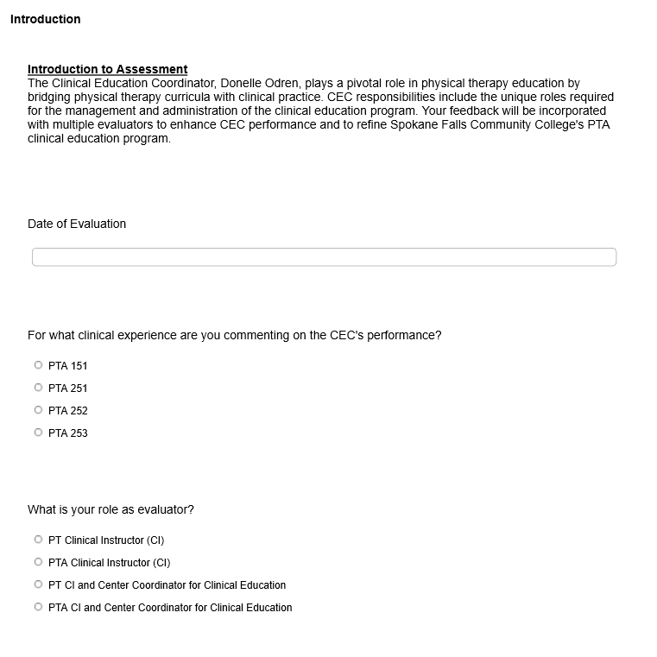

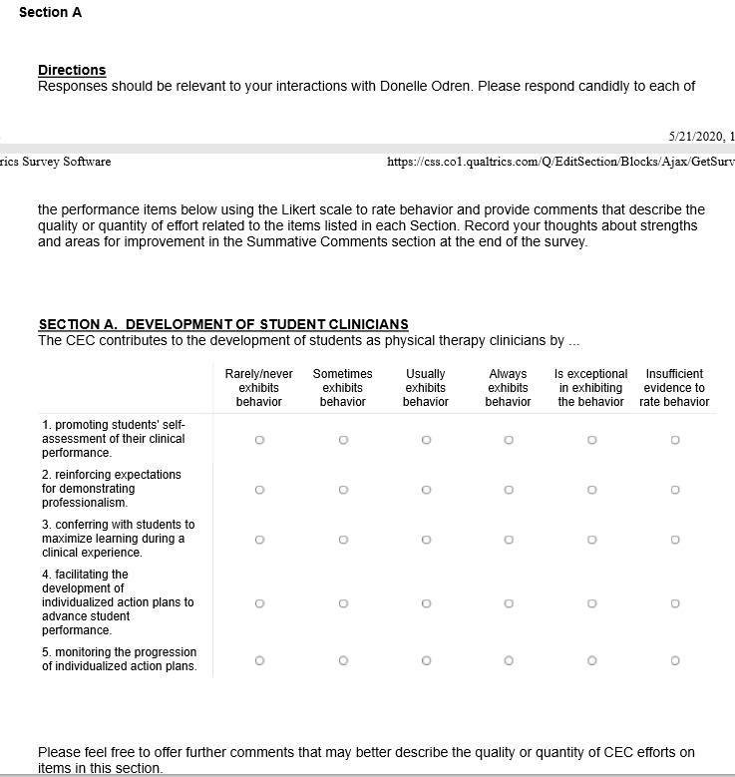
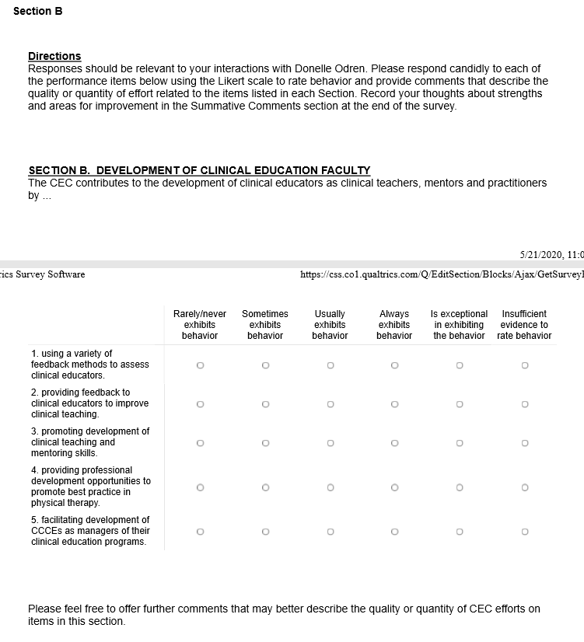
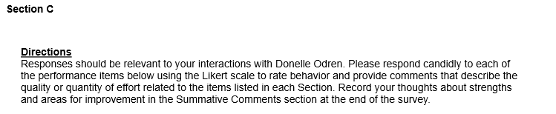
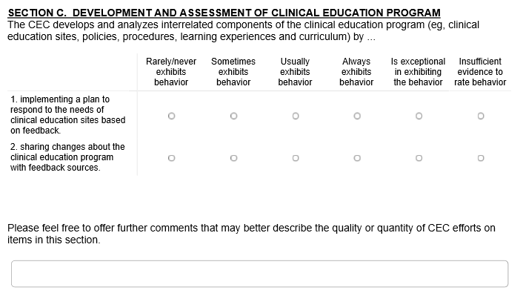
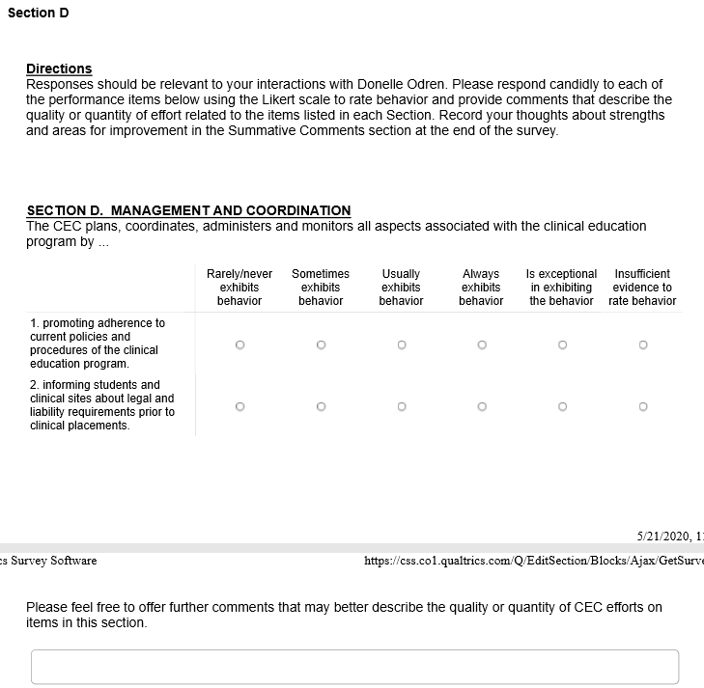
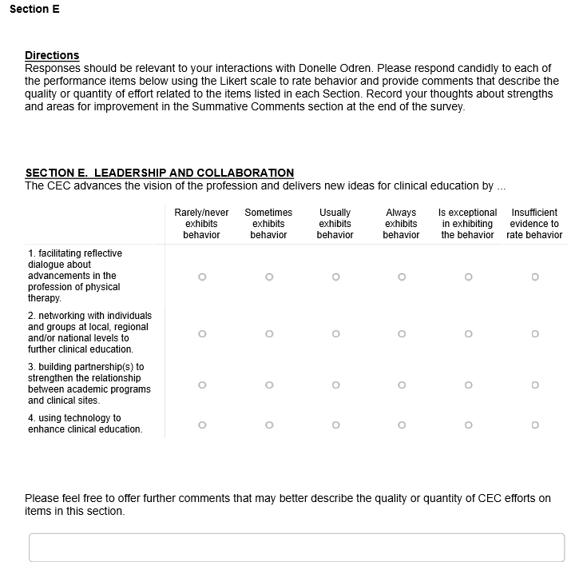
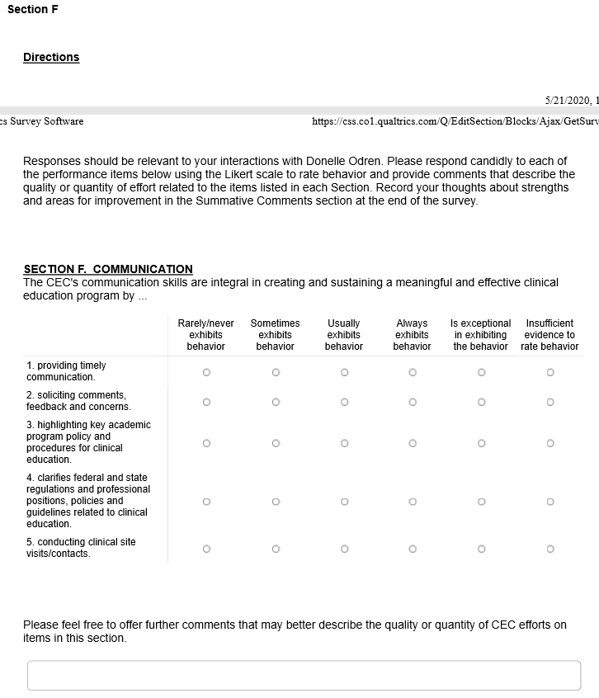
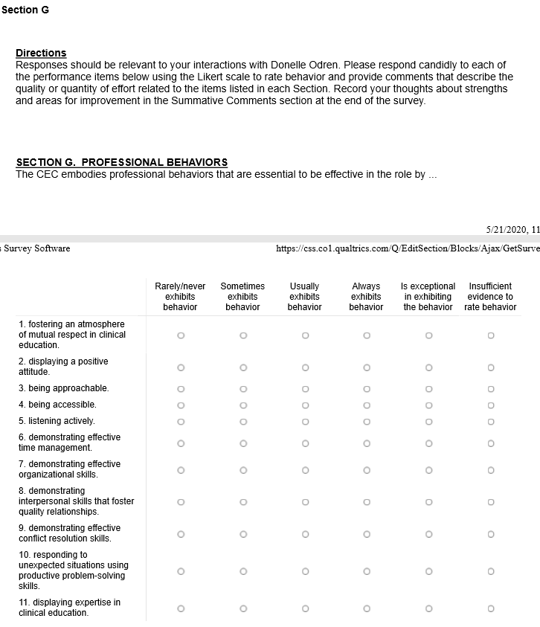
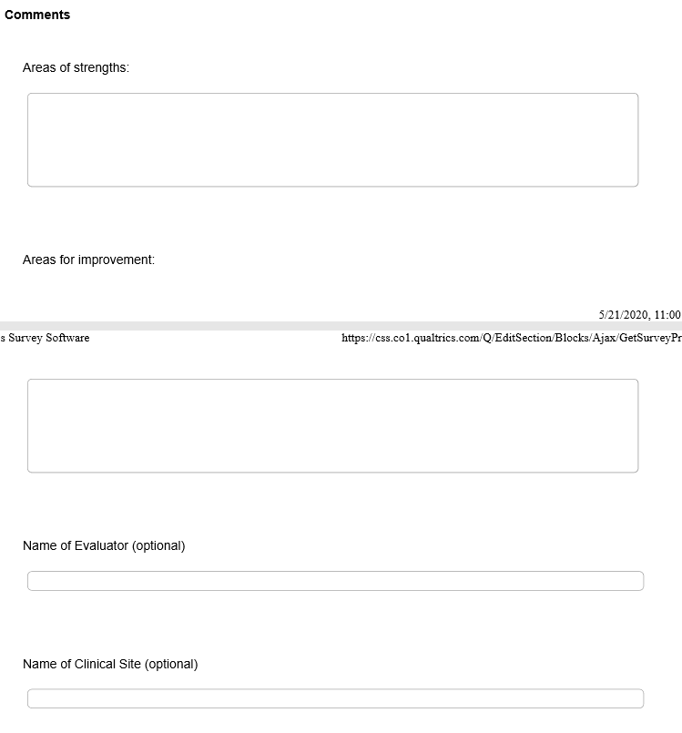
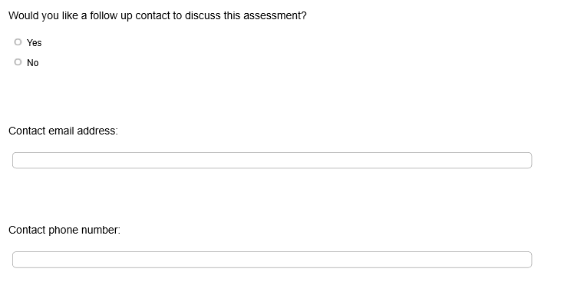

SITE ASSESSMENT OF CLINICAL CENTER (SAMPLE)

__________________________________________ ____________________________
NAME OF FACILITY DATE OF REVIEW

1.0 | The clinical center’s philosophy for patient care and clinical education are compatible with those of the academic program. | Lo Hi  1 2 3 4 5
2.0 | Clinical education programs for students are planned to meet specific objectives of the academic program, the physical therapy service and the individual student. | Lo Hi  1 2 3 4 5
3.0 | The physical therapy staff practices ethically and legally. | Lo Hi  1 2 3 4 5
4.0 | The clinical center is committed to the principle of equal opportunity and affirmative action as required by federal legislation. | Lo Hi  1 2 3 4 5
5.0 | The clinical center demonstrates administrative support of physical therapy clinical education. | Lo Hi  1 2 3 4 5
6.0 | The clinical center has a variety of learning experiences, appropriate to the setting, available to students across the lifespan. | Lo Hi  1 2 3 4 5
7.0 | The clinical center provides an active stimulating environment appropriate for the learning needs of students. | Lo Hi  1 2 3 4 5
8.0 | Selected support services are available to students. | Lo Hi  1 2 3 4 5
9.0 | Roles of physical therapy personnel are clearly defined and distinguished from one another. PT/PTA team utilized. | Lo Hi  1 2 3 4 5
10.0 | The physical therapy staff is adequate in number to provide an educational program for students. | Lo Hi  1 2 3 4 5
11.0 | A center coordinator of clinical education (SCCE), with specific qualifications, is responsible for coordinating the assignments and activities of students at the clinical center. | Lo Hi  1 2 3 4 5
12.0 | Physical therapy clinical instructors (CIs) are selected based on specific criteria. | Lo Hi  1 2 3 4 5
13.0 | Special expertise of the clinical center staff is available to students. | Lo Hi  1 2 3 4 5
14.0 | The clinical center encourages clinical educator (CI and SCCE) training and development. | Lo Hi  1 2 3 4 5
15.0 | There is an active support staff development program for the clinical center. | Lo Hi  1 2 3 4 5
16.0 | The physical therapy staff is active in professional activities. | Lo Hi  1 2 3 4 5
17.0 | The physical therapy service has an active and viable process of internal evaluation of its own affairs and is receptive to procedures of review and audit approved by appropriate external agencies and consumers. | Lo Hi  1 2 3 4 5

SITE ASSESSMENT WORKSHEET

1.0 | The clinical center’s philosophy for patient care and clinical education are compatible with those of the academic program. | yes | no | N/A
1.4 | After reviewing the academic program’s philosophy, do you believe the physical therapy service philosophy is compatible with that of the academic program?
2.0 | Clinical education programs for students are planned to meet specific objectives of the academic program, the physical therapy service and the individual student. | yes | no | N/A
2.2 | a. Does your physical therapy service have objectives for clinical education?
2.5 | Does the Siter Coordinator of Clinical Education (SCCE) or the Clinical Instructor (CI) discuss with the student objectives for this experience prior to establishing the individual student’s clinical learning experience?
2.6 | Are there organized procedures for the orientation of students?
2.7 | Do your clinical instructors participate in providing student feedback? (Daily, weekly, oral or written)
3.0 | The physical therapy staff practices ethically and legally. | yes | no | N/A
3.2 | Does your physical therapy service policy and procedure manual contain:  a. a current copy of the APTA Code of Ethics and Standard for Ethical Conduct of the Physical Therapist Assistant, and Guide for Professional Conduct and Guide for Conduct of the Affiliated Member, and a clinical center code of ethics?
 | b. a current copy of the State Practice Act and interpretive rules and regulations?
3.3 | Does your clinical center have written policies which include statements on patients’ rights, release of confidential information, photographic permission, clinical research, etc.?
3.5 | Does your clinical center have evidence of current licensure or registration for all physical therapists and physical therapist assistants, where appropriate?
4.0 | The clinical center is committed to the principle of equal opportunity and affirmative action as required by federal legislation. | yes | no | N/A
4.1 | Does your clinical center have written policies prohibiting discrimination on the basis of sex, race, creed, color, age, religion, sexual orientation, national or ethnic origin, disability, or health status?
4.2 | Does your clinical center ensure each student is provided equal opportunities?
4.3 | Does your clinical center demonstrate evidence of the above through an affiliation agreement, policies and procedures, or organized activities addressing issues of cultural diversity?
5.0 | The clinical center demonstrates administrative support of physical therapy clinical education. | yes | no | N/A
5.3 | Does your clinical center demonstrate continued support for clinical education by:  a. maintaining current affiliation agreements?
 | d. providing job flexibility to accommodate additional responsibilities in clinical education?
 | e. supporting clinical education in other professional disciplines?
6.0 | The clinical center has a variety of learning experiences, appropriate to the setting, available to students. | yes | no | N/A
6.1 | Do you believe you can provide quality learning experiences for:  a. observational experiences?
 | b. part-time experiences (less than 30 hours/week)?
 | c. full-time experiences (greater than 30 hours/week)?
6.3 | Do you provide supplemental learning experiences, such as: case conferences, observation of other health professionals?
 | Do you provide care across the lifespan & continuum of care?
6.7 | a. Does your clinical center have opportunities for students to participate in teaching experiences, such as inservices?
7.0 | The clinical center provides an active stimulating environment appropriate for the learning needs of students. | yes | no | N/A
7.1 | b. Does your physical therapy staff demonstrate characteristics, such as: EBP, diversity, expertise and flexibility?
7.3 | a. Are there regular formal mechanisms for communication within the clinical center, such as staff meetings?
7.4 | Does the physical environment include appropriate space for:  a. patient care services?
 | d. consultative functions?
 | e. documentation services?
 | f. personal belongings?
8.0 | Selected support services are available to students. | yes | no | N/A
8.2 | Does your clinical center provide for special learning needs of students, within reasonable accommodations?
9.0 | Roles of physical therapy personnel are clearly defined and distinguished from one another. | yes | no | N/A
9.0 | Do you utilize PT/PTA team roles in clinical environment?
9.1 | Do you have a job description for each type of personnel in the physical therapy service?
9.3 | Are the roles of the various physical therapy personnel explained to the students?
10.0 | The physical therapy staff is adequate in number to provide an educational program for students. | yes | no | N/A
10.2 | Does your staff have adequate time, in addition to service responsibilities, to assume responsibility for the education of students?
10.4 | Are you currently using or willing to consider alternative student to staff ratios for clinical education? Examples of such ratios are: (check those used)  _____ 1 CI : 1 student  _____ 1 CI : 2 students  _____ 1 CI : > 2 students  _____ 2 CIs : 2 students  _____ 2 CIs (split rotations) : 1 student  _____ 1 PT/PTA (CI team) : 1 PT/PTA (student team)  _____ other
11.0 | A site coordinator of clinical education, with specific qualifications, is responsible for coordinating the assignments and activities of students at the clinical center. | yes | no | N/A
11.2 | Are the criteria based on the APTA Guidelines for Site Coordinator of Clinical Education?
12.0 | Physical therapy clinical instructors are selected based on specific criteria. | yes | no | N/A
12.3 | Do your clinical instructors have at least one year of clinical experience or meet the recommended criteria as outlined by the APTA Guidelines for Clinical Instructors?
12.5 | Have your clinical instructors attended any formal clinical instructor training?
13.0 | Special expertise of the clinical center staff is available to students. | yes | no | N/A
13.1 | Are there any areas of special expertise within your clinical center?
 | a. Are these experiences available to students?
14.0 | The clinical center encourages clinical educator (CI and SCCE) training and development. | yes | no | N/A
14.1 | a. Does the clinical center foster formal and informal clinical educator training by providing support for attendance at clinical education training seminars?
15.0 | There is an active support staff development program for the clinical center. | yes | no | N/A
15.5 | Is student participation in staff development activities expected and encouraged?
16.0 | The physical therapy staff is active in professional activities. | yes | no | N/A
16.2 | Is the physical therapy staff encouraged to be professionally active?
16.4 | Does your physical therapy staff provide students with information about professional activities and encourage them to participate?
17.0 | The physical therapy service has an active and viable process of internal evaluation of its own affairs and is receptive to procedures of review and audit approved by appropriate external agencies and consumers. | yes | no | N/A
17.2 | a. Is the physical therapy service, including patient care, teaching and scholarly activities, evaluated at regularly scheduled intervals?

Additional Comments:

SPOKANE FALLS COMMUNITY COLLEGE
PHYSICAL THERAPIST ASSISTANT PROGRAM

RELEASE OF STUDENT Academic Information
TO CLINICAL EDUCATION FACILITIES

The Community Colleges of Spokane and, Spokane Falls Community College (SFCC)complies with the Family Educational Rights and Privacy Act (FERPA). 20 U.S.C. 1232g; 34 CFR Part 99. This is a Federal law that protects the privacy of student education records. FERPA generally provides: “The College shall not permit access to or the release of educational records, or personally identifiable information contained therein, other than “directory information” without the written consent of the student, to any party.” WAC 132Q-30-380. There are some limited exceptions, for example student education records may be released to “school officials who have a legitimate educational interest in the records.” WAC 132Q-30-380(3). School officials include administrative, supervisory, academic, research, support staff, law enforcement and health care professionals.

In regards to clinical education, Clinical Instructors are primarily responsible for the student’s clinical education in any particular medical facility. It is important for Center Coordinators and Clinical Instructors to share information about the students, their educational experience and their progress with clinical staff members to ensure patient/client health and safety, to make the clinical internship meaningful and to facilitate a positive learning experience for the students. For this reason, the following signed consent is required of each student in the Physical Therapist Assistant Program.

I, _______________________________________ give my consent to allow the SFCC Physical Therapist Assistant Program to release, either in writing or verbally, any educational records or information regarding my performance as a student at SFCC to clinical staff who I will collaborate with as part of my clinical internship. I understand that no information may be released without my signed consent. This consent form is valid from the date below until graduation from the PTA Program or until withdrawal of this consent is received by the SFCC Physical Therapy Assistant Program Director in writing from the person whose signature is entered below.

________________________________________ ________________________
Signature Date

SPOKANE FALLS COMMUNITY COLLEGE
PHYSICAL THERAPIST ASSISTANT PROGRAM

ACKNOWLEDGEMENT OF HEALTH CARE CONFIDENTIALITY
Laws and Regulations /Obligation to Comply
I understand that, as a physical therapist assistant student, I am required to protect information revealed by patients or discovered by physicians during the course of medical treatment. This is an ethical, professional, and legal obligation. Health care information is considered confidential under Washington Uniform Health Care Information Act, chapter 70.02 RCW which defines health information as: “Any information, whether oral or recorded in any form or medium, that identifies or can readily be associated with the identity of a patient and directly relates to the patient's health care, including a patient's DNA.

The information is also protected by federal law, under the federal Health Insurance Portability and Accountability Act, HIPAA. HIPAA governs the confidentiality of individually identifiable health information which is defined as follows:

Individually Identifiable Health Information is information that is a subset of health information, including demographic information collected from an individual, and:
1. Is created or received by a health care provider, health plan, employer, or health care clearinghouse; and
2. Relates to the past, present, or future physical or mental health or condition of an individual; the provision of health care to an individual; or the past, present, or future payment for the provision of health care to an individual; and
i. That identifies the individual; or
ii. With respect to which there is a reasonable basis to believe the information can be used to identify the individual.

I understand that any unauthorized disclosure of health care information in violation of any law, ethical requirement, or professional requirement including health provider policy/procedure will constitute grounds for immediate disciplinary action which may include failure of the clinical experience/affiliation and dismissal from the Physical Therapist Assistant Program.

When I do go to a clinical facility, I understand that I am obligated to follow applicable rules and regulations, and college and facility policies procedures this includes, but is not limited to and wearing appropriate uniform/clothing and a name badge. I understand that I will introduce myself as a student and that the patient has a right to refuse treatment.

I understand that if I am injured or have an incident involving contamination, I am responsible for the cost of any health care services, and I agree to participate in the appropriate follow-up and testing which may be needed.

I have read, understand, and will abide with the provisions of this Acknowledgement of Health Care Confidentiality Laws and Regulations /Obligation to Comply.

___________________________________________ ___________________________________
Signature Date

__________________________________________________________________________________
Printed Name
Physical Therapist Assistant Program

STUDENT BIOGRAPHICAL DATA SHEET

Clinic Course: | Quarter: |  | Year:
Facility/Dept.:
Student Name:
Address:
Phone:
Email:
Year in Program: Second |  | Expected Date of Graduation:
Personal Information:

Previous Work Experiences (include volunteer experience):

Previous Clinical Education Experiences:

Growth Area:

Specific Goals for this Clinical Experience:

Long Term Professional Goals:

Physical Therapist Assistant Program

APPENDIX

DIRECTION AND SUPERVISION OF THE PTA

Last Updated: 08/30/18
Contact: nationalgovernance@apta.org

DIRECTION AND SUPERVISION OF THE PHYSICAL THERAPIST ASSISTANT HOD P06‐18‐28‐35 [Amended: HOD P06‐05‐18‐ 26; HOD 06‐00‐16‐27; HOD 06‐99‐07‐11; HOD 06‐96‐30‐42; HOD 06‐95‐11‐06; HOD 06‐93‐08‐09; HOD 06‐85‐20‐41; Initial: HOD 06‐84‐16‐72/HOD 06‐78‐22‐61/HOD 06‐77‐19‐37] [Position]

Physical therapist practice and the practice of physical therapy are synonymous. Both phrases are inclusive of patient and client management, and direction and supervision. Direction and supervision apply to the physical therapist assistant, who is the only individual who assists a physical therapist in practice. The utilization of other support personnel, whether in the performance of tasks or clerical activities, relates to the efficient operation of the physical therapy service.

Physical therapists are responsible for providing safe, accessible, cost‐effective, and evidence‐based services. Services are rendered directly by the physical therapist and with responsible utilization of physical therapist assistants. The physical therapist's practice responsibility for patient and client management includes examination, evaluation, diagnosis, prognosis, intervention, and outcomes. Physical therapist assistants may be appropriately utilized in components of intervention and in collection of selected examination and outcomes data.

Direction and supervision are essential in the provision of quality physical therapist services. The degree of direction and supervision necessary for ensuring quality physical therapist services is dependent upon many factors, including the education, experiences, and responsibilities of the parties involved, as well as the organizational structure where physical therapist services are provided.

Regardless of the setting in which the physical therapist service is provided, the following responsibilities must be borne solely by the physical therapist:

- Interpretation of referrals when available
- Evaluation, diagnosis, and prognosis
- Development or modification of a plan of care, which is based on the initial examination or reexamination and includes the physical therapy goals and outcomes
- Determination of when the expertise and decision‐making capability of the physical therapist requires the physical therapist to personally render services and when it may be appropriate to utilize the physical therapist assistant
- Revision of the plan of care when indicated
- Conclusion of an episode of care
- Responsibility for any “hand off” communication
- Oversight of all documentation for services rendered to each patient or client

Only the physical therapist performs the initial examination and reexamination of the patient and may utilize the physical therapist assistant in collection of selected examination and outcomes data.

The physical therapist is responsible for services provided when the physical therapist’s plan of care involves the physical therapist assistant. Regardless of the setting in which the service is provided, the determination to utilize physical therapist assistants requires the education, expertise, and professional judgment of a physical therapist as described by the Standards of Practice for Physical Therapy, the Code of Ethics for the Physical Therapist, and the APTA Guide for Professional Conduct.

In determining the appropriate extent of assistance from the physical therapist assistant, the physical therapist considers:

- The physical therapist assistant’s education, training, experience, and skill level
- Patient or client criticality, acuity, stability, and complexity
- The predictability of the consequences
- The setting in which the care is being delivered
- Federal and state statutes
- Liability and risk management concerns
- The mission of physical therapist services for the setting
- The needed frequency of reexamination
Physical Therapist Assistant Definition
The physical therapist assistant assists the physical therapist in the provision of physical therapy. The physical therapist assistant is a graduate of a physical therapist assistant program accredited by the Commission on Accreditation in Physical Therapy Education.

Utilization
The physical therapist is directly responsible for the actions of the physical therapist assistant in all practice settings. The physical therapist assistant may provide services under the direction and at least general supervision of the physical therapist. In general supervision, the physical therapist is not required to be on site for direction and supervision but must be available at least by telecommunication. The ability of the physical therapist assistant to provide services shall be assessed on an ongoing basis by the supervising physical therapist.

Services provided by the physical therapist assistant must be consistent with safe and legal physical therapist practice and shall be predicated on the following factors: complexity and acuity of the patient’s or client’s needs; proximity and accessibility to the physical therapist; supervision available in the event of emergencies or critical events; and type of setting in which the service is provided. The physical therapist assistant makes modifications to elements of the intervention either to progress the patient or client as directed by the physical therapist or to ensure patient or client safety and comfort.

When supervising the physical therapist assistant in any offsite setting, the following requirements must be observed:
- A physical therapist must be accessible by telecommunication to the physical therapist assistant at all times while the physical therapist assistant is providing services to patients and clients.
- There must be regularly scheduled and documented conferences with the physical therapist assistant regarding patients and clients, the frequency of which is determined by the needs of the patient or client and the needs of the physical therapist assistant.
- In situations in which a physical therapist assistant is involved in the care of a patient or client, a supervisory visit by the physical therapist:
  - Shall be made upon the physical therapist assistant's request for a reexamination, when a change in the plan of care is needed, prior to any planned conclusion of the episode of care, and in response to a change in the patient’s or client’s medical status
  - Shall be made at least once a month, or at a higher frequency when established by the physical therapist, in accordance with the needs of the patient or client
  - Shall include:
    - An onsite reexamination of the patient or client
    - Onsite review of the plan of care with appropriate revision or termination
    - Evaluation of need and recommendation for utilization of outside resources
Explanation of Reference Numbers:
HOD P00‐00‐00‐00 stands for House of Delegates/month/year/page/vote in the House of Delegates minutes; the "P" indicates that it is a position (see below). For example, HOD P06‐17‐05‐04 means that this position can be found in the June 2017 House of Delegates minutes on Page 5 and that it was Vote 4.

P: Position | S: Standard | G: Guideline | Y: Policy | R: Procedure

THE ROLE OF AIDES IN A PHYSICAL THERAPY SERVICE

Last Updated : 09/20/19
Contact: nationalgove rnance@apta .org

THE ROLE OF AIDES IN A PHYSICAL THERAPY SERVICE
HOD P0G-19-12-07 [Amended: HOD P06-18-32-37; HOD P06-00-17-28; Initial: HOD 06-99-10-12] [Previously Titled: Provision of Physical Therapy Interventions and Related Tasks] [Position]

Physical therapy aides are any support personnel who perform designated tasks related to the operation of the physical therapy service. Tasks are activities that do not require the clinical decision making of the physical therapist or the clinical problem solving of the physical therapist assist ant. Tasks related to patient and client services must be assigned to the physical therapy aide by the physical therapist, or where allowable by law the physical therapist assistant, and may be performed by the aide only under direct personal supervision. Direct personal supervision requires that the physical therapist, or where allowable by law the physical therapist assistant, be physically present and immediately available to supervise tasks that are related to patient and client services. The physical therapist maintains responsibility for patient and client management at all times, including for tasks performed by a physical therapy aide.

Given this role of the physical therapy aide, the American Physical Therapy Association opposes certification or credentialing of physical therapy aides.

Explanation of Reference Numbers:
HOD P00 -00-00-00 stands for House of Delegat es/ mont h/ year/ page/ vot e in the House of Delegates minutes; the "P" indicates that it is a position (see below). For example, HOD P06-17-05-04 means that this position can be found in the June 2017 House of Delegates minutes on Page 5 and that it was Vote 4.

P: Position I S: Standard I G: Guideline I Y: Policy I R: Procedure

WAC 246-915-010, DEFINITIONS
The definitions in this section apply throughout this chapter unless the context indicates otherwise:
- "Board" means the Washington state board of physical therapy.
- "CAPTE" means the commission on accreditation for physical therapy education.
- "Close supervision" means that the supervisor has personally diagnosed the condition to be treated and has personally authorized the procedures to be performed. The supervisor is continuously on-site and physically present in the operatory while the procedures are performed and capable of responding immediately in the event of an emergency.
- "Consultation" means a communication regarding a patient's evaluation and proposed treatment plan with an authorized health care practitioner.
- "Department" means the Washington state department of health.
- "Direct supervision" means the supervisor shall:
  - Be continuously on-site and present where the person being supervised is performing services;
  - Be immediately available to assist the person being supervised in the services being performed; and
  - Maintain continued involvement in appropriate aspects of each treatment session in which a component of treatment is delegated to assistive personnel or is required to be directly supervised under RCW 18.74.180.
- "Indirect supervision" means the supervisor is not on the premises, but has given either written or oral instructions for treatment of the patient and the patient has been examined by the physical therapist at such time as acceptable health care practice requires, and consistent with the particular delegated health care task.
- "NPTE" means the National Physical Therapy Examination.
- "Other assistive personnel" means other trained or educated health care personnel, not defined in subsection (13)(a) or (b) of this section, who perform specific designated tasks that are related to physical therapy and within their license, scope of practice, or formal education, under the supervision of a physical therapist including, but not limited to, licensed massage therapists, licensed athletic trainers, and exercise physiologists. At the direction of the supervising physical therapist, and if properly credentialed and not prohibited by any other law, other assistive personnel may be identified by the title specific to their license, training or education.
- "Physical therapist" means a person who meets all the requirements of this chapter and is licensed as a physical therapist under chapter 18.74 RCW.
- "Sharp debridement" means the removal of devitalized tissue from a wound with scissors, scalpel, and tweezers without anesthesia. Sharp debridement does not mean surgical debridement.
- "Spinal manipulation" includes spinal manipulation, spinal manipulative therapy, high velocity thrust maneuvers, and grade five mobilizations of the spine and its immediate articulations.
- "Trained supportive personnel" means:
- "Physical therapist assistant" means a person who meets all the requirements of this chapter and is licensed as a physical therapist assistant and who performs physical therapy procedures and related tasks that have been selected and delegated only by the supervising physical therapist; or
- "Physical therapy aide" means an unlicensed person who receives ongoing on-the-job training and assists a physical therapist or physical therapist assistant in providing physical therapy
- patient care and who does not meet the definition of a physical therapist, physical therapist assistant, or other assistive personnel. A physical therapy aide may directly assist in the implementation of therapeutic interventions, but may not alter or modify the plan of therapeutic interventions and may not perform any procedure or task which only a physical therapist may perform under this chapter.

[Statutory Authority: RCW 18.74.023, chapter 18.74 RCW and 2018 c 222. WSR 20-06-029, §246-915-010, filed 2/26/20, effective 3/28/20. Statutory Authority: RCW 18.74.023 and chapter 18.74 RCW, RCW 18.340.020. WSR 18-15-067, § 246-915-010, filed 7/17/18, effective 8/17/18. Statutory Authority: RCW 18.74.023. WSR 08-17-026, § 246-915-010, filed 8/13/08, effective 8/13/08. Statutory Authority: RCW 18.74.023 (3), (6) and (7). WSR 04-13-052, § 246-915-010, filed 6/11/04, effective 7/12/04. Statutory Authority: RCW 43.70.280. WSR 98-05-060, § 246-915-010, filed 2/13/98, effective 3/16/98. Statutory Authority: RCW 18.74.023. WSR 92-08-039 (Order 259B), § 246-915-010, filed 3/24/92, effective 4/24/92; WSR 91-05-094 (Order 144B), § 246-915-010, filed 2/20/91, effective 3/23/91; WSR 91-02-011 (Order 103B), recodified as § 246-915-010, filed 12/21/90, effective 1/31/91. Statutory Authority: RCW 18.74.023(3). WSR 89-21-007, § 308-42-010, filed 10/6/89, effective 11/6/89; WSR 88-23-014 (Order PM 789), § 308-42-010, filed 11/7/88. Statutory Authority: RCW 18.74.023. WSR 84-13-057 (Order PL 471), § 308-42-010, filed 6/19/84; Order PL 191, § 308-42-010, filed 5/29/75; Order 704207, § 308-42-010, filed 8/7/70, effective 9/15/70.]

WAC 246-915-140, PERSONNEL IDENTIFICATION

- Each person shall wear identification showing his or her clinical title, and their role in the facility as a physical therapist, a physical therapist assistant, a physical therapy aide, a graduate physical therapist, or a graduate physical therapist assistant as appropriate. Trained supportive personnel may not use any term or designation which indicates or implies that he or she is licensed as a physical therapist or physical therapist assistant in the state of Washington.
- The physical therapist or physical therapist assistant shall post the license or interim permit, or a copy of the license or interim permit, or a printout from the department's provider credential search website, in a safe, conspicuous location at the physical therapist's or physical therapist assistant's work site. The physical therapist or physical therapist assistant may block out his or her address before posting the license or interim permit.
- If the physical therapist or physical therapist assistant does not have a principal place of business or conducts business in any other location, he or she shall have a copy of his or her license available for inspection while performing services within his or her authorized scope of practice.

[Statutory Authority: RCW 18.74.023 and chapter 18.74 RCW, RCW 18.340.020. WSR 18-15-067, §246-915-140, filed 7/17/18, effective 8/17/18. Statutory Authority: RCW 18.74.023 (3), (6) and (7). WSR 04-13-052, § 246-915-140, filed 6/11/04, effective 7/12/04. Statutory Authority: RCW 18.74.023. WSR 94-05-014 (Order 403B), § 246-915-140, filed 2/4/94, effective 3/7/94; WSR 91-05-094 (Order 144B), § 246-915-140, filed 2/20/91, effective 3/23/91; WSR 91-02-011 (Order 103B), recodified as § 246-915-140, filed 12/21/90, effective 1/31/91; WSR 84-17-032 (Order PL 477), § 308-42-135, filed
8/8/84.]

WAC 246-915-180, PROFESSIONAL CONDUCT

  - The patient's lawful consent is to be obtained before any information related to the patient is released, except to the consulting or referring authorized health care practitioner or an authorized governmental agency(s).
- Physical therapists are responsible for answering legitimate inquiries regarding a patient's physical dysfunction and treatment progress, and
- Information is to be provided by physical therapists and physical therapist assistants to insurance companies for billing purposes only.
  - Physical therapists and physical therapist assistants are not to compensate or to give anything of value to a representative of the press, radio, television, or other communication medium in anticipation of, or in return for, professional publicity in a news item. A paid advertisement is to be identified as such unless it is apparent from the context it is a paid advertisement.
  - It is the physical therapist's and physical therapist assistant's responsibility to report any unprofessional, incompetent or illegal acts that are in violation of chapter 18.74 RCW or any rules established by the board.
  - It is the physical therapist's and physical therapist assistant's responsibility to recognize the boundaries of his or her own professional competencies and that he or she uses only those in which he or she can prove training and experience.
  - Physical therapists and physical therapist assistants shall recognize the need for continuing education and shall be open to new procedures and changes.
  - It is the physical therapist's and physical therapist assistant's responsibility to represent his or her academic credentials in a way that is not misleading to the public.
  - It is the responsibility of the physical therapist and physical therapist assistant to refrain from undertaking any activity in which his or her personal problems are likely to lead to inadequate performance or harm to a client or colleague.
  - A physical therapist and physical therapist assistant shall not use or allow to be used any form of public communication or advertising connected with his or her profession or in his or her professional capacity as a physical therapist which:
- Is false, fraudulent, deceptive, or misleading;
- Guarantees any treatment or result; or
- Makes claims of professional superiority.
- Physical therapists and physical therapist assistants are to recognize that each individual is different from all other individuals and to be tolerant of and responsive to those differences.
  - Physical therapists shall not receive reimbursement for evaluating or treating him or herself.
  - Physical therapists shall only delegate physical therapy tasks to trained supportive personnel as defined in WAC 246-915-010 (13)(a) and (b).

[Statutory Authority: RCW 18.74.023, chapter 18.74 RCW and 2018 c 222. WSR 20-06-029, §246-915-180, filed 2/26/20, effective 3/28/20. Statutory Authority: RCW 18.74.023. WSR 08-17-026, § 246-915-180, filed 8/13/08, effective 8/13/08; WSR 05-06-023, § 246-915-180, filed 2/22/05, effective 3/25/05; WSR 92-08-039 (Order 259B), § 246-915-180, filed 3/24/92, effective 4/24/92; WSR 91-05-094 (Order 144B), § 246-915-180, filed 2/20/91, effective 3/23/91; WSR 91-02-011 (Order 103), recodified as § 246-915-180, filed 12/21/90, effective 1/31/91; WSR 84-13-057 (Order PL 471), § 308-42-150, filed 6/19/84.]

RCW 18.74.010, DEFINITIONS
The definitions in this section apply throughout this chapter unless the context clearly requires otherwise.
  - "Authorized health care practitioner" means and includes licensed physicians, osteopathic physicians, chiropractors, naturopaths, podiatric physicians and surgeons, dentists, and advanced registered nurse practitioners: PROVIDED, HOWEVER, That nothing herein shall be construed as altering the scope of practice of such practitioners as defined in their respective licensure laws.
  - "Board" means the board of physical therapy created by RCW 18.74.020.
  - "Close supervision" means that the supervisor has personally diagnosed the condition to be treated and has personally authorized the procedures to be performed. The supervisor is continuously on-site and physically present in the operatory while the procedures are performed and capable of responding immediately in the event of an emergency.
  - "Department" means the department of health.
  - "Direct supervision" means the supervisor must
- be continuously on-site and present in the department or facility where the person being supervised is performing services;
- be immediately available to assist the person being supervised in the services being performed; and
- maintain continued involvement in appropriate aspects of each treatment session in which a component of treatment is delegated to assistive personnel or is required to be directly supervised under RCW 18.74.190.
  - "Indirect supervision" means the supervisor is not on the premises, but has given either written or oral instructions for treatment of the patient and the patient has been examined by the physical therapist at such time as acceptable health care practice requires and consistent with the particular delegated health care task.
  - "Physical therapist" means a person who meets all the requirements of this chapter and is licensed in this state to practice physical therapy.

- "Physical therapist assistant" means a person who meets all the requirements of this chapter and is licensed as a physical therapist assistant and who performs physical therapy procedures and related tasks that have been selected and delegated only by the supervising physical therapist. However, a physical therapist may not delegate sharp debridement to a physical therapist assistant.
- "Physical therapy aide" means an unlicensed person who receives ongoing on-the-job training and assists a physical therapist or physical therapist assistant in providing physical therapy patient care and who does not meet the definition of a physical therapist, physical therapist assistant, or other assistive personnel. A physical therapy aide may directly assist in the implementation of therapeutic interventions, but may not alter or modify the plan of therapeutic interventions and may not perform any procedure or task which only a physical therapist may perform under this chapter.
- "Other assistive personnel" means other trained or educated health care personnel, not defined in (a) or (b) of this subsection, who perform specific designated tasks that are related to physical therapy and within their license, scope of practice, or formal education, under the supervision of a physical therapist, including but not limited to licensed massage therapists, athletic trainers, and exercise physiologists. At the direction of the supervising physical therapist, and if properly credentialed and not prohibited by any other law, other assistive personnel may be identified by the title specific to their license, training, or education.
- "Physical therapy" means the care and services provided by or under the direction and supervision of a physical therapist licensed by the state. Except as provided in RCW 18.74.190, the use of Roentgen rays and radium for diagnostic and therapeutic purposes, the use of electricity for surgical purposes, including cauterization, and the use of spinal manipulation, or manipulative mobilization of the spine and its immediate articulations, are not included under the term "physical therapy" as used in this chapter.
  - "Practice of physical therapy" is based on movement science and means:
- Examining, evaluating, and testing individuals with mechanical, physiological, and developmental impairments, functional limitations in movement, and disability or other health and movement-related conditions in order to determine a diagnosis, prognosis, plan of therapeutic intervention, and to assess and document the ongoing effects of intervention;
- Alleviating impairments and functional limitations in movement by designing, implementing, and modifying therapeutic interventions that include therapeutic exercise; functional training related to balance, posture, and movement to facilitate self-care and reintegration into home, community, or work; manual therapy including soft tissue and joint mobilization and manipulation; therapeutic massage; assistive, adaptive, protective, and devices related to postural control and mobility except as restricted by (c) of this subsection; airway clearance techniques; physical agents or modalities; mechanical and electrotherapeutic modalities; and patient-related instruction;
- Training for, and the evaluation of, the function of a patient wearing an orthosis or prosthesis as defined in RCW 18.200.010. Physical therapists may provide those direct-formed and prefabricated upper limb, knee, and ankle-foot orthoses, but not fracture orthoses except those for hand, wrist, ankle, and foot fractures, and assistive technology devices specified in RCW 18.200.010 as exemptions from the defined scope of licensed orthotic and prosthetic services. It is the intent of the legislature that the unregulated devices specified in RCW 18.200.010 are in the public domain to the extent that they may be provided in common with individuals or other health providers, whether unregulated or regulated under this title, without regard to any scope of practice;
- Performing wound care services that are limited to sharp debridement, debridement with other agents, dry dressings, wet dressings, topical agents including enzymes, hydrotherapy, electrical stimulation, ultrasound, and other similar treatments. Physical therapists may not delegate sharp debridement. A physical therapist may perform wound care services only by referral from or after consultation with an authorized health care practitioner;
- Reducing the risk of injury, impairment, functional limitation, and disability related to movement, including the promotion and maintenance of fitness, health, and quality of life in all age populations; and
- Engaging in administration, consultation, education, and research.
  - "Secretary" means the secretary of health.
  - "Sharp debridement" means the removal of devitalized tissue from a wound with scissors, scalpel, and tweezers without anesthesia. "Sharp debridement" does not mean surgical debridement. A physical therapist may perform sharp debridement, to include the use of a scalpel, only upon showing evidence of adequate education and training as established by rule. Until the rules are established, but no later than July 1, 2006, physical therapists licensed under this chapter who perform sharp debridement as of July 24, 2005, shall submit to the secretary an affidavit that includes evidence of adequate education and training in sharp debridement, including the use of a scalpel.
  - "Spinal manipulation" includes spinal manipulation, spinal manipulative therapy, high velocity thrust maneuvers, and grade five mobilization of the spine and its immediate articulations.
  - Words importing the masculine gender may be applied to females.

[ 2018 c 222 § 1; 2016 c 41 § 16. Prior: 2014 c 116 § 3; 2007 c 98 § 1; 2005 c 501 § 2; 1997 c 275 §8; 1991 c 12 § 1; (1991 c 3 §§ 172, 173 repealed by 1991 sp.s. c 11 § 2); (1990 c 297 § 17 repealed by 1991 c 12 § 6); 1988 c 185 § 1; 1983 c 116 § 2; 1961 c 64 § 1; 1949 c 239 § 1; Rem. Supp. 1949 § 10163-1.]

NOTES:
Effective date—2016 c 41: See note following RCW 18.108.010.
Effective date—2014 c 116: see note following RCW 18.74.190.
Effective dates—1991 c 12 §§ 1, 2, 3, 6: "(1) Sections 1, 2, and 6 of this act are necessary for the immediate preservation of the public peace, health, or safety, or support of the state government and its existing public institutions, and shall take effect June 30, 1991. (2) Section 3 of this act shall take effect January 1, 1992." [ 1991 c 12 § 7.]

Number and gender: RCW 1.12.050.

Physical Therapist Assistant Program

Clinical Instrument Evaluation Tool
CIET

Clinical Instrument Evaluation Tool (CIET)

FACULTY AND STAFF

Megan Guthrie-Martinez, PTA ATC 279-6249; Bldg. 27, Rm. 347
Director of Clinical Education, Instructor m.guthrie-martinez@sfcc.spokane.edu

Renee Compton, PTA 279-6224; Bldg. 27, Rm. 351
Program Director, Instructor Renee.compton@sfcc.spokane.edu

Emily Orne 279-6204; Bldg. 27, Rm. 355
Program Coordinator Emily.Orne@sfcc.spokane.edu

GENERAL INFORMATION

The goal of the Physical Therapist Assistant Program at SFCC is to provide the community with graduates who are educationally and clinically prepared to accept an entry-level position as a PT assistant, and who are capable of providing quality physical therapy services under the supervision of a licensed physical therapist. Upon successful completion of this program, students are awarded an Associate in Applied Science Degree (AAS). Licensure for physical therapist assistants is required in the state of Washington. A graduate of an APTA accredited program is allowed to practice in Washington by the State Board of Physical Therapy within established regulations of the RCW 18.74 Washington Administrative Code. Further, graduates are eligible to sit for the National Examination for the Physical Therapist Assistant. It is recommended that graduates of PTA programs in Washington become licensed in a state of their choice.

ACCREDITATION

This educational program is planned in accordance with the standards, guidelines, regulations, and evaluative criteria set forth by:

• Community Colleges of Spokane and the Washington Community College System
• Spokane Falls Community College
• American Physical Therapy Association (APTA)
• Commission on Accreditation in Physical Therapy Education (CAPTE)
• Washington State Law, Chapter 18.74 RCW, Physical Therapy
• Washington State Board of Physical Therapy

Spokane Falls Community College is accredited by the Commission on Colleges of the Northwest Association of Schools and Colleges. Both the college and the PTA program are approved for veterans training by the Veterans Administration.

This program is currently accredited by the Commission on Accreditation in Physical Therapy Education for the American Physical Therapy Association. Accreditation of a physical therapy education program is an ongoing process. Please be reminded that your participation in all accreditation activities is vitally important to the ongoing success and high standards of the program.

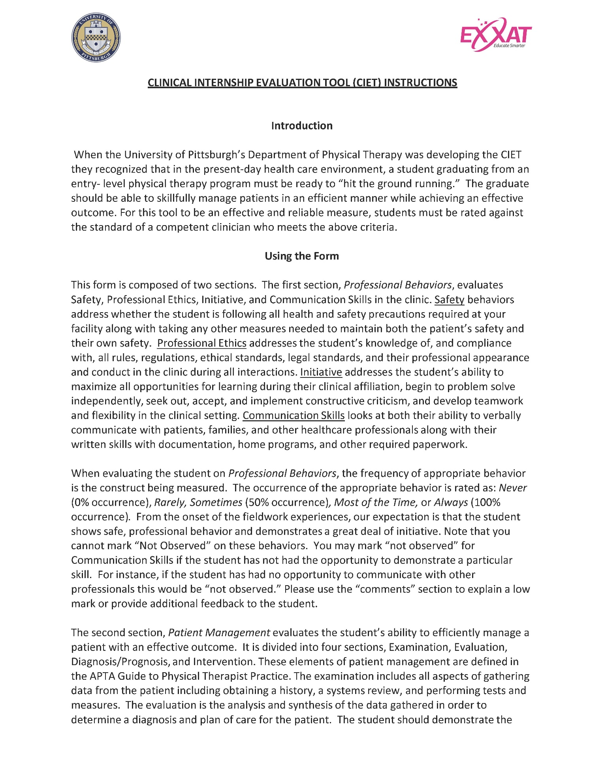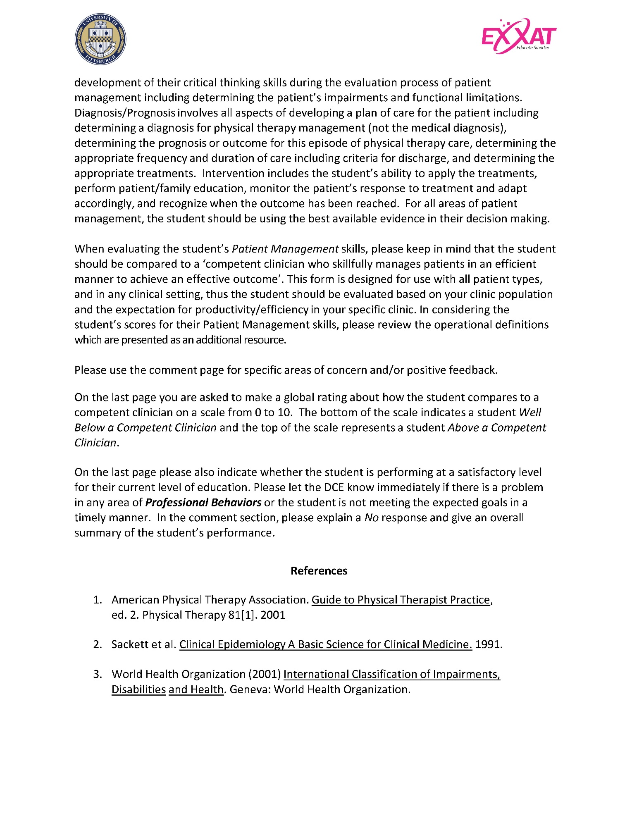
Clinical Internship Evaluation Tool – PTA CIET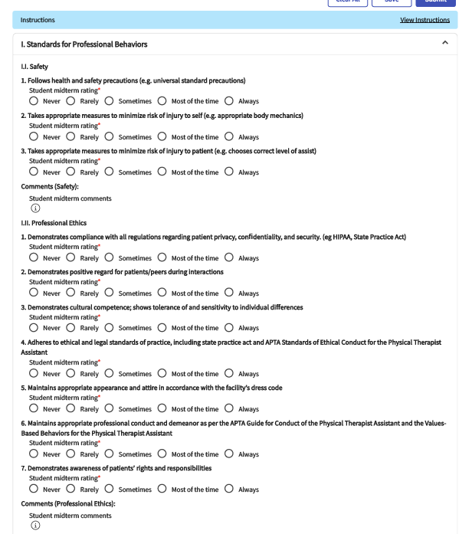 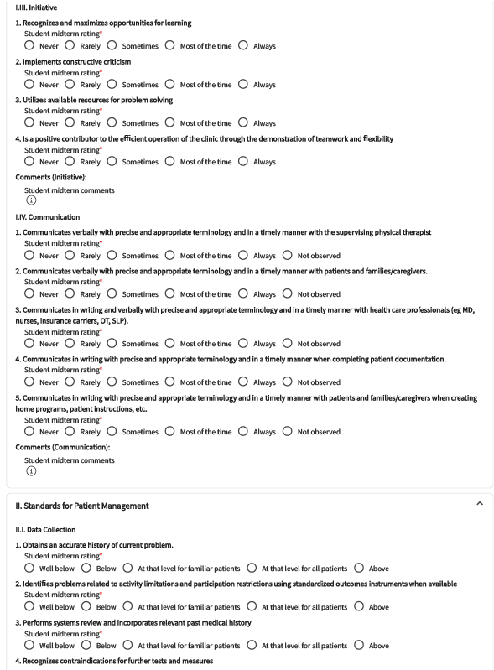 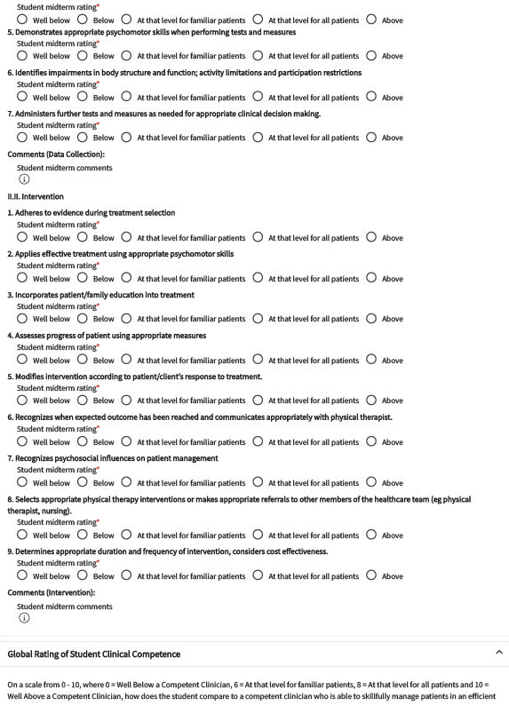 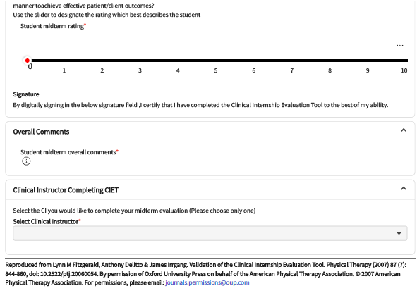

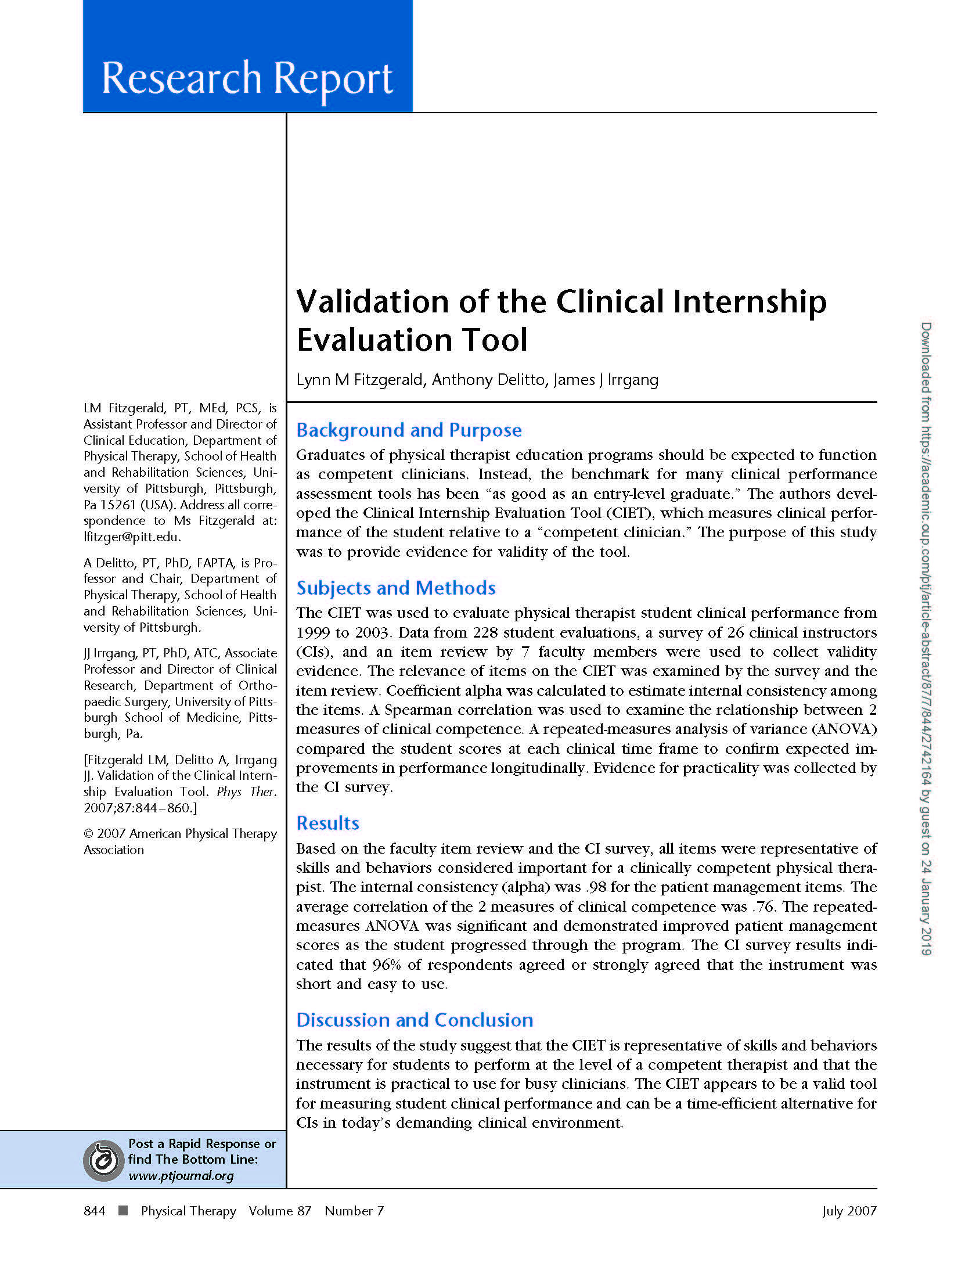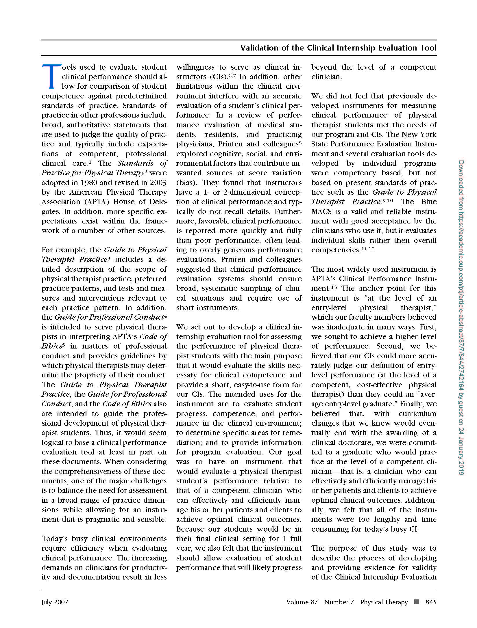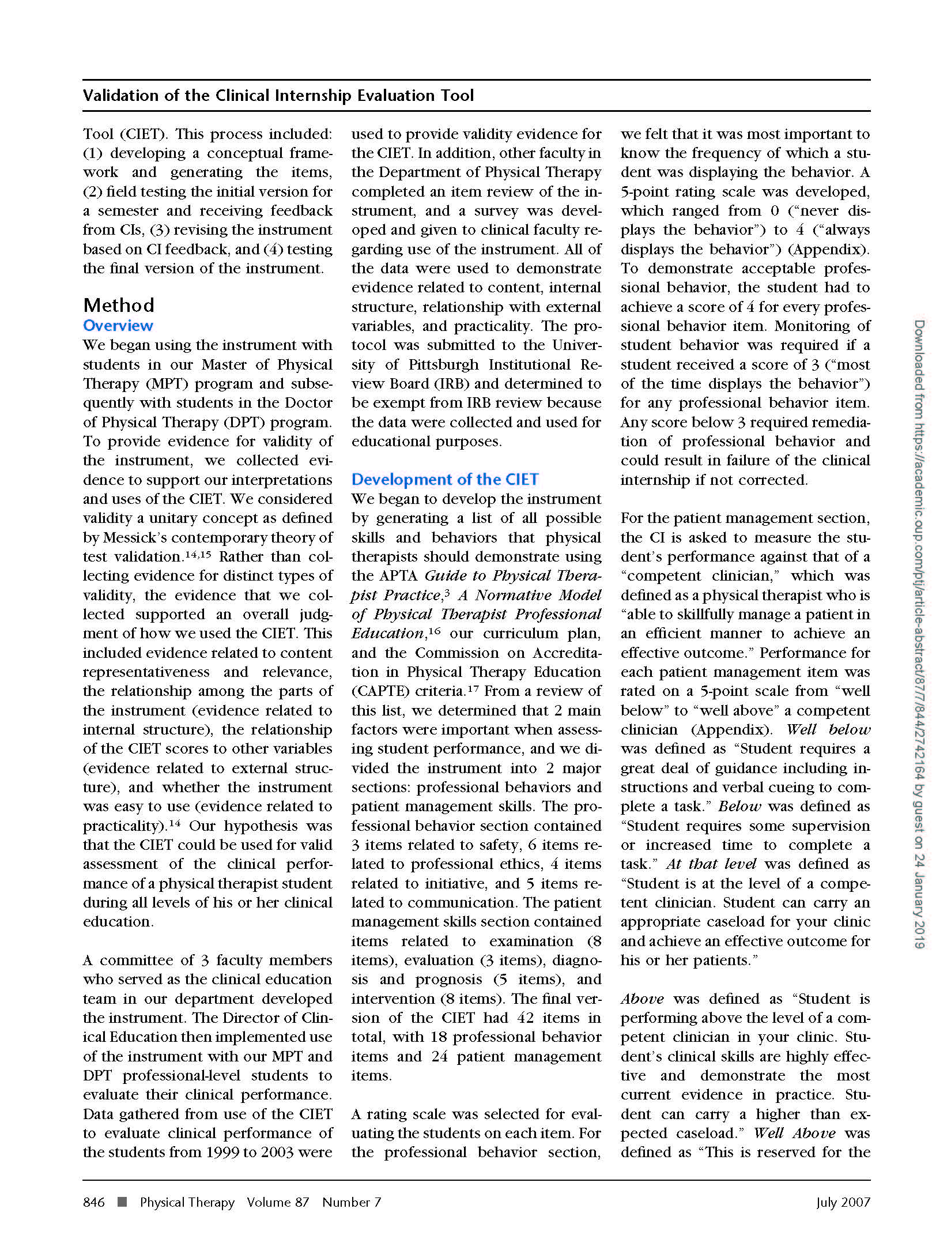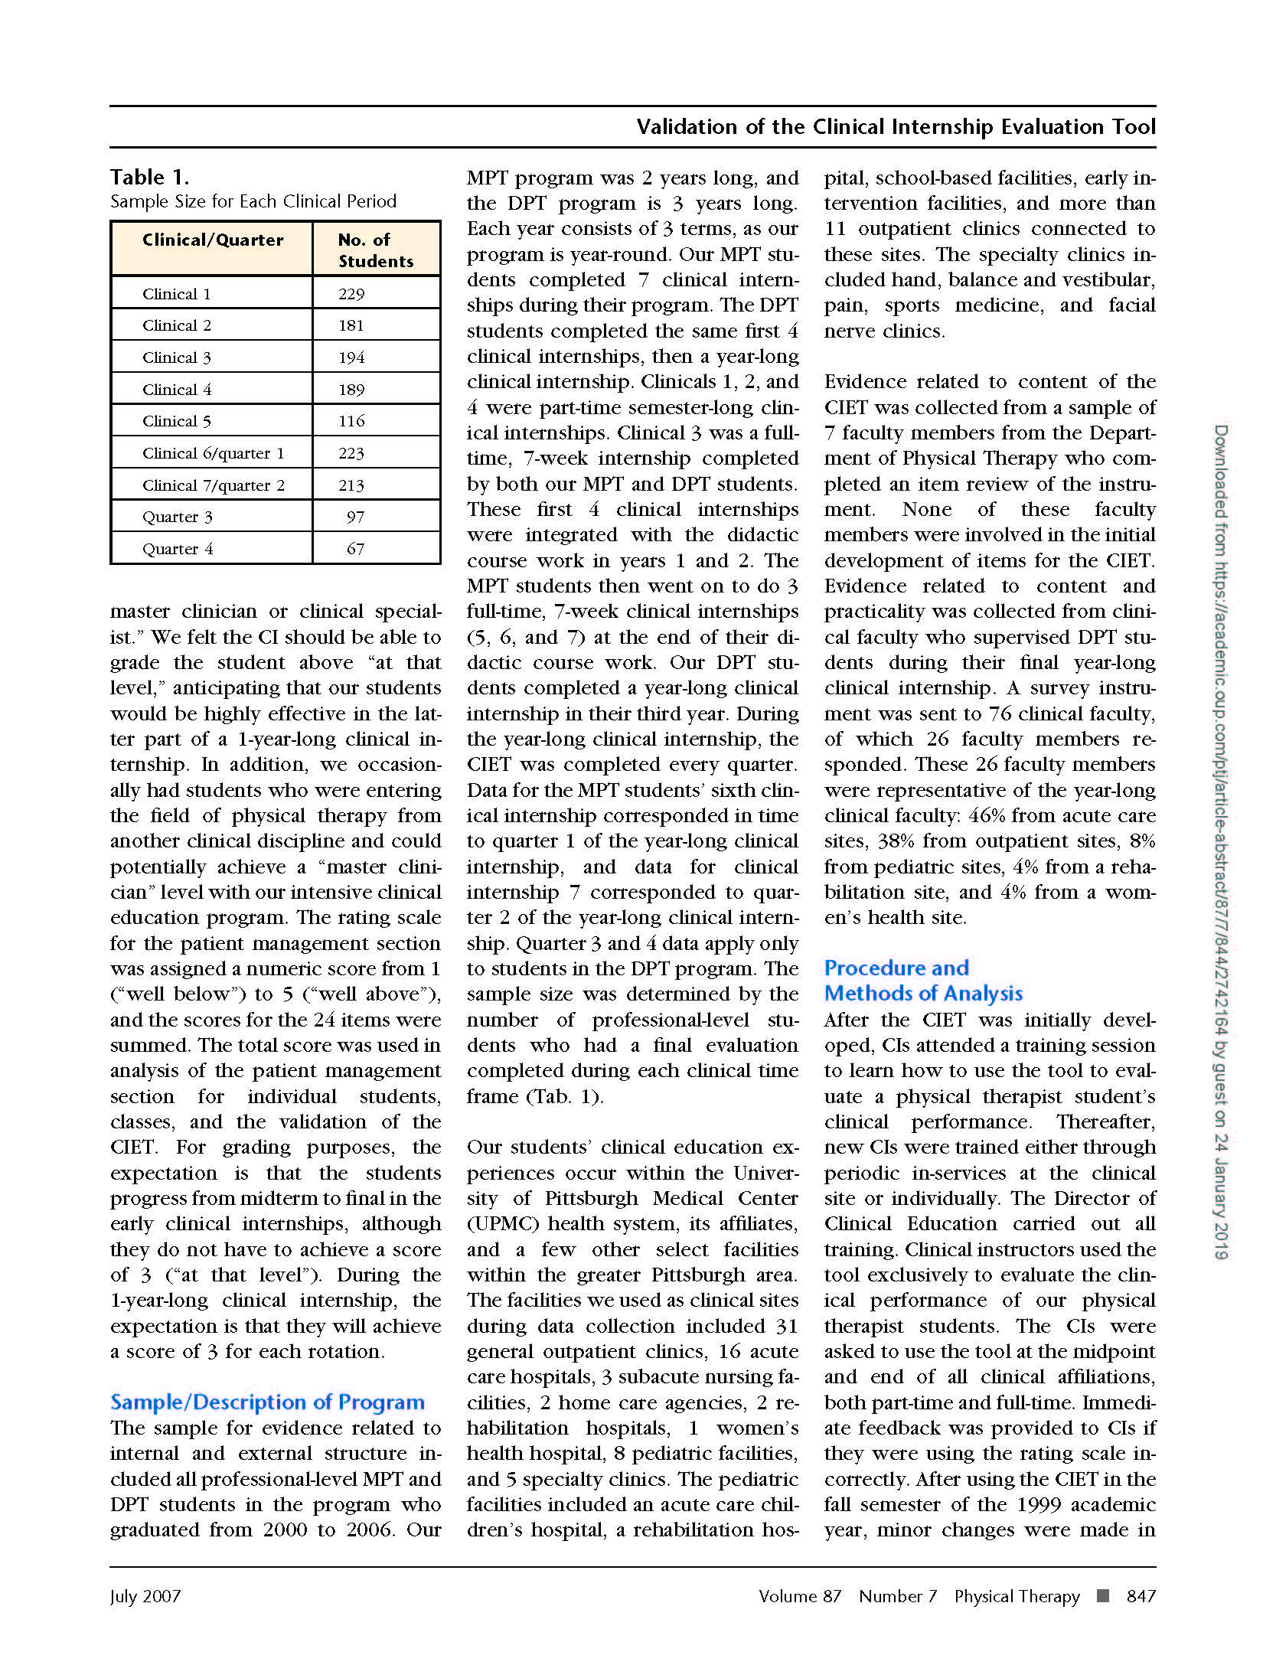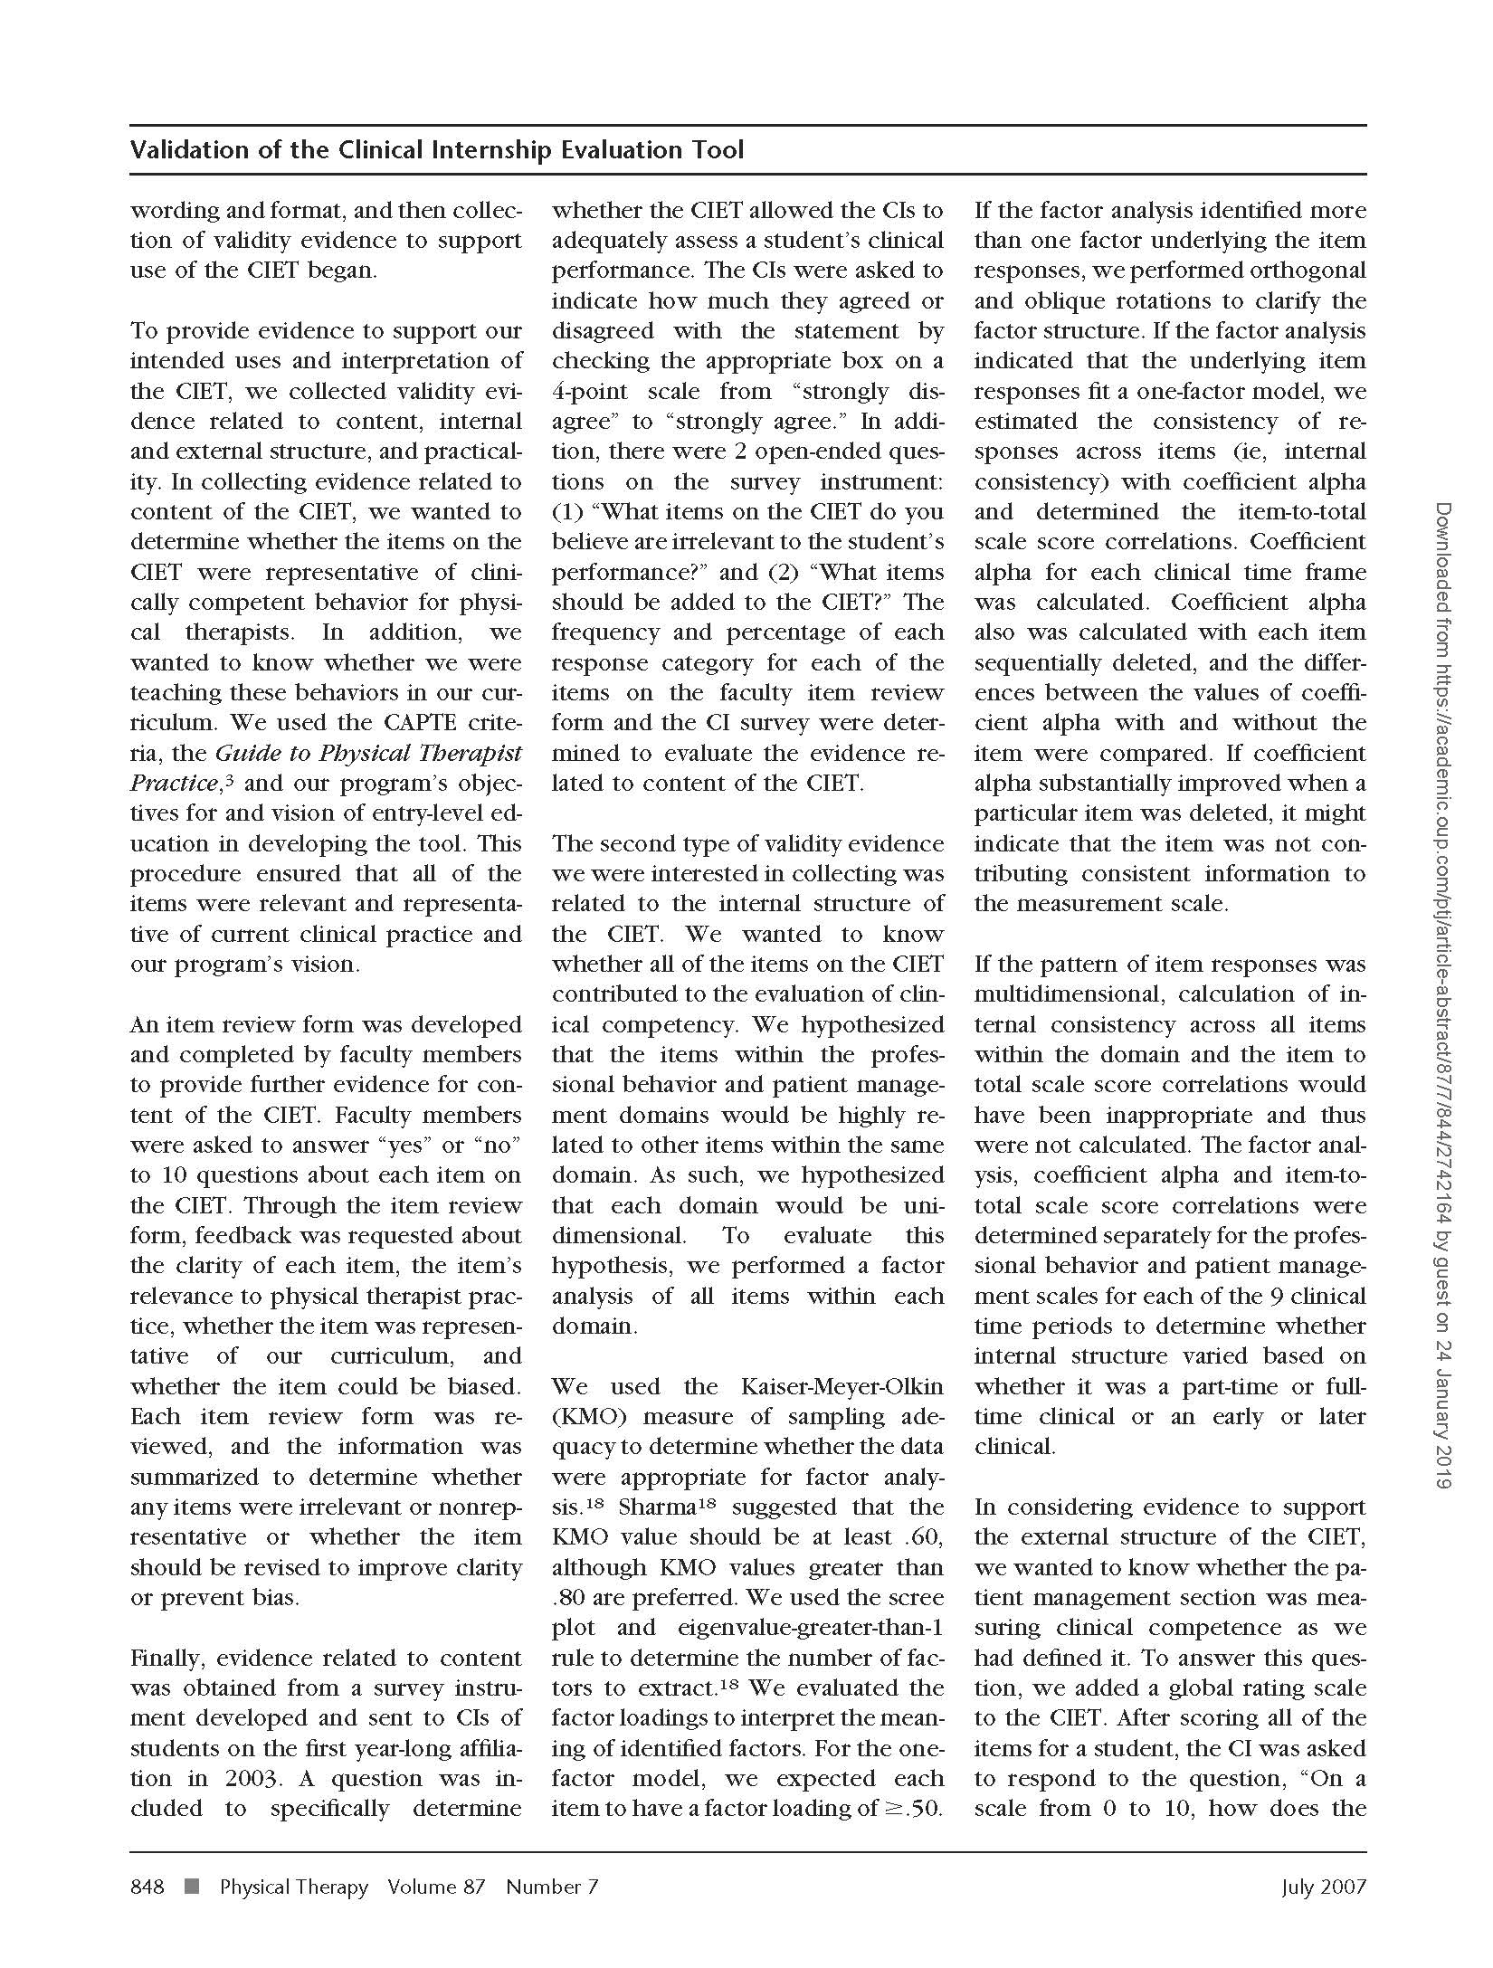

APPENDIX A:

PHYSICAL THERAPIST ASSISTANT
CLINICAL INSTRUMENT EDUCATION TOOL

DEFINITIONS
Academic coordinator of clinical education (ACCE/DCE): Individual who is responsible for managing and coordinating the clinical education program at the academic institution, including facilitating clinical site and clinical faculty development. This person also is responsible for coordinating student placements, communicating with clinical educators about the academic program and student performance, and maintaining current information on clinical sites.1

Accountability: Active acceptance of responsibility for the diverse roles, obligations, and actions of the physical therapist including self-regulation and other behaviors that positively influence patient/client outcomes, the profession, and the health needs of society.7

Activities of daily living (ADL): The self-care, communication, and mobility skills (eg, bed mobility, transfers, ambulation, dressing, grooming, bathing, eating, and toileting) required for independence in everyday living.1

Adaptive devices: A variety of implements or equipment used to aid patients/clients in performing movements, tasks, or activities. Adaptive devices include raised toilet seats, seating systems, environmental controls, and other devices. 1

Advanced beginner performance: A student who requires direct personal supervision 75% – 90% of the time working with patients with simple conditions, and 100% of the time working with patients with more complex conditions. At this level, the student demonstrates consistency in developing proficiency with simple tasks (eg, medical record review), clinical problem solving, interventions (eg, monitoring therapeutic exercise), and related data collection (eg, single angle goniometry), but is unable to perform more complex tasks, clinical problem solving, interventions/data collection without assistance. The student may begin to share the patient care workload with the clinical instructor.

Advanced intermediate performance: A student who requires clinical supervision less than 25% of the time working with new patients or patients with complex conditions and is independent working with patients with simple conditions. At this level, the student is consistent and proficient in simple tasks, clinical problem solving, and interventions/data collection and requires only occasional cueing for more complex tasks, clinical problem solving, and interventions/data collection. The student is capable of maintaining 75% of a full-time physical therapist assistant’s patient care workload.

Aerobic activity/conditioning: The performance of therapeutic exercise and activities to increase endurance.1

Aerobic capacity: A measure of the ability to perform work or participate in activity over time using the body’s oxygen uptake and delivery and energy release mechanisms.1

Affective: Relating to the expression of emotion (eg, affective behavior).

Airway clearance techniques: A broad group of activities used to manage or prevent consequences of impaired mucocilliary transport, or impaired cough.1

Altruism: The primary regard for or devotion to the interest of patients/clients, thus assuming the fiduciary responsibility of placing the needs of the patient/client ahead of the physical therapist’s self interest. 7

Anthropometric characteristics: Human body measurements such as height, weight, girth, and body fat composition.1

Assistive devices: A variety of implements or equipment used to aid patients in performing movements, tasks, or activities. Assistive devices include crutches, canes, walkers, wheelchairs, power devices, long- handled reachers, and static and dynamic splints.1

Beginning performance: A student who requires direct personal supervision 100% of the time working with patients with constant monitoring and feedback, even with patients with simple conditions. At this level, performance of essential skills is inconsistent and clinical problem solving* is performed in an inefficient manner. Performance reflects little or no experience in application of essential skills with patients. The student does not carry a patient care workload with the clinical instructor.

Body mechanics: The interrelationships of the muscles and joints as they maintain or adjust posture in response to environmental forces. 1
Caring: The concern, empathy, and consideration for the needs and values of others. 7

Caregiver: One who provides care, often used to describe a person other than a health care professional.

Center Coordinator of Clinical Education: Individual who administers, manages, and coordinates CI assignments and learning activities for students during their clinical education experiences. In addition, this person determines the readiness of persons to serve as clinical instructors for students, supervises clinical instructors in the delivery of clinical education experiences, communicates with the academic program regarding student performance, and provides essential information about the clinical education program to physical therapy programs.1

Clinical education: That portion of a physical therapy program that is conducted in the health care environment rather than the academic environment.1

Clinical education experiences: The aspect of the curriculum in which students’ learning occurs directly as a function of being immersed within physical therapy practice. These experiences comprise all of the formal and practical "real-life" learning experiences provided for students to apply classroom knowledge, skills, and professional behaviors in the clinical environment. These experiences would be further defined by short and long duration (eg, part-time and full-time experiences) and those that vary how learning experiences are provided (eg, rotations on different units within the same practice setting, rotations between different practice settings within the same health care system) to include comprehensive care of patients/clients across the life span and related activities. Part-time clinical education experiences are less than 35 hours per week. Full-time clinical education experiences are 35 or more hours per week. (CAPTE)1

Clinical education site: The physical therapy practice environment in which clinical education occurs; that aspect of the clinical education experience that is managed and delivered exclusively within the physical therapy practice environment. (Syn: clinical facility, clinical site, clinical center)1

Clinical indications: The patient factors (eg, symptoms, impairments, deficits) that suggest that a particular kind of care (examination, intervention) would be appropriate.

Clinical instructor (CI): Individual at the clinical education site who directly instructs and supervises students during their clinical learning experiences. These individuals are responsible for facilitating clinical learning experiences and assessing students’ performance in cognitive, psychomotor, and affective domains as related to entry-level performance expectations and academic and clinical preparation. For a PTA student, the CI may be a physical therapist or a physical therapist assistant under the direction and supervision of a physical therapist. (Syn: clinical teacher, clinical tutor, and clinical supervisor.)1

Cognitive: Characterized by awareness, reasoning, and judgment.1

Communication: A process by which information is exchanged between individuals through a common system of symbols, signs, or behavior.1

Compassion: The desire to identify with or sense something of another’s experience; a precursor of caring.7

Competence: The possession, application, and evaluation of requisite professional knowledge, skills, and abilities to meet or exceed the performance standards, based on the physical therapist assistant’s roles and responsibilities, within the context of public health, welfare, and safety.

Competency: A significant, skillful, work-related activity that is performed efficiently, effectively, fluidly, and in a coordinated manner.

Complexity: Multiple requirements of the tasks or environment (eg, simple, complex), or patient (see Complex patient). The complexity of the tasks or environment can be altered by controlling the number and types of elements to be considered in the performance, including patients, equipment, issues, etc. As a student progresses through clinical education experiences, the complexity of tasks/environment should increase, with fewer elements controlled by the CI.

Conflict management: The act, manner, or practice of handling or controlling the impact of disagreement, controversy, or opposition; may or may not involve resolution of the conflict.1
Consistency: The frequency of occurrences of desired behaviors related to the performance criterion (eg, infrequently, occasionally, and routinely). As a student progresses through clinical education experiences, consistency of quality performance is expected to progress from infrequently to routinely.

Cost-effectiveness: Economically worthwhile in terms of what is achieved for the amount of money spent; tangible benefits in relation to expenditures.

Cultural awareness: Refers to the basic idea that behavior and ways of thinking and perceiving are culturally conditioned rather than universal aspects of human nature.8

Cultural competence: Cultural and linguistic competence is a set of congruent behaviors, attitudes and policies that come together in a system, agency or among professionals that enables effective work in cross-cultural situations. ―Culture‖ refers to integrated patterns of human behavior that include the language, thoughts, communications, actions, customs, beliefs, values, and institutions of racial, ethnic, religious or social groups. ―Competence‖ implies having the capacity to function effectively as an individual and an organization within the context of the cultural beliefs, behaviors and needs presented by consumers and their communities. (Working definition adapted from Assuring Cultural Competence in Health Care: Recommendations for National Standards and an Outcomes-Focused Research Agenda.) 2

Cultural sensitivity: Awareness of cultural variables that may affect assessment and treatment.6

Data collection skills: Those processes/procedures used throughout the intervention to gather information about the patient’s/client’s progress through observation; measurement; subjective, objective, and functional findings. 1

Direction: The act by which the physical therapist authorizes the physical therapist assistant to perform selected physical therapy interventions and related tasks; always preceded by a decision-making process through which the physical therapist determines when and what to direct; and always followed by supervision of the physical therapist assistant relative to the directed intervention or related task. 1

Documentation: The recording of specific, functional, objective, and subjective pieces of information that are obtained through observation and measurement during intervention sessions and in consultation with the patient, the family, the physical therapist, or other members of the health care team. Recording can include handwritten entries, use of computerized medical records, dictation, etc. This includes information in the patient’s/client’s medical record that is considered a legal document; administrative documentation for non-direct patient/client care, such as total-quality management, continuous quality improvement, quality assurance, performance improvement, and utilization review; attendance records; peer review; chart audits; training materials; case studies; scheduling; preparation of charge slips for billing; and training and supervision of other physical therapist assistants and physical therapist assistant students. 1
Education: Knowledge or skill obtained or developed by a learning process; a process designed to change behavior by formal instruction and/or supervised practice, which includes teaching, training, information sharing, and specific instructions.

Efficiency: The ability to perform in a cost-effective and timely manner (eg, inefficient/slow, efficient/timely). As the student progresses though clinical education experiences, efficiency should progress from a high expenditure of time and effort to economical and timely.

Empathy: The action of understanding, being aware of, being sensitive to, and vicariously experiencing the feelings, thoughts, and experience of another of either the past or present without having the feelings, thoughts, and experience fully communicated in an objectively explicit manner. 1

Entry-level performance: A student who is capable of completing tasks, clinical problem solving, and interventions/data collection for patients with simple or complex conditions under general supervision of the physical therapist. At this level, the student is consistently proficient and skilled in simple and complex tasks, clinical problem solving, and interventions/data collection. The student consults with others to resolve unfamiliar or ambiguous situations. The student is capable of maintaining 100% of a full-time physical therapist assistant’s patient care workload in a cost effective* manner.

Entry-level work: The initial point of entry into the health system working under the direction and supervision of a physical therapist, and characterized by successful completion of an accredited physical therapist assistant education program and the acquisition of the appropriate credential (license/registration/certificate) to function as a physical therapist assistant. Also, characterized by little or no experience as a credentialed, working physical therapist assistant. 1

Essential skills: Statements of knowledge, skills, and behaviors required to successfully meet the performance criteria.

Evidenced-based practice: Integration of the best possible research evidence with clinical expertise and patient values, to optimize patient/client outcomes and quality of life to achieve the highest level of excellence in clinical practice. 9 Evidence includes randomized or nonrandomized controlled trials, testimony or theory, meta-analysis, case reports and anecdotes, observational studies, narrative review articles, case series in decision making for clinical practice and policy, effectiveness research for guidelines development, patient outcomes research, and coverage decisions by health care plans.

Excellence: Excellence is physical therapy practice that consistently uses current knowledge and theory while understanding personal limits, integrates judgment and the patient/client perspective, embraces advancement, challenges mediocrity, and works toward development of new knowledge. 7

Fiscal management: An ability to identify the fiscal needs of a unit and to manage available fiscal resources to maximize the benefits and minimize constraints. 1

Fitness: A dynamic physical state—comprising cardiovascular/pulmonary endurance; muscle strength, power, endurance, and flexibility; relaxation; and body composition—that allows optimal and efficient performance of daily and leisure activities. 4

Function: The special, normal, or proper action of any part or organ; an activity identified by an individual as essential to support physical and psychological well-being as well as to create a personal sense of meaningful living; the action specifically for which a person or thing is fitted or employed; an act, process, or series of processes that serve a purpose; to perform an activity or to work properly or normally.

Goals: The intended results of patient/client management. Goals indicate changes in impairment, functional limitations, and disabilities and changes in health, wellness, and fitness needs that are expected as a result of implementing the plan of care. Goals should be measurable and time limited (if required, goals may be expressed as short-term and long-term goals.) 4
Guide to Physical Therapist Practice: Document that describes the scope of practice of physical therapy and assists physical therapists in patient/client management. Specifically, the Guide is designed to help physical therapists: 1) enhance quality of care, 2) improve patient/client satisfaction, 3) promote appropriate utilization of health care services, 4) increase efficiency and reduce unwarranted variation in the provision of services, and 5) promote cost reduction through prevention and wellness initiatives. The Guide also provides a framework for physical therapist clinicians and researchers as they refine outcomes data collection and analysis and develop questions for clinical research.4

Health care provider: A person or organization offering health services directly to patients or clients.

Health promotion: The combination of educational and environmental supports for actions and conditions of living conducive to health. The purpose of health promotion is to enable people to gain greater control over the determinants of their own health.3

Impairment: A loss or abnormality of physiological, psychological, or anatomical structure or function.4

Integrity: Steadfast adherence to high ethical principles or professional standards; truthfulness, fairness, doing what you say you will do, and “speaking forth” about why you do what you do. 7

Intermediate clinical performance: A student who requires direct personal supervision less than 50% of the time working with patients with simple conditions, and 75% of the time working with patients with complex conditions. At this level, the student is proficient with simple tasks, clinical problem solving, and interventions/data collection and is developing the ability to consistently perform more complex tasks, clinical problem solving, and interventions/data collection. The student is capable of maintaining 50% of a full-time physical therapist assistant’s patient care workload.

Intervention: The purposeful interaction of the physical therapist or physical therapist assistant with the patient/client, and, when appropriate, with other individuals involved in patient/client care, using various physical therapy procedures and techniques to produce changes in the patient’s/client’s condition. 4

Manual therapy techniques: Skilled hand movements intended to improve tissue extensibility; increase range of motion; induce relaxation; mobilize or manipulate soft tissue and joints; modulate pain; and reduce soft tissue swelling, inflammation, or restriction. 4

Mobilization/manipulation: A manual therapy technique performed by physical therapists comprising a continuum of skilled passive movements to the joints and/or related soft tissues that are applied at varying speeds and amplitudes, including a small amplitude/high velocity therapeutic movement. 4

Modality: A broad group of agents that may include thermal, acoustic, radiant, mechanical, or electrical energy to produce physiologic changes in tissues for therapeutic purposes. 1

Modify interventions: Within the objective (measurable and observable) parameters documented in an established physical therapist plan of care, the physical therapist assistant may adjust the interventions either to progress the patient/client as directed by the physical therapist or to ensure patient/client safety and comfort. The physical therapist assistant completes written documentation of any adjustments to the interventions. Ongoing communication between the physical therapist and the physical therapist assistant occurs regarding the patient’s/client’s status. 1

Multicultural/multilingual: Characteristics of populations defined by changes in the demographic patterns of consumers.

Objective: A measurable behavioral statement of an expected response or outcome; something worked toward or striven for; a statement of direction or desired achievement that guides actions and activities.

Orthotic devices: Devices to support weak or ineffective joints or muscles, such as splints, braces, shoe inserts, and casts. 1

Patients: Individuals who are the recipients of physical therapy and direct interventions.

Patient/client management model:
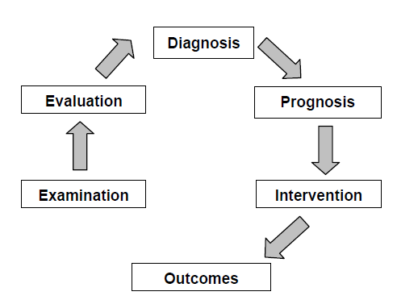
(Adapted from the Guide to Physical Therapist Practice.) 4

Performance criterion: A description of outcome knowledge, skills, and behaviors that define the expected performance of students. When criteria are taken in aggregate, they describe the expected performance of the graduate upon entry into the practice of physical therapy.

Performance Expectations: Level at which an entry-level physical therapist assistant is expected to demonstrate competence in the areas of knowledge, skills, and behaviors in the delivery of physical therapy services as directed by the physical therapist. 1

Physical agent: A form of thermal, acoustic or radiant energy that is applied to tissues in a systematic manner to achieve a therapeutic effect: a therapeutic modality used to treat physical impairments. 1

Physical therapist: A person who is a graduate of an accredited physical therapist professional education program and is licensed to practice physical therapy. 4
Physical therapist assistant: A technically educated health care provider who assists the physical therapist in the provision of selected physical therapy interventions. The physical therapist assistant is the only individual who provides selected physical therapy interventions under the direction and supervision of the physical therapist. The physical therapist assistant is a graduate of an accredited physical therapist assistant associate degree program. 4

Plan of care: Statements written by the physical therapist that specify the anticipated goals and the expected outcomes, predicted level of optimal improvement, specific interventions to be used, and proposed duration and frequency of the interventions that are required to reach the goals and outcomes. The plan of care includes the anticipated discharge plans.4

Posture: The alignment and positioning of the body in relation to gravity, center of mass, and base of support. 1

Prevention: Activities that are directed toward 1) achieving and restoring optimal functional capacity, 2) minimizing impairments, functional limitations, and disabilities, 3) maintaining health (thereby preventing further deterioration or future illness), 4) creating appropriate environmental adaptations to enhance independent function. Primary prevention: Prevention of disease in a susceptible or potentially susceptible population through such specific measures as general health promotion efforts. Secondary prevention: Efforts to decrease the duration of illness, severity of diseases, and sequelae through early diagnosis and prompt intervention. Tertiary prevention: Efforts to limit the degree of disability and promote rehabilitation and restoration of function in patients/clients with chronic and irreversible diseases. 4

Professional duty: Professional duty is the commitment to meeting one’s obligations to provide effective physical therapy services to individual patients/clients, to serve the profession, and to positively influence the health of society. 7

Protective devices: External supports to protect weak or ineffective joints or muscles. Protective devices include braces, protective taping, cushions, and helmets. 1

Quality: The degree of skill or competence demonstrated (eg, limited skill, high skill), the relative effectiveness of the performance (eg, ineffective, highly effective), and the extent to which outcomes meet the desired goals. A continuum of quality might range from demonstration of limited skill and effectiveness to a highly skilled and highly effective performance.

Resource management: The effective use and integration of human, fiscal, and systems resources that follows regulatory and legal guidelines. 1

Social responsibility: The promotion of a mutual trust between the physical therapist assistant as a part of the profession and the larger public that necessitates responding to societal needs for health and wellness. 7

Supervision/guidance: Level and extent of assistance required by the student to achieve clinical performance at entry-level. As a student progresses through clinical education experiences, the degree of monitoring needed is expected to progress from full-time monitoring/direct supervision or cuing for assistance to initiate, to independent performance with consultation. The degree of supervision and guidance may vary with the complexity of the patient or environment. 1

Supportive devices: External supports to protect weak or ineffective joints or muscles. Support devices include supportive taping, compression garments, corsets, slings, neck collars, serial casts, elastic wraps, and oxygen. 1

Technically competent: Correct performance of a skill.

Therapeutic exercise: A broad range of activities intended to improve strength, range of motion (including muscle length), cardiovascular fitness, or flexibility, or to otherwise increase a person’s functional capacity. 1

Wellness: An active process of becoming aware of and making choices toward a more successful existence. 5

SOURCES

1 A Normative Model of Physical Therapist Assistant Education: Version 2007, Alexandria, Va: American Physical Therapy Association; 2007.

2 Assuring Cultural Competence in Health Care: Recommendations for National Standards and an Outcomes-Focused Research Agenda, Office of Minority Health, Public Health Service, U S Department of Health and Human Services; 1999.

3 Green LW, Kreuter MW. Health Promotion Planning. 2nd ed. Mountain View, CA: Mayfield Publishers; 1991:4.

4 Guide to Physical Therapist Practice. Rev 2nd Ed. Alexandria, Va: American Physical Therapy Association; 2003.

5 National Wellness Organization. A Definition of Wellness. Stevens Point, WI: National Wellness Institute Inc; 2003.)

6 Paniagua FA. Assessing and Treating Culturally Diverse Clients. Thousand Oaks, Calif: Sage Publications; 1994.

7 Professionalism in Physical Therapy: Core Values, American Physical Therapy Association, August 2003.

8 Pusch MD, ed. Multicultural Education. Yarmouth, Maine: Intercultural Press Inc; 1999.

9 Sackett DL, Haynes RB, Guyatt GH, Tugwell P. Clinical Epidemiology: A Basic Science for Clinical Medicine. 2nd ed. Boston: Little, Brown and Company; 1991:1.

APPENDIX B:
EXAMPLE OF COMPLETED CIET

APPENDIX C: DATA COLLECTION TECHNIQUES
INTERVENTIONS AND ASSOCIATED DATA COLLECTION TECHNIQUES

This table illustrates the connection between the interventions and associated data collection techniques used by physical therapist assistants to document patient/client progress. The table is not meant to be all-inclusive or restrictive, but to provide a guide for instruction of interventions and the data collection techniques that are essential indicators of the outcome or patient/client response to the intervention. The matrix that follows this table details each of the data collection categories including a list of the associated interventions, examples of techniques used, and sample terminal behavioral objectives. (A Normative Model of Physical Therapist Assistant Education: Version 2007. Alexandria, VA: American Physical Therapy Association; 2007.)

 | Data Collection Techniques
Procedural Interventions | Anthropometric Characteristics | Arousal, Attention, and Cognition | Assistive & Adaptive Devices, Orthotics, Prosthetics | Body Mechanics | Environmental, Self- Care, and Home Issues | Gait, Locomotion, and Balance | Integumentary Integrity | Muscle Performance | Neuromotor Function | Pain | Posture | Range of Motion | Sensory Response | Vital Signs
Therapeutic Exercise:  - Aerobic capacity/ endurance conditioning/ reconditioning | X |  |  |  |  | X |  |  |  |  |  |  |  | X
- Balance, coordination, and agility training |  |  |  |  |  | X |  |  | X |  | X
- Body mechanics and postural stabilization |  |  |  | X |  |  |  | X |  |  | X
- Flexibility exercises |  |  |  |  |  |  |  |  | X | X |  | X
- Gait and locomotion training |  |  | X |  | X | X |  |  | X
- Neuromotor development training |  | X |  |  |  |  |  |  | X
- Relaxation |  | X |  |  |  |  |  |  | X |  |  |  |  | X
- Strength, power and endurance training |  |  |  |  |  |  |  | X |  |  | X
Functional Training in Self- Care and Home Management |  | X | X | X | X | X |  |  | X
Manual Therapy Techniques | X |  |  |  |  |  | X |  |  | X |  | X
Application of Devices and Equipment | X |  | X |  |  |  | X |  |  | X | X |  | X
Airway Clearance Techniques |  |  |  |  |  |  | X |  |  |  |  |  |  | X
Integumentary Repair and Protection Techniques | X |  |  |  |  |  | X |  |  | X |  |  | X
Electrotherapeutic Modalities | X | X |  |  |  |  | X | X | X | X |  |  | X
Physical Agents | X | X |  |  |  |  | X |  |  | X |  | X | X | X

APPENDIX D: PROBLEM SOLVING ALGORITHM
UTILIZED BY PTAs IN PATIENT INTERVENTIONS

This algorithm, developed by APTA’s Departments of Education, Accreditation, and Practice, is intended to reflect current policies and positions on the problem solving processes utilized by physical therapist assistants in the provision of selected interventions. The controlling assumptions are essential to understanding and applying this algorithm. (This document can be found in A Normative Model of Physical Therapist Assistant Education: Version 2007.)

Controlling Assumptions
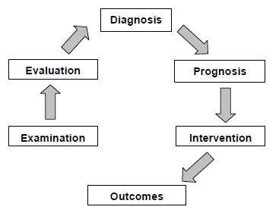

- The physical therapist integrates the five elements of patient/client management – examination, evaluation, diagnosis, prognosis, and intervention – in a manner designed to optimize outcomes. Responsibility for completion of the examination, evaluation, diagnosis, and prognosis is borne solely by the physical therapist. The physical therapist’s plan of care may involve the physical therapist assistant to assist with selected interventions. This algorithm represents the decision making of the physical therapist assistant within the intervention element.

- The physical therapist will direct and supervise the physical therapist assistant consistent with APTA House of Delegates positions, including Direction and Supervision of the Physical Therapist Assistant (HOD P06-05-18-26); APTA core documents, including Standards of Ethical Conduct for the PTA; and federal and state legal practice standards; and institutional regulations.

- All selected interventions are directed and supervised by the physical therapist. Additionally, the physical therapist remains responsible for the physical therapy services provided when the physical therapist’s plan of care involves the physical therapist assistant to assist with selected interventions.

- Selected intervention(s) includes the procedural intervention, associated data collection, and communication, including written documentation associated with the safe, effective, and efficient completion of the task.

- The algorithm may represent the thought processes involved in a patient/client interaction or episode of care. Entry into the algorithm will depend on the point at which the physical therapist assistant is directed by the physical therapist to provide selected interventions.

- Communication between the physical therapist and physical therapist assistant regarding patient/client care is ongoing. The algorithm does not intend to imply a limitation or restriction on communication between the physical therapist and physical therapist assistant.

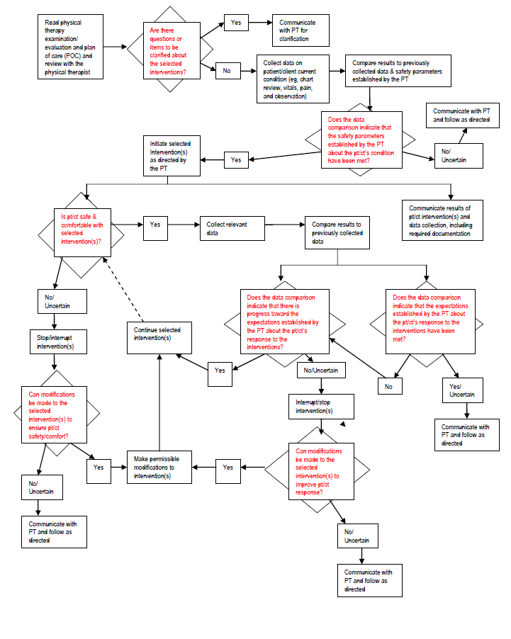

APPENDIX E: PTA CPI PERFORMANCE CRITERIA
MATCHED WITH ELEMENTS FOR PTA PROGRAMS

This table provides the physical therapist assistant academic program with a mechanism to relate the performance criteria from the Physical Therapist Assistant Clinical Performance Instrument with the Standards and Required Elements for Accreditation of Physical Therapist Assistant Education Program

PC # | Physical Therapist Assistant Clinical Performance Instrument  Performance Criteria (PC) | CAPTE Reference  Number | Required Elements for Accreditation of  Physical Therapist Assistant  Education Programs
1 | Safety | 7D24a  7D24c  7D24d  7D24e  7D24m  7D26  7D27 | Measurement of standard vital signs  Mental Functions  Safety for devices and equipment  Safety for gait, locomotion and, balance  Self-Care and civic, community, domestic, education, social, work life  Respond to emergencies  Contribute to patient and healthcare provider safety
2 | Clinical Behavior | 7D4  7D1  7D6  7D2  7D3 | Practice Consistent with Code of Ethics and Guide for conduct PTA  Adhere to Legal Practice Standards  Moral Reasoning  Report Abuse  Report Fraud
3 | Accountability | 7D20  7D5  7D13 | Report Changes in Patient Status  Practice consistent to APTA’s Values  Participate in professional/community organizations
4 | Cultural Competence | 7D8  7D9 | Respect for differences  Apply knowledge, theory, and judgment from client’s perspective
5 | Communication | 7D7  7D12  7D28 | Communicate effectively  Educate patient, caregiver or healthcare personnel  Interprofessional collaboration
6 | Self-Assessment and Lifelong Learning | 7D10  7D11  7D14 | Identify basic concepts in scientific literature  Integrate evidence based resources  Career development & lifelong learning
7 | Clinical Problem Solving | 7D15  7D17  7D18  7D19  7D21 | Interview patients/clients, caregivers, family  Communicate understanding of plan of care  Review healthcare records  Monitor and adjust interventions in the plan of care  Determine when an intervention should not be performed
8 | Interventions: Therapeutic Exercise | 7D23h  7D24h  7D24k  7D24l | Therapeutic Exercise  Muscle Performance  Posture: normal and abnormal alignment  Range of Motion
9 | Interventions: Therapeutic Techniques | 7D23e  7D23i  7D24f  7D24g  7D24h | Manual Therapy Techniques: therapeutic massage, passive range of motion  Wound management  Integumentary integrity  Joint integrity and mobility  Muscle Performance
10 | Interventions: Physical Agents and Mechanical Modalities | 7D23c  7D24b  7D24i | Biophysical Agents: compression therapies  Anthropometric Characteristics  Neuromotor development
11 | Interventions: Electrotherapeutic Modalities | 7D23c | Biophysical Agents: compression therapies
12 | Interventions: Functional Training and Application of Devices and Equipment | 7D23a  7D23b  7D23d  7D23f  7D23g  7D23h  7D24k  7D24l  7D24m  7D24n | Airway Clearance Techniques: breathing exercise, coughing techniques and secretion  Application of devices and equipment  Functional Training: self-care, domestic, education, work, community social and civic  Motor Function Training  Patient/client education  Therapeutic Exercise  Posture: normal and abnormal alignment  Safety in home, community, and work  Self-care and Civic Life: recognize safety barriers in home, community, and work  Activities that aggravate or relieve pain
13 | Documentation | 7D16  7D25 | Use ICF  Documentation
14 | Resource Management | 7D22  7D31  7D30  7D29 | Contribute to discontinuation of care  Accurate and timely billing  Describe organizational planning and operation  Quality Assurance & Improvement

Revised February 2024

U.S. Equal Employment Opportunity Commission. The Americans with disabilities act: applying performance and conduct standards to employees with disabilities. https://www.eeoc.gov/facts/performance-conduct.html. Modified January 20, 2011. Accessed January 18, 2017.

