GENERAL OVERVIEW OF THE SFCC’S ADDICTION STUDIES (AS) PROGRAM
1. WE ARE AN EDUCATIONAL AAS DEGREE and A WORKFORCE PROGRAM:
We are and Applied Associate of Science Degree (AAS): 90 credits to meet WA State Academic College Requirement and also meet the State of WA Substance Use Disorder Professional Educational requirements outlined in WAC 246-811-030.

SFCC AAS Academic Requirements include:
 | Classes:
1 | Computer Skills Classes: (4cr) | Can take any combination, but need 4 credits, i.e. Combination of CAPPS classes, Word, Excel. PowerPoint
2 | Business Math  (BUS) 123 or Math 107 (5cr) | In the Addiction Studies Program, do NOT have to take Math Placement test because you can take BUS MATH, but if you want to take a math that will transfer to a 4 yr. school, you can take the Math placement and take Math 107, which is a transferrable math class.
3 | ENG 101 (Comp)  (5cr) | Please contact the English Placement Center at New Student Orientation to take the test to get into the correct English class. (Most of the AS students need a few quarters to work their way into Eng 101 , no worries!).
4 | Psych 100& and 200& (5 cr each) | These are sequential, so be sure to plan your pathway with enough time to take

*These classes can be transferred in from other colleges and universities, but you must have your transcripts sent to the Registration office to be evaluated. Then, the Addiction Studies faculty can look to see if we can ask our Dean to accept them. Look under the Addiction Studies Canvas Advising Shell for the process.
AND
The Addiction Studies program also meets the Washington State Department of Health (DOH) Educational Requirements for the Certification as a Substance Use Disorder Professional (SUDPT). Which State:
WA State DOH Education Requirements for SUDP: | Minimum education requirements: completion of an AA degree in human services or a related field from an approved school or completion of 90 quarter or 60 semester college credits. Completion of at least 45 quarter or 30 semester credits in courses relating to the topics listed in WAC 246-811-030(a)-(w).
The table below will list the topics and which classes we have provided these requirements.
It is important to understand that SFCC offers the academic credits which are required by Washington State as part of the credentialing process to become a Substance Use Disorder Professional/Trainee.
- SFCC does not grant the SUDP or Training credential.
- SFCC does not review student’s transcripts to see if the DOH will accept certain courses. We are an AAS degree program. If someone is looking to see if their degree or classes meet the DOH’s requirements, we ask that they contact the DOH.
- We also cannot give advice or recommendations on student background checks, please contact the DOH. SFCC cannot give legal advice or determine how the DOH will grant certification approvals. Overview of the Process to Become a Chemical Dependency Professional

WA State DOH Educational Requirements FOR AAS DEGREE

The SFCC Courses that meet the State A-W Requirement
Minimum education requirements: completion of an AA degree in human services or a related field from an approved school or completion of 90 quarter or 60 semester college credits. Completion of at least 45 quarter or 30 semester credits in courses relating to the topics listed in WAC 246-811-030(a)-(w).
 | State Requirement | SFCC Courses Meeting State Requirements  All of the courses below are specific to addiction counseling and have the prefix AS.
A | Understanding addiction. | 131 Survey of Addictions
B | Pharmacological actions of alcohol and other drugs. | 275 Physiological Actions of Alcohol and Drugs
C | Substance abuse and addiction treatment methods. | 176 Addiction Counseling Techniques  277 Group Facilitation for Addiction Treatment  221 Treatment Theories for Addictions
D | Understanding addiction placement, continuing care, and discharge criteria, including American Society of Addiction Medicine (ASAM) criteria. | 279 Case Management I: Screening, Diagnosis, Assessment, and ASAM
E | Cultural diversity including people with disabilities and its implication for treatment. | 182 Cultural Diversity; Risk Intervention for Health/HIV  290 Co-Occurring Behavioral Health Disorders
F | Chemical dependency clinical evaluation (screening and referral to include comorbidity). | 280 Case Management 2: Treatment Planning and Continuing Care  290 Co-Occurring Behavioral Health Disorders
G | HIV/AIDS brief risk intervention for the chemically dependent. Chemical dependency treatment planning. | 182 Cultural Diversity; Risk Intervention for Health/HIV
H | Chemical dependency treatment planning. | 279 Case Management I: Screening, Diagnosis, Assessment, and ASAM
I | Referral and use of community resources. | 280 Case Management 2: Treatment Planning and Continuing Care  172 Family Systems and Adolescent Treatment in Addictions
J | Service coordination (implementing the treatment plan, consulting, continuing assessment and treatment planning). | 280 Case Management 2: Treatment Planning and Continuing Care
K | Individual counseling. | 176 Addiction Counseling Techniques  221 Treatment Theories for Addictions
L | Group counseling. | 277 Group Facilitation for Addiction Treatment
M | Chemical dependency counseling for families, couples and significant others. | 172 Family Systems and Adolescent Treatment in Addictions
N | Client, family and community education. | 172 Family Systems and Adolescent Treatment in Addictions
O | Developmental psychology. | PSYC&100 General Psychology  PSYC&200 Lifespan Psychology
P | Psychopathology/abnormal psychology. | 290 Co-Occurring Behavioral Health Disorders
Q | Documentation, to include, screening, intake, assessment, treatment plan, clinical reports, clinical progress notes, discharge summaries and other client related data. | 279 Case Management I: Screening, Diagnosis, Assessment, and ASAM  280 Case Management 2: Treatment Planning and Continuing Care  172 Family Systems and Adolescent Treatment in Addictions
R | Chemical dependency confidentiality. | 141 Law, Ethics, and Professional Development for Addiction Counseling
S | Professional and ethical responsibilities. | 141 Law, Ethics, and Professional Development for Addiction Counseling
T | Relapse prevention. | 176 Addiction Counseling Techniques  221 Treatment Theories for Addictions
U | Adolescent chemical dependency assessment and treatment. | 172 Family Systems and Adolescent Treatment in Addictions
V | Chemical dependency case management. | 279 Case Management I: Screening, Diagnosis, Assessment, and ASAM  280 Case Management 2: Treatment Planning and Continuing Care
W | Chemical dependency rules and regulations. | 141 Law, Ethics, and Professional Development for Addiction Counseling

These classes can be transferred in from other colleges and universities, but you must have your transcripts sent to the Registration office to be evaluated. Then, the Addiction Studies faculty can look to see if we can ask our Dean to accept them. Look under the Addiction Studies Canvas Advising Shell for the process. Attention: For ALL ADDICTION STUDIES SPECIFIC CLASSES: According to the WAC, the classes must be specific to Addiction. Students asking to transfer classes that are not specific to addiction will not be accepted due to State requirements. For example, a Group class must be specific to addiction populations and demonstrate proof in the class title, syllabus or description that the course was specific to populations with addictions or the course will not be accepted. It is the student’s responsibility to provide and identify these specifics or it will not be accepted.
IMPORTANT NOTE: When you apply for your official Substance Use Disorder Professional Credential, The Washington State Department of Health (DOH) will require you to fill out the information above as part of your application. If you have substituted classes as part of your SFCC AAS Degree or if you did not graduate with the SFCC AAS Degree, you will need to provide the documented support for any substituted or non-SFCC Addiction Studies courses with the other school’s information supporting that it meets the content of the letter (A-W) competencies. This might be the original school’s course syllabi, course description, etc. Please be aware that it is the student’s responsibility to provide all supporting documentation for substituted course documentation or other non-SFCC documentation to the DOH. SFCC does not maintain or take responsibility to provide documentation to the DOH.

2. VERY BRIEF OVERVIEW OF ADDICTION STUDIES PROGRAM PATHWAY/COURSES
This is a brief overview, LISTING of the courses and our AS Pathway. Please refer to other videos for a more complete understanding of how our Pathway works and how to use it for Registration and Student Program Planning.
This is an EXAMPLE of our Pathway listing all of our Courses specific to Addiction Studies. The most current and updated can always be found in the CANVAS AS Advising Addiction Studies Shell.

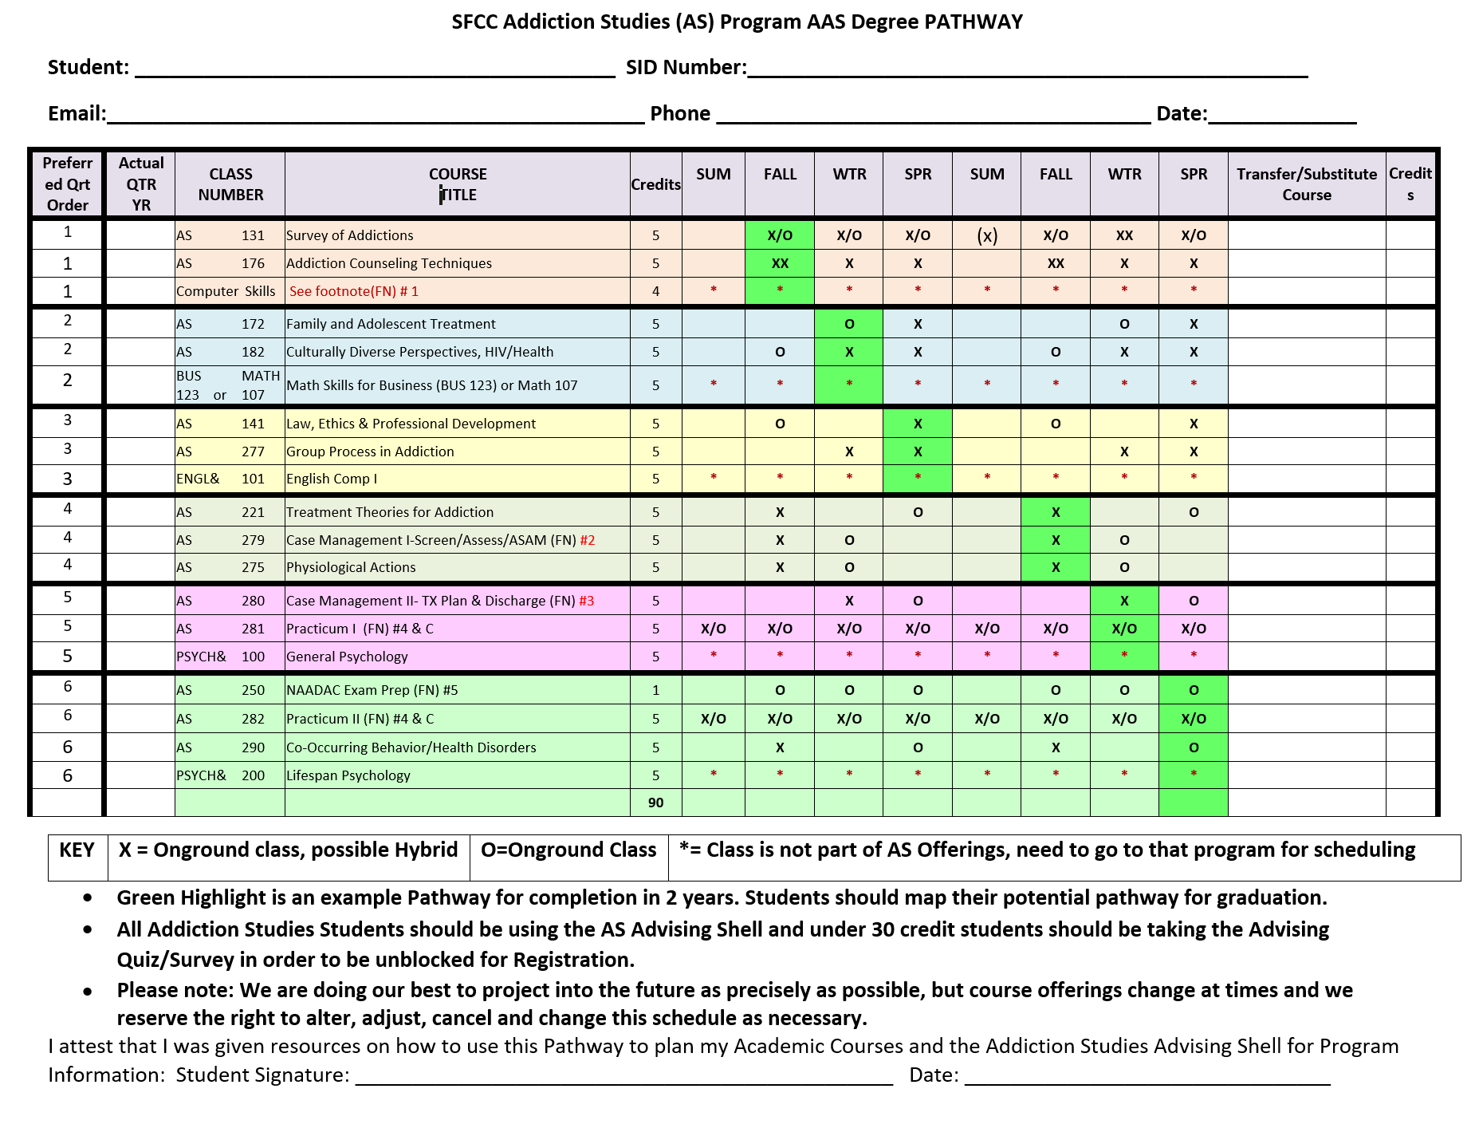

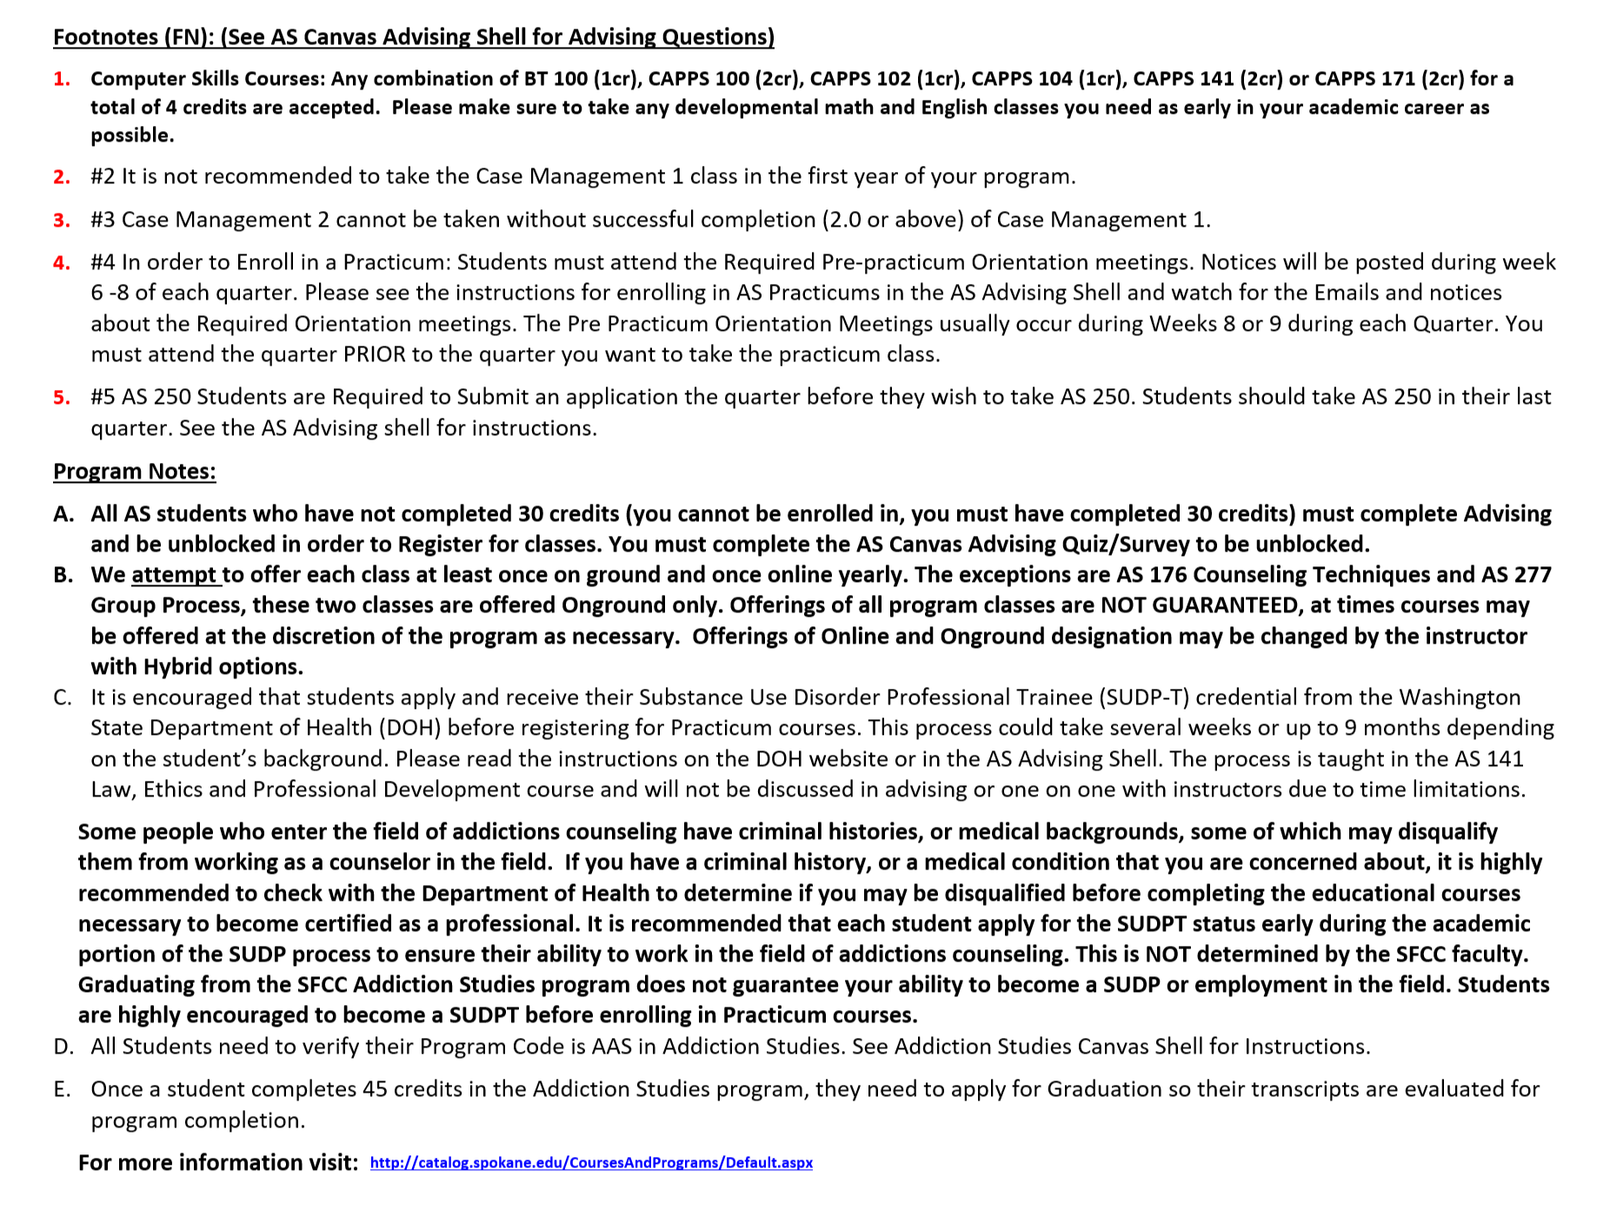

3. WHAT DOES IT REQUIRE TO BECOME A SUDP IN WASHINGTON STATE?
Please go to the DOH webpage for the full directions, but for a short and incomplete overview, here is what we usually tell students. Also, look for other videos on the Addiction Studies Advising Shell for more information.

1. Academic Educational Requirements | …the minimum educational requirements are: an associate’s degree in human services or related field from an approved school; or successful completion of ninety quarter or sixty semester college credits in courses from an approved school. At least forty-five quarter or thirty semester credits must be in courses relating to the chemical dependency profession.
2. Completing Supervised Hours | (This step comes after applying and receiving a SUDPT credential from the DOH, which requires passing a DOH background investigation). See DOH webpage for more info. We typically cover this information in the AS 141 Law, Ethics and Professional Development class and have students fill out a mock SUDPT application. There is a fee associated with the actual SUDPT.  - We strongly encourage students to become SUDPTs before the end of our program and to be able to complete their 10 credits of AS 218 and 282 Practicums in the function of SUDPTs. If students work with State licensed agencies to be supervised as an SUDPT, these hours can be counted both as Practicum and as their SUDPT Supervised hours. This beneficial partnership assists students to transition towards their credential. (SFCC is not responsible or able to supervise SUDPT hours).
3. Successfully Passing the WA State Exam (NAADAC) | Students will study and take the exam in SFCC’s AS 250 class. Passing the exam is not a requirement for passing the AS 250 course.

Therefore, if you need an associate degree or 90 quarter/60 semester college credits or the Washington State required 45 credits specific to the Substance Use Disorder profession, you would enroll in our A.A.S. Addictions Studies Program. If a student already has other credits or a bachelor’s degree, please see the Advising Section titled: “Course Substitutions”.

If you have a master’s degree in a counseling related field and are (or will become) licensed as a Mental Health Counselor, Social Worker, etc. you may qualify for the Addiction Studies Advanced Professional Certificate Program. Please see DOH for other State requirements, as they differ from the requirements listed for our AAS Degree students. (Please see the Continuing Education Department for Possible Programs Available).

Some Rules of Thumbs for Starting the Addiction Studies Program:
- Please watch the other videos about our Pathway and registering, etc.
- It is not necessary to be accepted by the SFCC Addiction Studies program before taking classes. We do recommend talking to an advisor. If you would like to take a few classes to see what the program is about, we advise taking the Survey of Addiction (AS 131) and Counseling Techniques (AS 176). Each course is five (5) credits.
- Although it is highly suggested to follow the order of classes on the Pathway, it is only a suggestion. Things may occur in which you will need to take classes out of order: classes are full, you need to take a developmental English. Try to stay as close as possible to the Pathway and please try not to take anything in the bottom half of the chart in the first half of the program. Practicums should be taken towards the end of your program.
- Any student who has less than a designated number of credits, (i.e. 45) credits will need to meet with an advisor prior to being released for registration in SFCC classes. A general counselor/advisor may complete this step with you. An AS program faculty member may also assist you with this step. Initial advising to enter the program occurs with the general advising and access with the Addiction Studies Canvas shell. Students will have Addiction Studies faculty academic advising once they are involved in Addiction Studies courses.
- The AS faculty hold group advising sessions to help students understand the program and to provide general advising. This is not mandatory before attending classes, much of the info will be presented again in group advising sessions during classes and/or online advising sessions. You do not have to have prior advising from the AS program before you enroll in courses. Classes fill up quickly, so the most important action is to register for a seat in the class! Please do not wait to meet individually with an AS faculty member. Our program only has two faculty members who teach full-time. If you cannot attend a group advising session, please utilize the SFCC advisors/counselors. To schedule an appointment, call 509-533-3525. The Counseling Center is located in Building 30, Upper Concourse, room 243.

