Ally Student

Ally creates accessible content in your courses by offering your course files in multiple formats. You can download accessible versions of files anywhere that files are stored.

When you are in a course in Canvas, if a file is linked on a page, you will see a small dropdown icon at the end of the file name. If you click on this arrow, you will be given the option to download the file in its current format, or download accessible formats.

Hover over the file you wish to open to view accessible versions. Click the tool dropdown next to the file, and select Accessible versions.

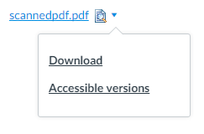

A list of accessible file options will appear. The accessible versions include audio, ePub, PDF with structure classification indications, electronic Braille, and HTML. The versions listed may vary depending on the file’s content.

Select the version you would like to open and click Download. If this is the first time you are downloading a specific type of file, a Preparing download notification will appear.

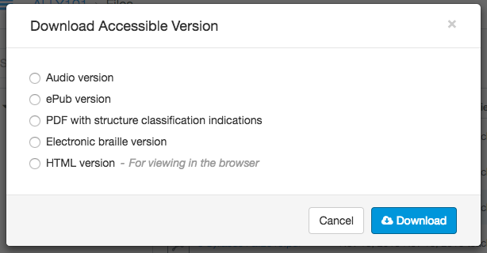

After the download is complete, you can open or save the file. You can also return to the file to download different versions.

